CONSIDER FOR TALK
2024 SEA Faculty Meeting Abstract
Minnesota State University Moorhead
Moorhead MN
Corresponding Faculty Member: Michelle Tigges (michelle.tigges@mnstate.edu)
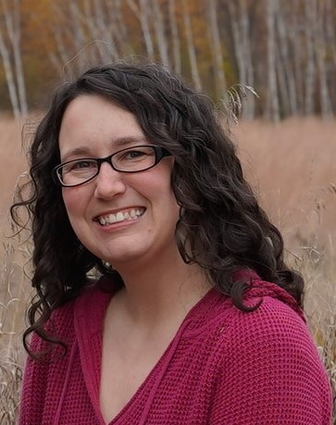
Michelle M Tigges
Is This Really Chemistry? Using Phage Discovery as a General Chemistry Lab CURE
Michelle M Tigges
While phages are generally thought to fit best into science curriculum through the context of biology, Minnesota State University Moorhead has modified the phage discovery portion of the SEA PHAGES program to utilize it as an applied, interdisciplinary general chemistry lab experience. Over the course of four years, we have adjusted how we carry out our phage discovery lab, focusing on combining phage discovery with soil chemistry characterization techniques to teach chemistry objectives. The phage purification and amplification process lends itself well to development of laboratory skills associated with understanding measurement, solutions, dilutions, and dimensional analysis. We extend this by adding in a soil analysis component to the course, where students determine how the chemical characteristics of the soil samples they collected connect to M. foliorum phage presence or absence. Tests including pH, moisture content, phosphate content, nitrate content, metals analysis, organic carbon content, and pigment analysis are used to introduce students to chemistry techniques through the context of their phage project via assays like colorimetric absorption spectroscopy, standard curve preparation, cation exchange and acid/base equilibria, combustion, atomic absorption spectroscopy, and FTIR. Students then compare their methods and data to values reported in primary literature papers, such as phage diversity studies, enabling them to contextualize and compare their results and methods. This approach to general chemistry lab emphasizes the interdisciplinary nature of research, making chemistry more accessible by introducing it through the meaningful context of phage discovery.

