DO NOT CONSIDER FOR TALK
2024 SEA Faculty Meeting Abstract
University of Wisconsin-River Falls
River Falls WI
Corresponding Faculty Member: Karen Klyczek (karen.k.klyczek@uwrf.edu)
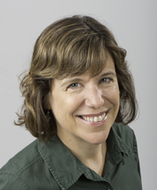
Karen K Klyczek
Phage Genomics Guide Revision
Karen K Klyczek, Debbie Jacobs-Sera*
* University of Pittsburgh, Pittsburgh PA
The Phage Genomics Guide (a.k.a. Bioinformatics Guide) is undergoing revisions and will be available on a new platform that is improved for user accessibility (similar to the new Phage Discovery guide). The core of the new Genomics Guide will focus on the process of refining the auto-annotation, organized around three main questions to be asked for each gene identified in the auto-annotation: Is it a gene? What is its start? What is its function? Other updates include the use of PECAAN as well as DNA Master throughout the guide. Faculty meeting participants will have an opportunity to provide input and feedback on the guide.

