DO NOT CONSIDER FOR TALK
2024 SEA Faculty Meeting Abstract
Indiana University-Southeast
New Albany IN
Corresponding Faculty Member: Elizabeth Rueschhoff (erueschh@iu.edu)
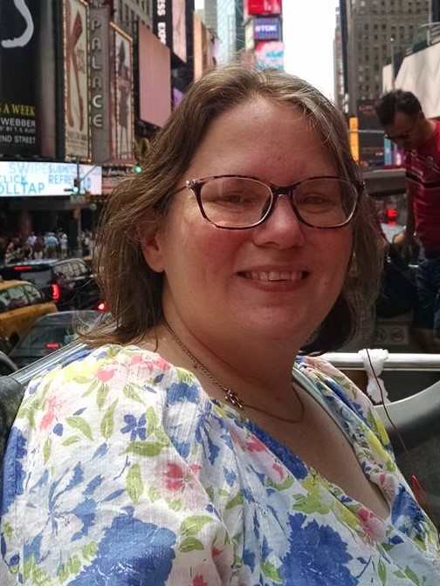
Elizabeth E Rueschhoff
Conference Presentation: Enhancement of the Student’s Research Experience
Elizabeth E Rueschhoff
One of the key features of the SEA-PHAGES program is that students are exposed to the scientific process. One of the important components of the scientific process is the communication of science. For the first two years, we required students to present to the class, but presenting at a conference was optional. While some students presented at a conference, many did not and therefore did not gain that experience. In our third and most recent year in the SEA-PHAGES program, we required students to present at a conference. In the Fall Discovery semester, students presented at the Indiana University Undergraduate Research Conference (IUURC) and in the Spring Bioinformatics semester students presented at the Indiana University Southeast Student Showcase and Research Conference. This required more time and involvement on the part of both the students and the faculty. However, requiring conference participation had several positive outcomes. More students gained experience presenting to a diverse audience. The quality of the presentations was higher, and they also learned to communicate their science to a broad audience, including answering questions regarding the scientific process and their results. We intend to continue requiring conference participation as part of their research experience.

