CONSIDER FOR TALK
2024 SEA Faculty Meeting Abstract
Connecticut State Community College Northwestern
Winsted CT
Corresponding Faculty Member: Sharon Gusky (sharon.gusky@ctstate.edu)
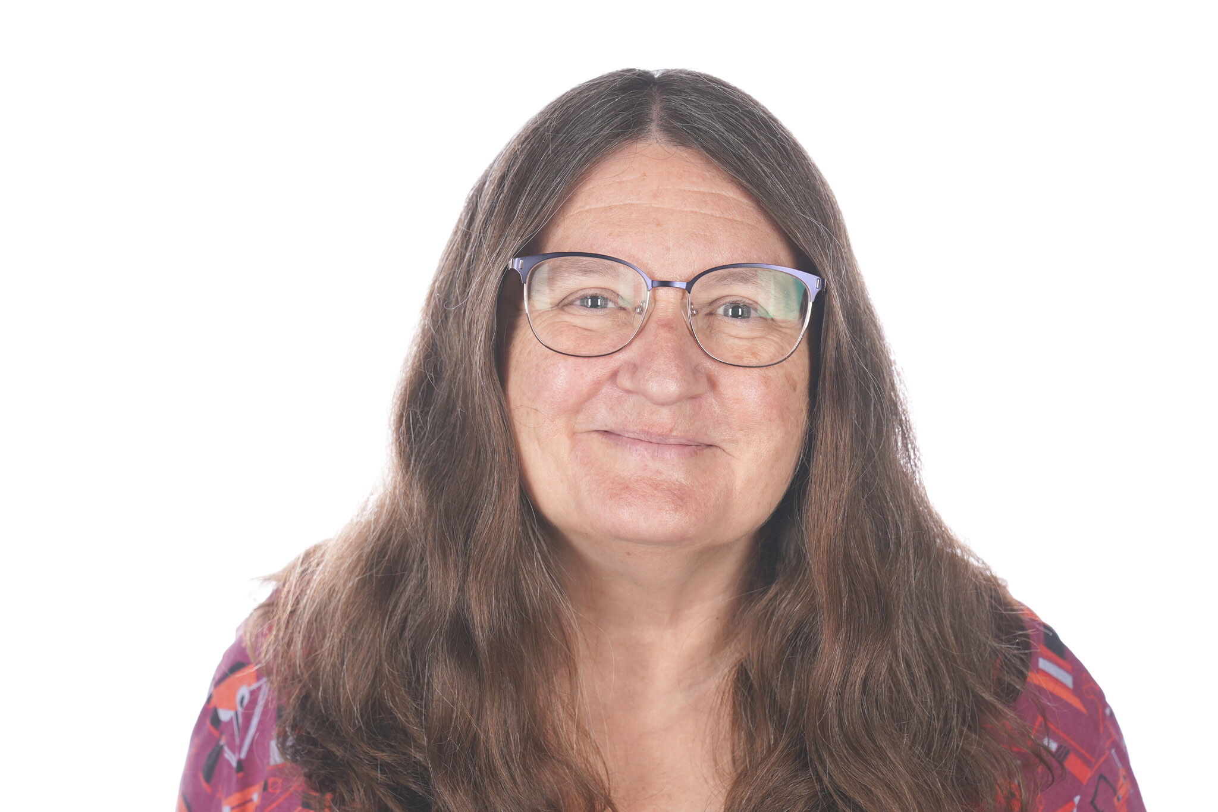
Sharon B Gusky
Using DNA Master and BPROM to Identify Promoter Regions
Sharon B Gusky
Upon completion of the Gene Annotation project, students are often excited about bioinformatic and want to do more and learn more. To feed their excitement and facilitate their learning I give them the opportunity to identify the promoter regions of current and previously annotated genomes. By doing this they learn how to use a new function in DNA Master and learn how to use a new software program, Softberry's BPROM.

