CONSIDER FOR TALK
2024 SEA Faculty Meeting Abstract
College of William & Mary
Williamsburg VA
Corresponding Faculty Member: Margaret Saha (mssaha@wm.edu)
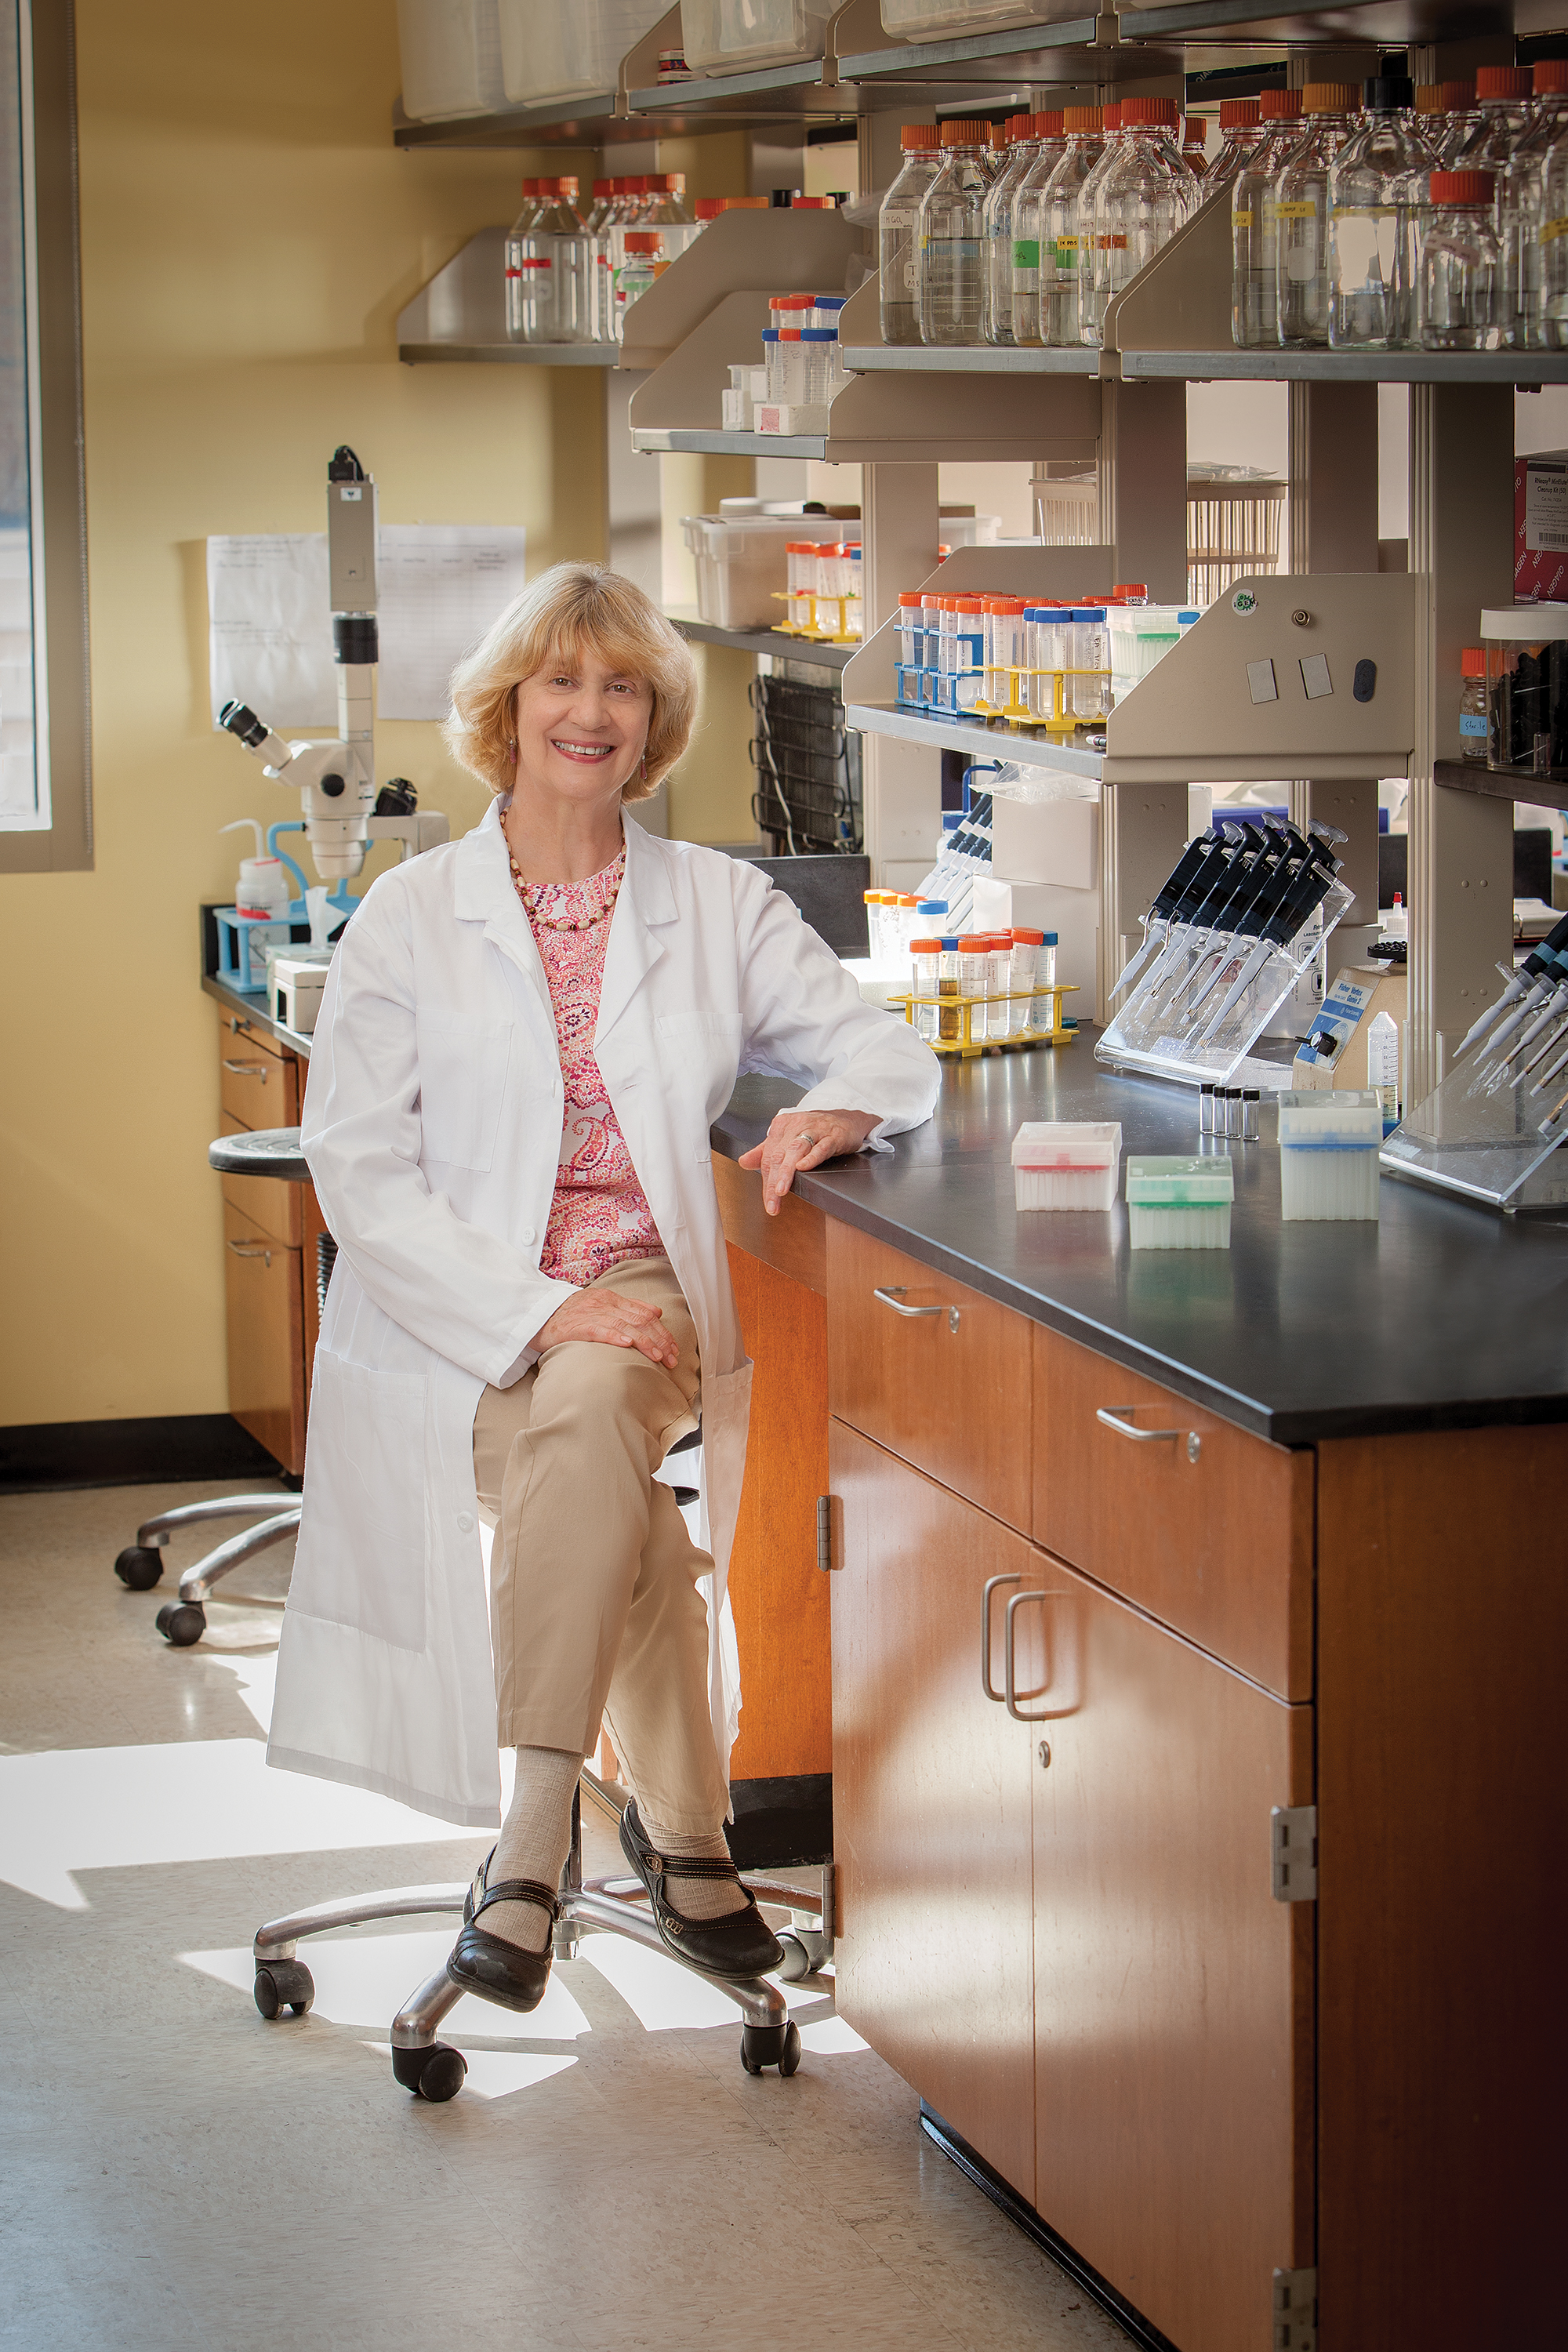
Margaret S Saha
Isolation and Characterization of Phagelets: Satellite Phages that Parasitize an A2 Prophage in M. aichiense
Margaret S Saha, Jason D Robinson, Anne Roman, Mitchell Doherty, Mahima Shijo, Zoe Riddick
While bacteriophages may be the most diverse and abundant biological entities in the biosphere, there is another class of class of equally important viral-like particles that modulate bacterial-phage interactions, bacterial population dynamics, and evolution. Generically known as "satellite phages,' these entities harbor a small number of genes and parasitize other bacteriophages to acquire key proteins to ensure their own propagation. Employing a diverse group of mechanisms, satellite phages have been isolated and characterized in E.coli, Streptomyces scaabiei, and Vibrio cholerae. Here we report the existence of a group of ten highly related satellite phages that parasitize an A2 prophage (HerbertWM) in M aichiense. The satellite phages (or phagelets as we call them) have ~11KB genomes, extremely low, unstable titers, and variable stoichiometries of phagelet vs. HerbertWM. Moreover, isolation of additional phagelets has proved exceptionally idiosyncratic. The goal of this presentation is to elicit discussion and suggestions regarding the nature and mechanisms of action of these distinctive particles.

