DO NOT CONSIDER FOR TALK
2024 SEA Faculty Meeting Abstract
Carthage College
Kenosha WI
Corresponding Faculty Member: Deb Tobiason (dtobiason@carthage.edu)
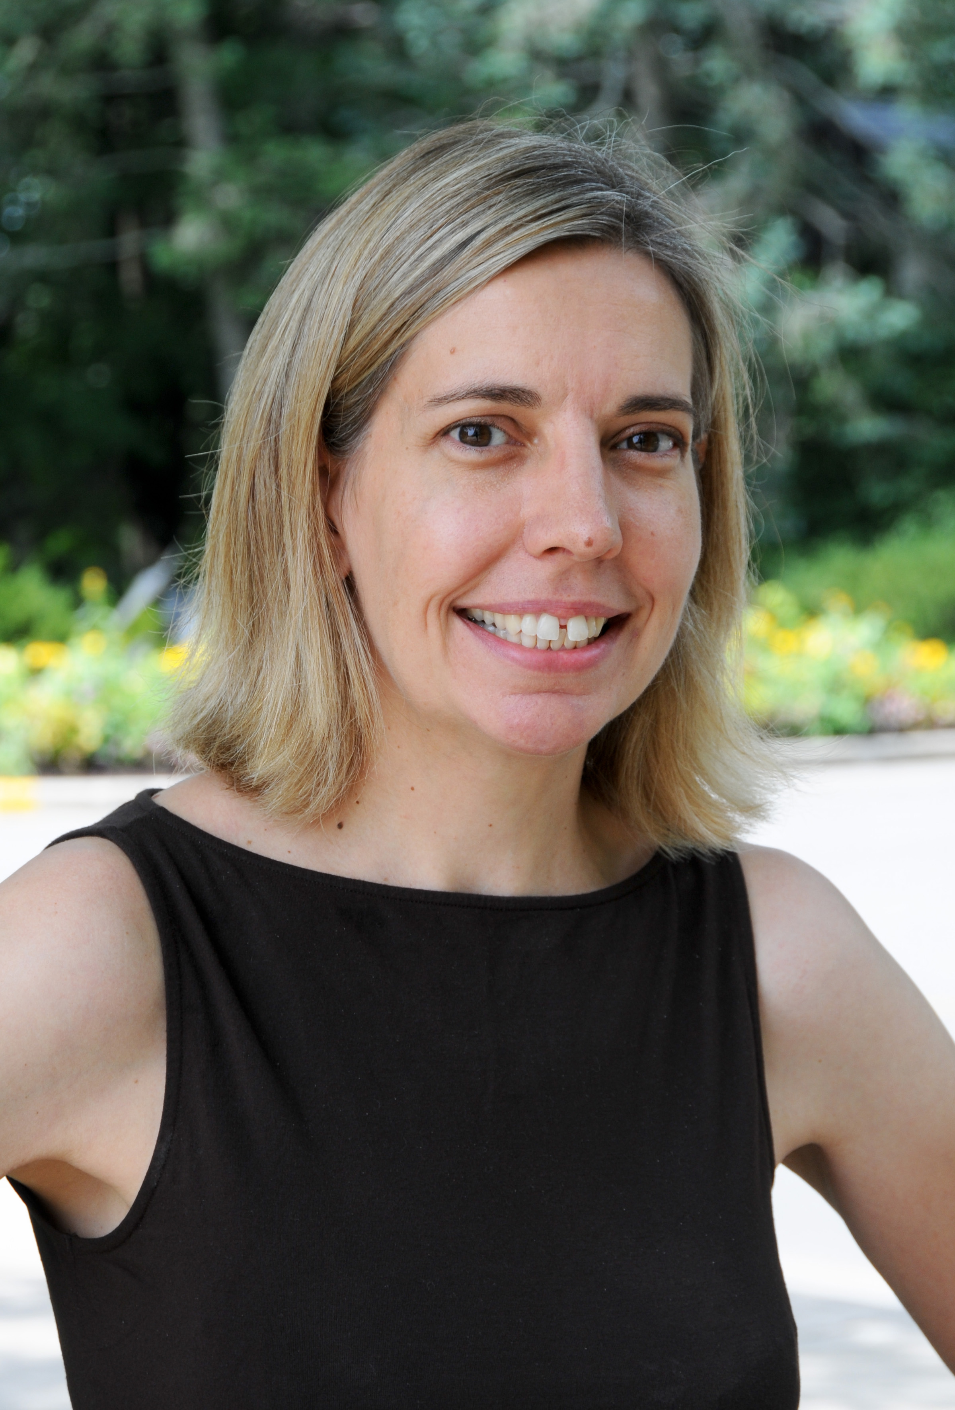
Deborah M Tobiason
The Effects of Simulated Microgravity Conditions on Mycobacteriophage Lysogen Stability
Deborah M Tobiason, Jessica Leo, Alli Pacocha, Owen Lewer, Patrick Zaker
The space flight environment as well as microgravity conditions simulated on Earth are known to affect various plants, animals and bacteria, but little research has been done to see how these conditions affect bacteriophages. We propose that microgravity may stimulate temperate phages to switch to the lytic cycle, resulting in increased lysis of bacterial lysogens in microgravity environments like on the International Space Station. Temperate Mycobacteriophages Cerasum (F1) and SpikeBT (A1) were used to isolate stable lysogens. These lysogens were tested using a high aspect ratio vessel (HARV) to simulate microgravity. The effect of microgravity on lysogen stability was determined by measuring phage particle release. Our results suggest that lysogens produced with the same phage vary in their stability under normal growth conditions. Lysogens that were more stable, hence very little release of phage particles under standard growth conditions, exhibited an increased switch to the lytic cycle under microgravity conditions in comparison to standard growth conditions. Phages play a key role in the environment by limiting the levels of bacteria present. If lysis of bacterial cells increases due to microgravity in the space environment, then the composition of the spacecraft microbiome and the astronauts’ microbiomes may be affected, impacting their overall health and the success of manned space flights in the future.

