CONSIDER FOR TALK
8th Annual SEA-PHAGES Symposium Abstract
Carthage College
Kenosha WI
Corresponding Faculty Member: Deb Tobiason (dtobiason@carthage.edu)
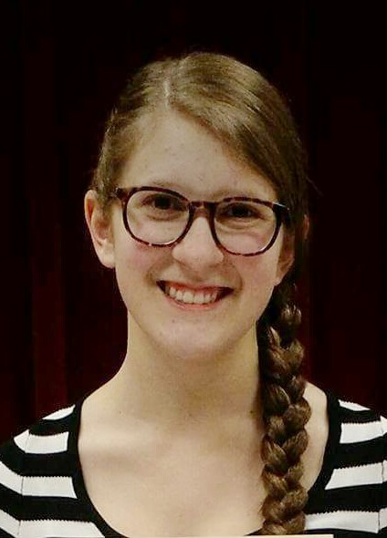
Olivia DeRoach
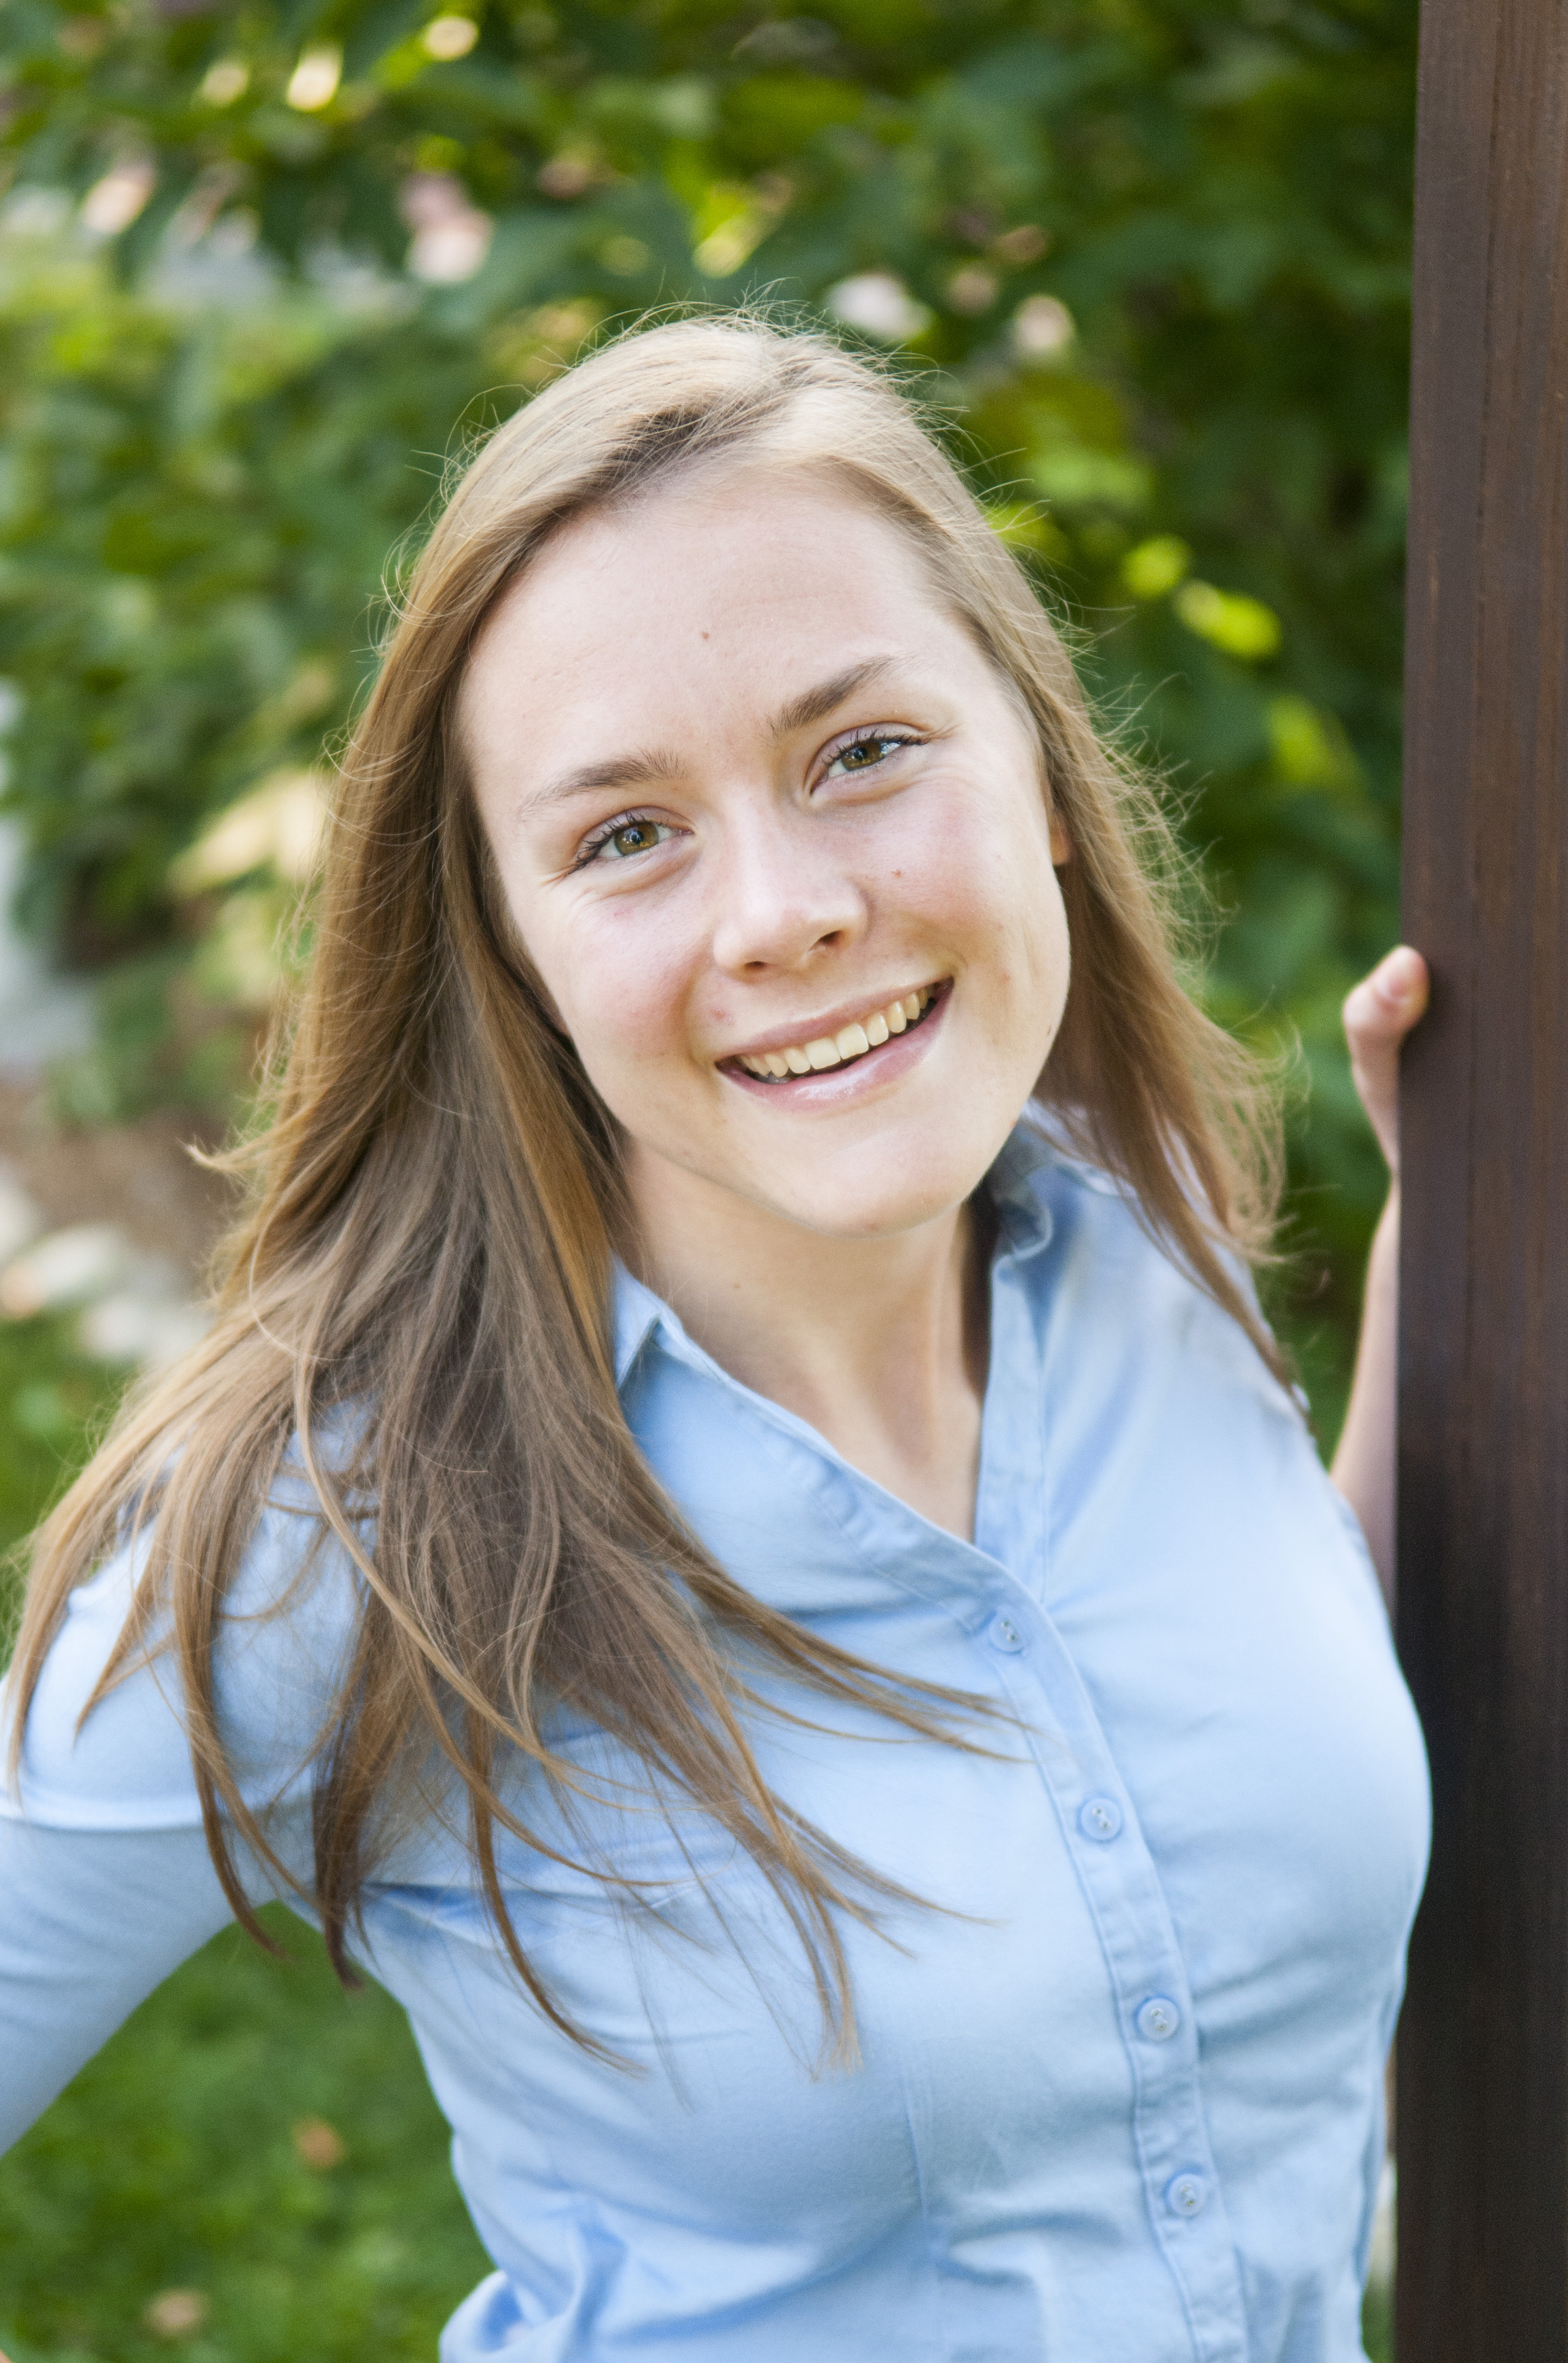
Erin Magennis
Investigation and Annotation of Cluster B1 Mycobacteriophages: SassyCat97, Surely, and TomBombadil
Olivia DeRoach, Erin Magennis, Rebecca Farmer, Stephanie Hartling, James Hasbrouck, Cara Hull, Rebekah Krejci, Claire Pfeffer, Morgan Popek, Jelena Romanovic, Paden Sheumaker, Krista Sreniawski, Aileen Szczepanski, Rebecca Thomas, Jeremy Behnke, Allison Dreyer, Emma Dresen, Benjamin Ho, Maria Garza, Annie Jacklin, Andrea Henle, Qinzi Ji, Deborah Tobiason
Through the SEA-PHAGES program in Fall 2015, the Carthage College Biology Department isolated 56 novel mycobacteriophages that infect Mycobacterium smegmatis. Individual populations were isolated through a series of steps including enrichment, streak tests, dilution purification, and titer assays. Electron microscopy revealed that 54 of the phages are siphoviridae and two are myoviridae phages. DNA isolation was performed for each phage, and sequencing four of these phages’ genomic DNA revealed that three cluster B1 and one cluster C1 phages were isolated. The cluster B1 phages, SassyCat97, Surely and TomBombadil, were annotated and further characterized using a number of bioinformatics tools. The cluster B1 phages generally have high sequence similarity, and these phages are no exception. Surely and TomBombadil differ by only 8 basepairs and share 99% identity with SassyCat97. Currently, genomic differences between these three phages and other cluster B phages are being examined, along with investigation of possible differences in plaque morphology. These studies will help to broaden our knowledge of the cluster B phages.

