DO NOT CONSIDER FOR TALK
2024 SEA Faculty Meeting Abstract
College of Coastal Georgia
Brunswick GA
Corresponding Faculty Member: Holly Nance (hnance@ccga.edu)
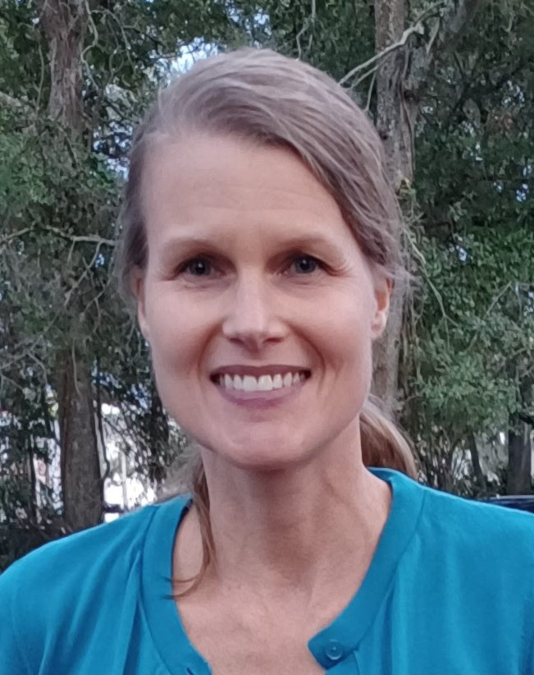
Holly Nance
Going Viral - Five years of PHAGES at the College of Coastal Georgia
Holly Nance
Since 2019, the College of Coastal Georgia in Brunswick, GA has been an institutional member of the SEA-PHAGES program. In those five years, we’ve taught four sections of discovery and five sections of bioinformatics, now called Going Viral I and Going Viral II, respectively. We’ve had the genomes of four phages sequenced and annotated five genomes. As a small, open-access PUI with limited resources, SEA-PHAGES has greatly enhanced our ability to engage students in authentic research. To date, we have had 84 students take the courses and currently have 14 registered for Going Viral I in the Fall 2024 semester. All 48 students who have completed Going Viral II have also presented independent research on a specific gene at our college’s annual research symposium. This poster presentation is a requirement for the course and a major portion of their grade. With this form of assessment, students must annotate a gene needing a more extensive literature/database search, gather evidence to support their decision and report to the rest of the class. This offers students a small portion of the annotation that is ‘theirs’, while still working collaboratively with their peers to annotate all other genes and come to a consensus with the rest of the class. The poster presentation further provides students with a chance to complete the scientific method with that critical component of sharing their work with a broader community. Their presentations also help promote the program and highlight our accomplishments to the rest of the college. We offer the Going Viral sequence as 3000-level elective courses at Coastal with Introductory Biology or Instructor Permission as the only prerequisites. Feedback on course evaluations is always positive, as both courses are CV-builders for our students and help to foster a sense of purpose and identity in their field of study. Several students have used their experience in SEA-PHAGES to continue other independent research and/or pursue graduate degrees after leaving Coastal.

