CONSIDER FOR TALK

2024 SEA Faculty Meeting Abstract

University of South Florida

Tampa FL

Corresponding Faculty Member: Richard Pollenz (pollenz@usf.edu)

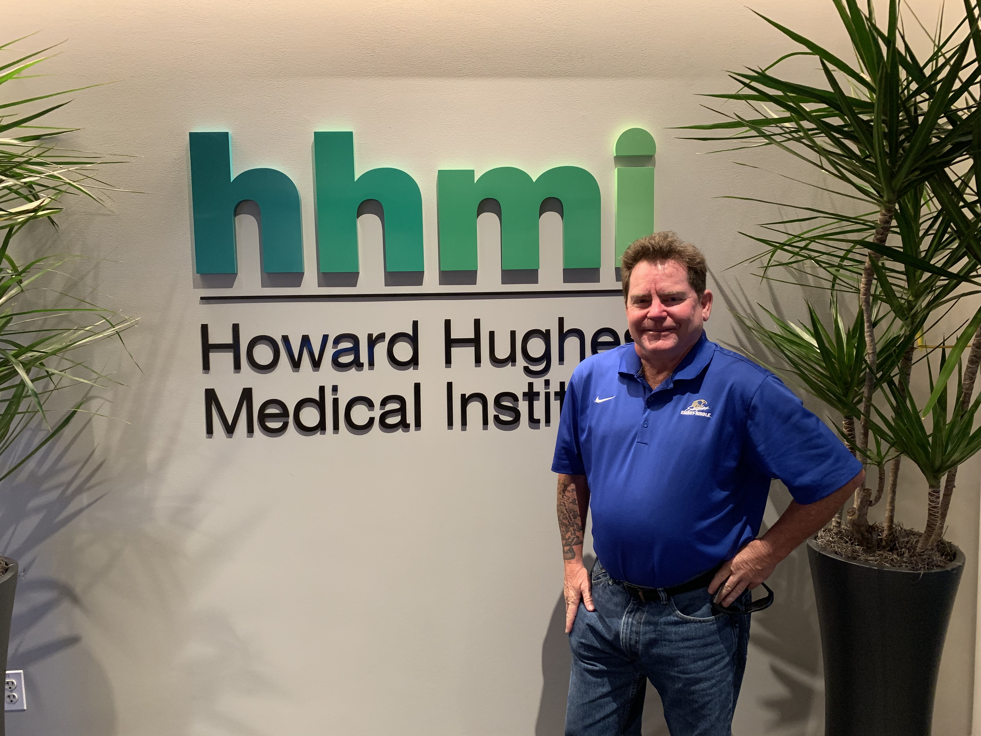

Richard S Pollenz

Functional Analysis of a Second Holin Gene in A2 Custer Phage D29 that is not Localized Within the Putative Lysis Cassette and is Essential for Efficient Bacterial Lysis

Richard S Pollenz, Kira Ruiz-Houston

The lysis cassette of most tailed phages is typically localized downstream of the tape measure and minor tail genes and consists of one or more endolysin genes encoding proteins involved in cell wall digestion and one or more genes encoding small transmembrane domain (TMD) proteins that function as holins. Holins are responsible for controlling 1) the timing of bacterial lysis following infection and 2) triggering the lysis event by destruction of the bacterial PMF. Typically, holins also create pores in the bacterial inner membrane that allow the exit of endolysins. Thus, holin deletions present as lethal phenotypes in phages that infect Gram-negative hosts. D29 is a cluster A2 phage with a lysis cassette found within the structural genes upstream of the tape measure. In D29, gene 10 encodes a lysin A, gene 11 encodes a putative holin with two TMDs and gene 12 encodes lysin B. Previous work has shown that deletion of gene 11 results in a viable phage with a 20% reduced plaque size and delay in lysis timing. Due to the survival of the KO 11 phage, the D29 genome was evaluated for other TMD genes that might serve holin function. Analysis of 792 cluster A phage genomes showed that all contained one or more TMD genes downstream of the tape measure and minor tails in the location expected for a canonical lysis cassette. Within this region, every A cluster phage contains a gene encoding a 1TMD protein. In D29, the 1TMD protein is encoded from gene 30 and the protein is grouped within a pham of >700 proteins from phages in clusters A, F, DZ, I, J, N, and P. In every cluster other than A, the gene encoding the 1TMD protein is found within a canonical lysis cassette directly downstream of endolysins and one other TMD gene. We hypothesized that D29 gene 30 encoded a second holin even though it was not localized in the D29 lysis cassette. Recombineering was utilized to delete genes 11, 12 and 30 from D29. All deletions were viable with the gene 30 deletion (D29-D30) showing the most severe phenotype that is manifest as a >63% reduction in plaque size and near 90% reduction in plaque area compared to WT D29. One-step growth curves with D29-D30 did not show a timing defect to burst, but released significantly less phage than WT D29. Liquid infection assays to assess cell lysis did not show significant reductions in OD comparable to WT D29, and no viable cells could be recovered after infection. Importantly, D29-D30 adsorbs to M. smeg with high efficiency and the plaque size defect was partially complemented by expression of D29 gp30 or Waterfoul gp32 (a 1TMD protein from a different pham). Collectively, the data support a hypothesis that gp30 is essential for the efficient release of endolysins for complete cells lysis. The implications of this work are: 1) actinobacteriophages utilize more than one holin for lysis, 2) 1TMD holins serve a critical role in host cell lysis and 3) holins may be localized to genomic regions that are distal to the lysis cassette.