CONSIDER FOR TALK
2024 SEA Faculty Meeting Abstract
Monmouth College
Monmouth IL
Corresponding Faculty Member: James Godde (jgodde@monm.edu)
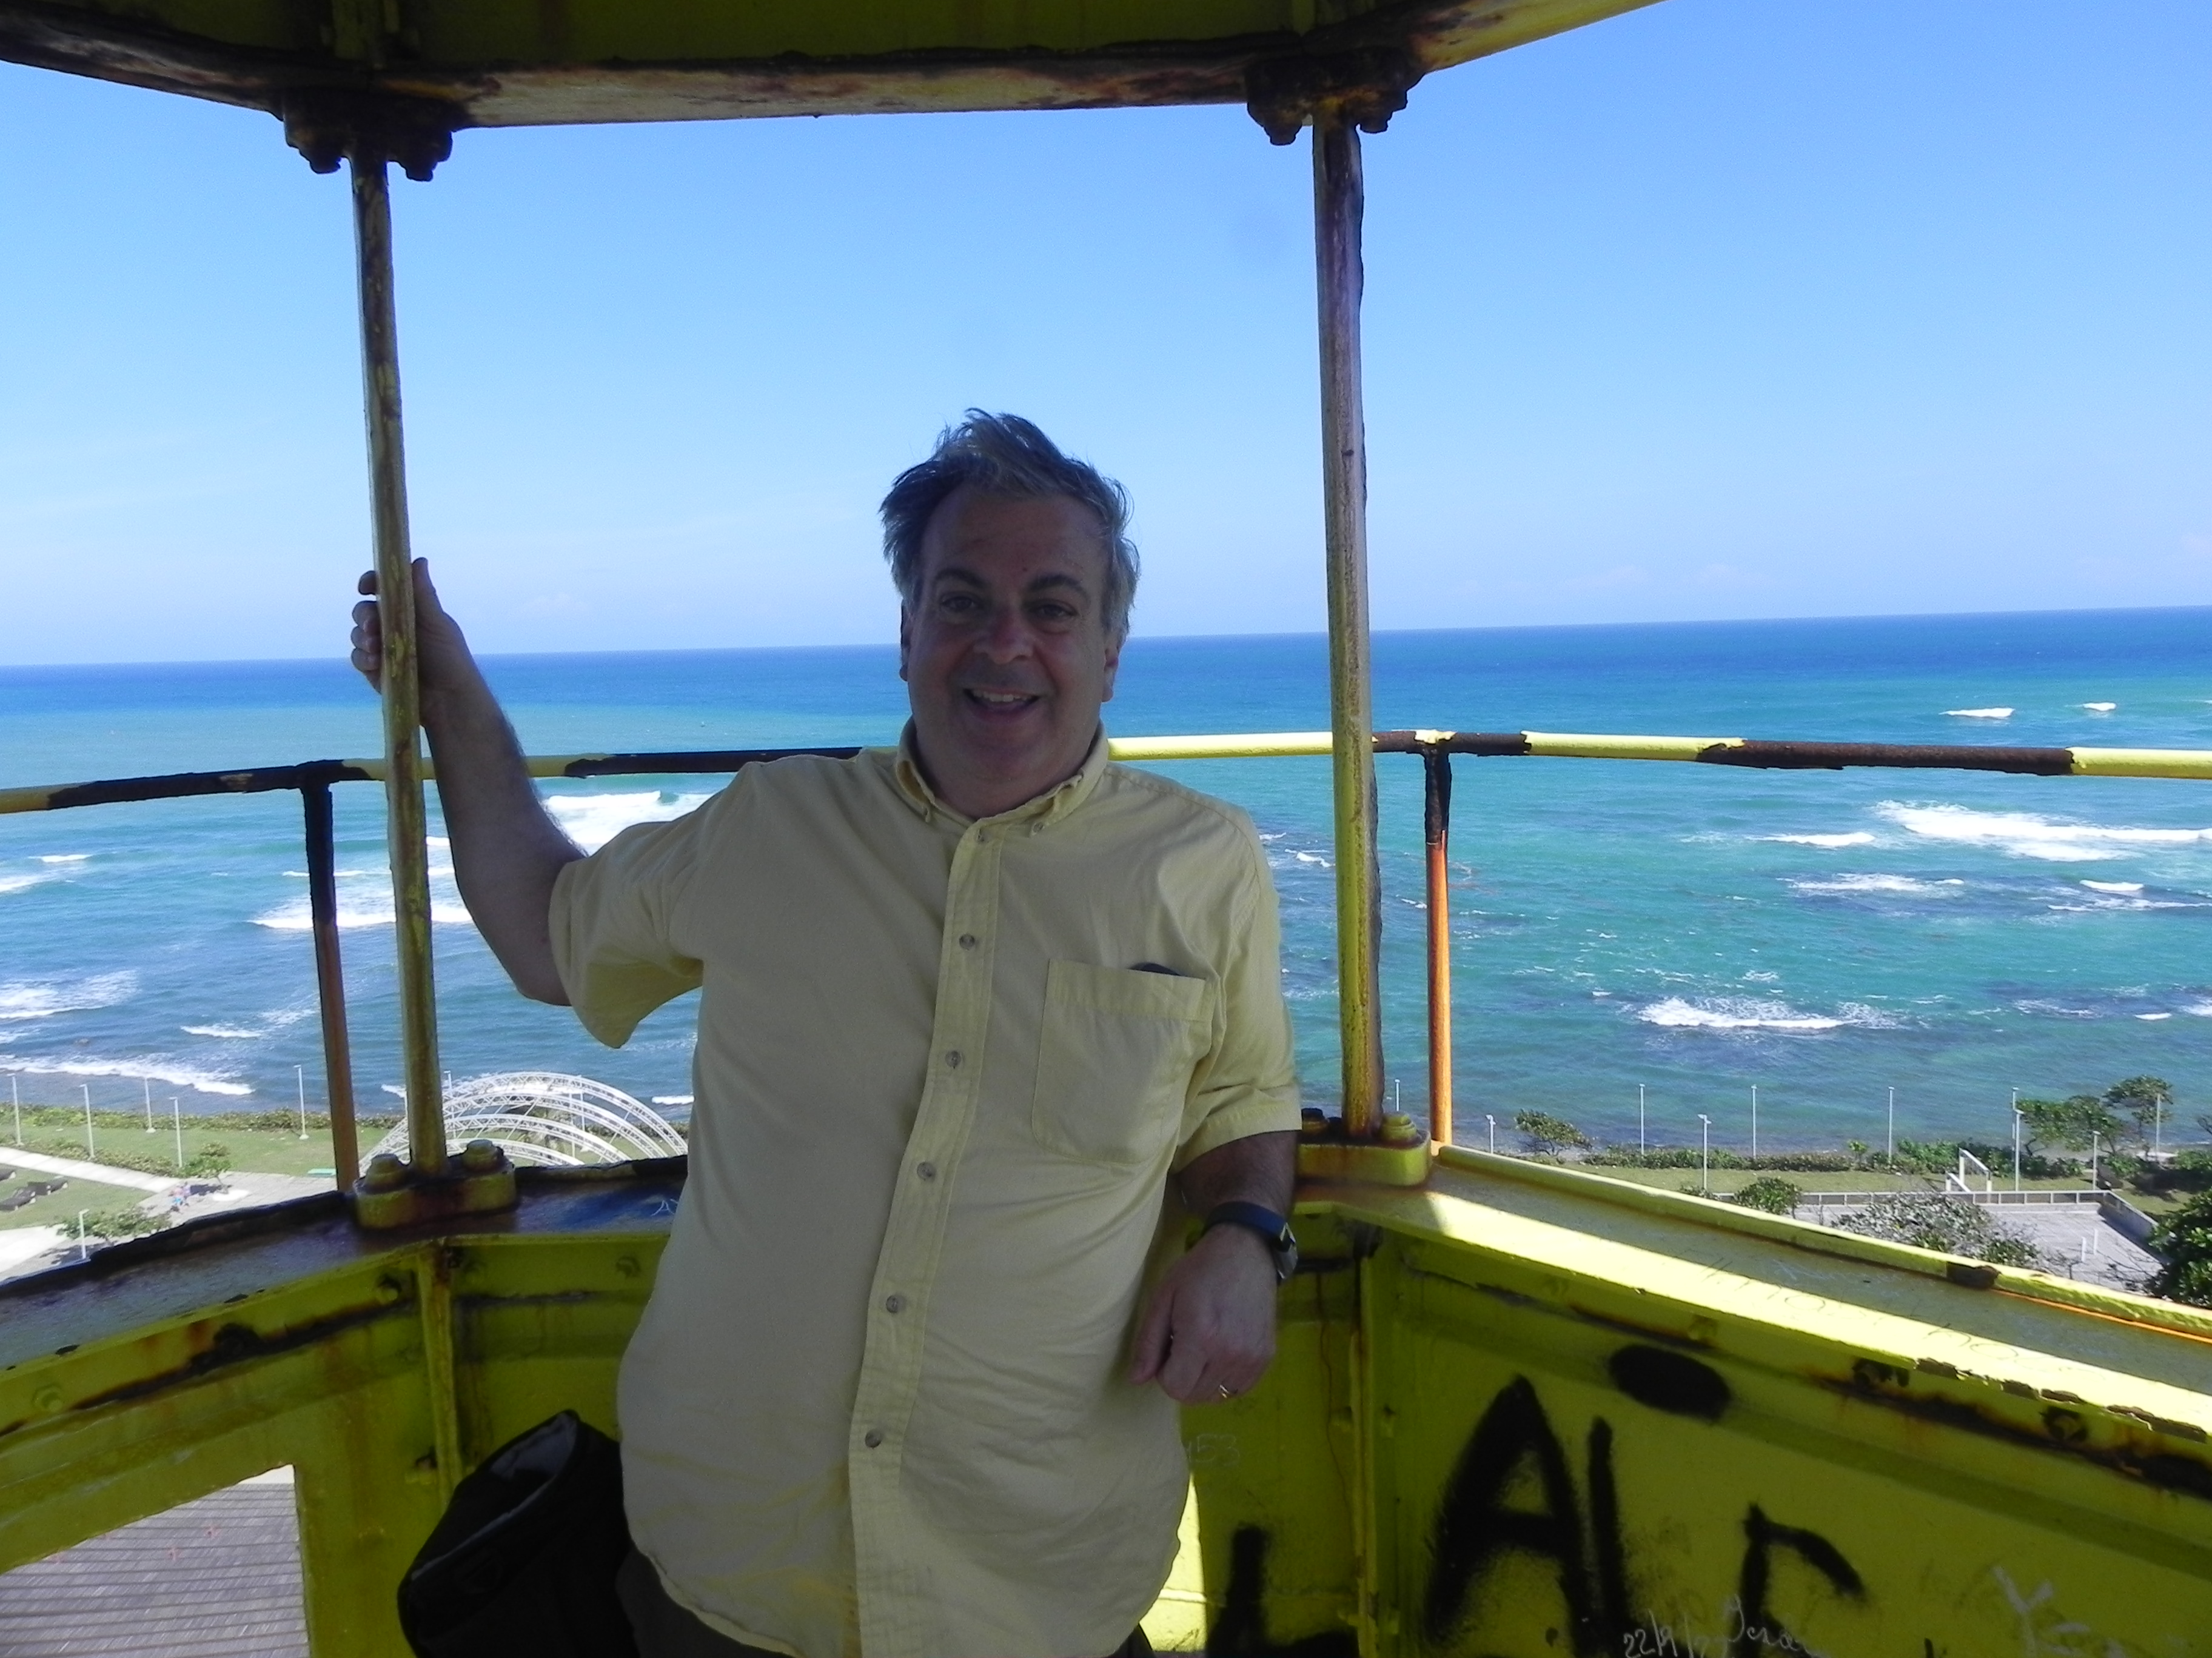
James S Godde
A Programmed Translational Frameshift in Various Microbacterium Phages and Prophages May Lead to a Holin Isoform With Multiple Transmembrane Helices Instead of One
Cally G Tate, Kimber G Calvert, James S Godde
It has been well established the PTFs, programmed translational frameshifts, occur when a ribosome encounters “slippery” mRNA sequences, such as those produced by most tail assembly chaperone genes in the Siphoviridae, flexible non-contractile tailed phages. PTFs thus cause a single base frameshift in either direction, changing the reading frame of the mRNA and potentially bypassing the original stop codon, forming a larger isoform of the encoded protein. Additional PTFs have yet to be characterized in these phages. We have used bioinformatics to predict a potential PTF in a putative superfamily VI holin gene in 29 Microbacterium phages and 23 prophages found in Microbacterium and related genera. This PTF, upon slippage, would create a protein with 3-5 TMSs, transmembrane alpha-helical segments, as opposed to the single one found in the original protein.

