CONSIDER FOR TALK
2024 SEA Symposium Abstract
Austin Community College
Austin TX
Corresponding Faculty Member: Kissaou Tchedre (kissaou.tchedre@austincc.edu)
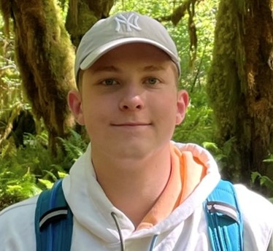
Andrew Teodorovich
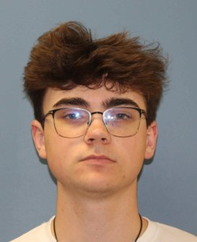
Aidan Sheridan
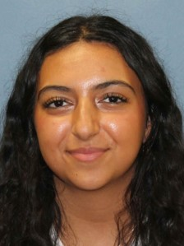
Agam Zadok
Isolation and characterization of Bacteriophage Agaliana and Teodoridan at Austin Community College in Texas.
Andrew Teodorovich, Aidan Sheridan, Agam Zadok
Almost eight million people die every year from bacterial infections, making it the second leading cause of death. With bacteria becoming increasingly immune to antibiotics, bacteriophage research has become vital to help reduce bacteria-based deaths. The main goal of this research project was to isolate and analyze bacteriophages discovered at ACC Eastview Campus while also developing important lab work skills. Using direct isolation, plaque assays, spot tests, phage purification and lysate collection, plate titers, phage amplification, gel electrophoresis, and mounting samples for transmission electron microscopy, the phages were able to be identified and pictured. The phages discovered, Teodoridan and Agaliana, then had their genomes analyzed using the tool DNA Master. The discovery of these phages and their information has been sent to the University of Pittsburgh database, where they may be used in the future to help people suffering from bacterial infections.

