DO NOT CONSIDER FOR TALK
2024 SEA Symposium Abstract
University of California, Los Angeles
Los Angeles CA
Corresponding Faculty Member: Amanda Freise (afreise@ucla.edu)
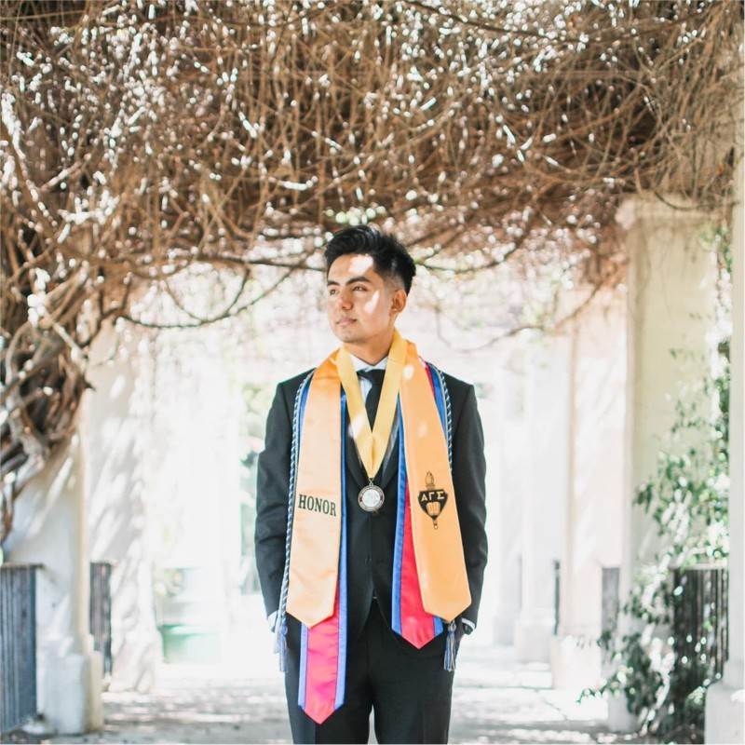
Aryan Bhattarai
Mila Daniel
Alix Kang
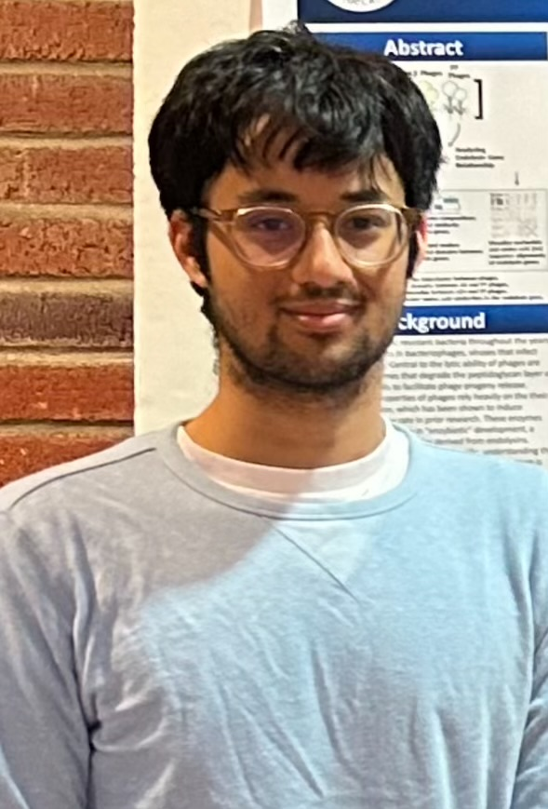
Arnav Saud
Diversity in The Endolysin Gene of Arthrobacter sulfureus Bacteriophages: Genetic and Structural Insights
Aryan Bhattarai, Mila Daniel, Alix Kang, Arnav Saud, Jarod Olay, Juliet Stephenson, Krisanavane Reddi, Tejas Bouklas, Daniel Velez-Ramirez, Amanda Freise
The rise in antibiotic-resistant bacteria has increased interest in bacteriophages, viruses that infect and lyse bacteria during the past decades. Central to the lytic ability of bacteriophages are endolysins, enzymes that degrade the peptidoglycan layer of bacterial cell walls to facilitate phage progeny release. “Enzybiotics” prove to be a promising class of antibiotics derived from the endolysin enzyme. The present study sought to understand potential relationships between the endolysin genes of Arthrobacter sulfureus phages using bioinformatic tools for comparative analyses. The bacterial cell wall specificity of endolysin proteins highlights the importance of uncovering their potential role in host specificity. A. sulfureus phages were selected for this experiment as they are relatively understudied, with only 15 fully sequenced phages found on the PhagesDB database. They also enabled an analysis of genome and protein comparisons across different clusters FP, AX, and AZ4. Phamerator, GCS Heatmap, SplitsTree, and GEPARD dotplot showed low intercluster similarities of the endolysin gene across the three clusters. Amino acid sequence alignment, Interpro and CDD analyses in combination with AlphaFold revealed conserved endolysin construction and function between cluster representative phages BaileyBlu (FP) and Adaia (AX) but not JasmineDragon (AZ4). Findings indicate that endolysins of A. sulfureus phages exhibit diverse endolysin structures and functions that target different regions of the host peptidoglycan matrix. Our work provides valuable insights into the functional and structural characterization of endolysins for future work on enzybiotics.

