CONSIDER FOR TALK
2024 SEA Symposium Abstract
University of North Texas
Denton TX
Corresponding Faculty Member: Lee Hughes (lhughes@unt.edu)
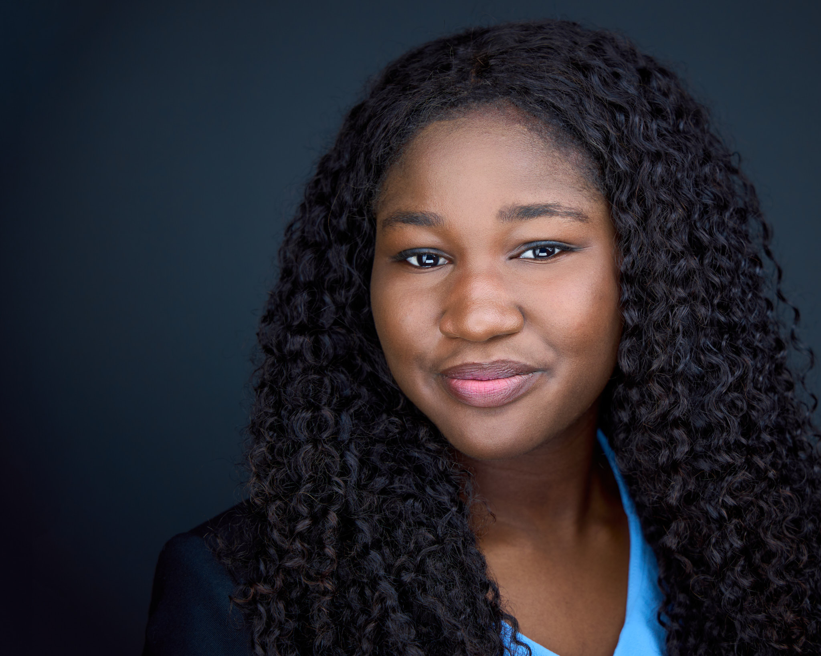
Ifeabia Okororie
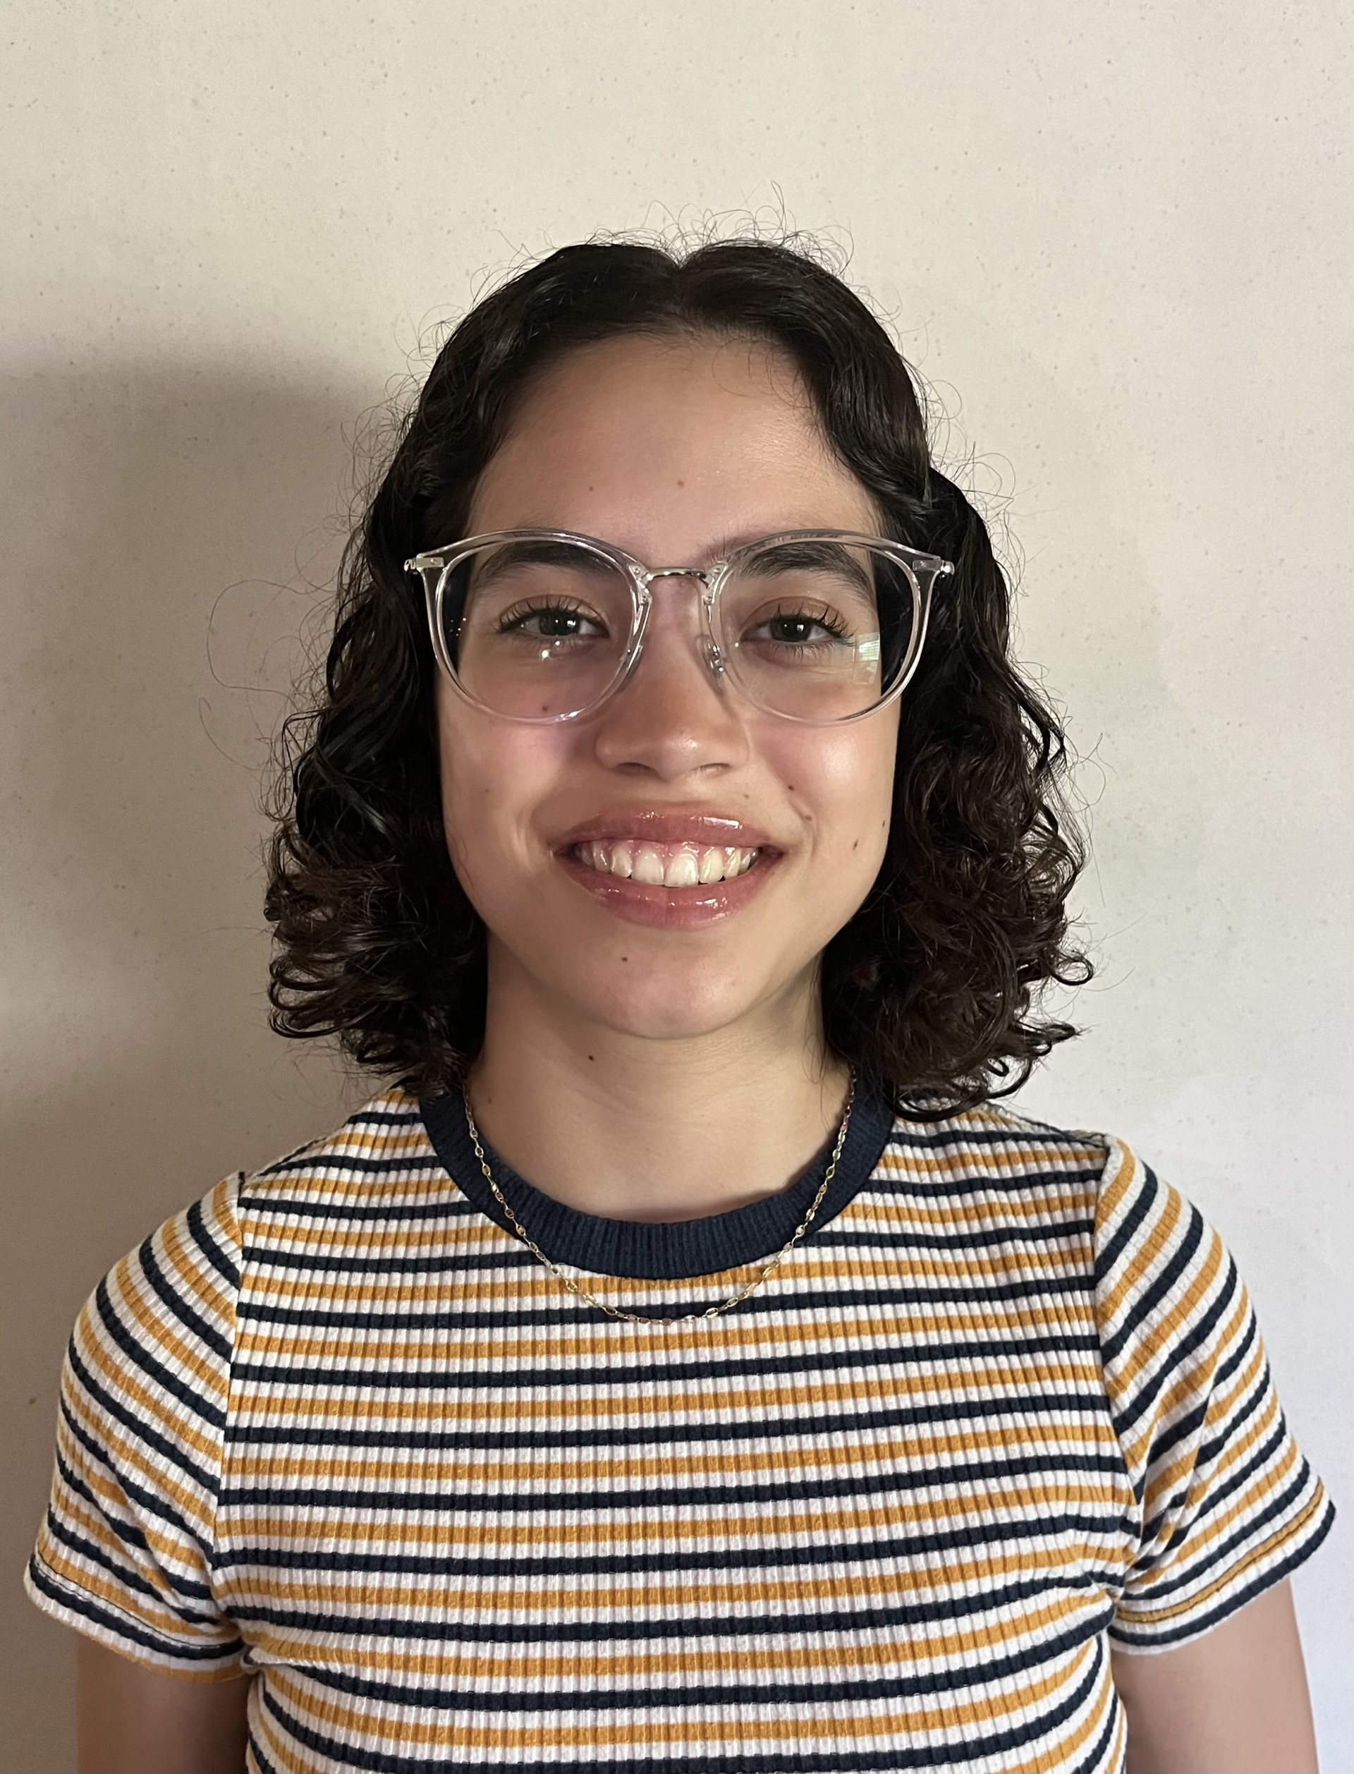
Luisa Trujillo Soto
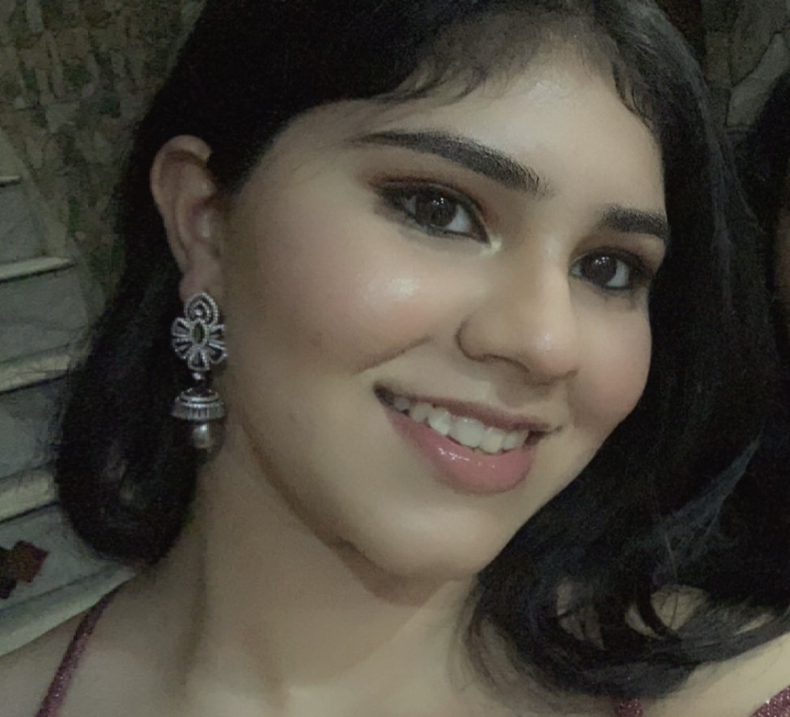
Tanvi Verma
Riley Hunt
Isolation and Characterization of Three Phages infecting Streptomyces baarnensis
Ifeabia Okororie, Luisa Trujillo Soto, Tanvi Verma, Riley Hunt, Ahmad Sulaiman, Lee Hughes
Bacteriophages, also known as “phages”, are viruses that infect bacteria. Phages Zainub, GirlDinner, and Conan were isolated from the host bacterium Streptomyces baarnensis NRRL B-2842 following the Streptomyces Phage Discovery Guide (2017), published by the Howard Hughes Medical Institute. While Zainub’s sample was collected under a tree in Benbrook, TX, GirlDinner and Conan were collected from soil samples in Denton, TX. The average diameter of plaques of Zainub and GirlDinner was 1mm while that of Conan was 1.25mm. The three phages had circular plaques. While Zainub and Conan had clear plaques, GirlDinner had cloudy plaques. All three phages were sequenced at Pittsburgh Bacteriophage Institute where they were sequenced using the Illumina Sequencing shotgun method. All observed phages had similar GC contents ranging from 65.9% (Conan), 67% (GirlDinner) to 67.4% (Zainub) with 3’ sticky overhangs [Conan - CGGTACGTGAT, Girl Dinner - CGCCGTGTCTT and Zainub - CGCTACGTCTT]. The phages were also similar in length with 51761bp for Zainub, 50291bp for GirlDinner, and 48953bp for Conan. Zainub and GirlDinner are from the BD2 subcluster, making them more like each other than to Conan, which is from the BD3 subcluster. Zainub has 87 ORFs, GirlDinner has 76 ORFs, and Conan has 79 ORFs. Zainub was the only phage to have 1 tRNA. All genes were annotated with the use of bioinformatics tools such as PECAAN, Glimmer, GeneMark, HHPRED, NCBI, Phamerator, Starterator, TMHMM, and PhagesDB.

