DO NOT CONSIDER FOR TALK
2024 SEA Symposium Abstract
Kansas State University
Manhattan KS
Corresponding Faculty Member: Martha Smith-Caldas (mscaldas@ksu.edu)
Nathan R Jones
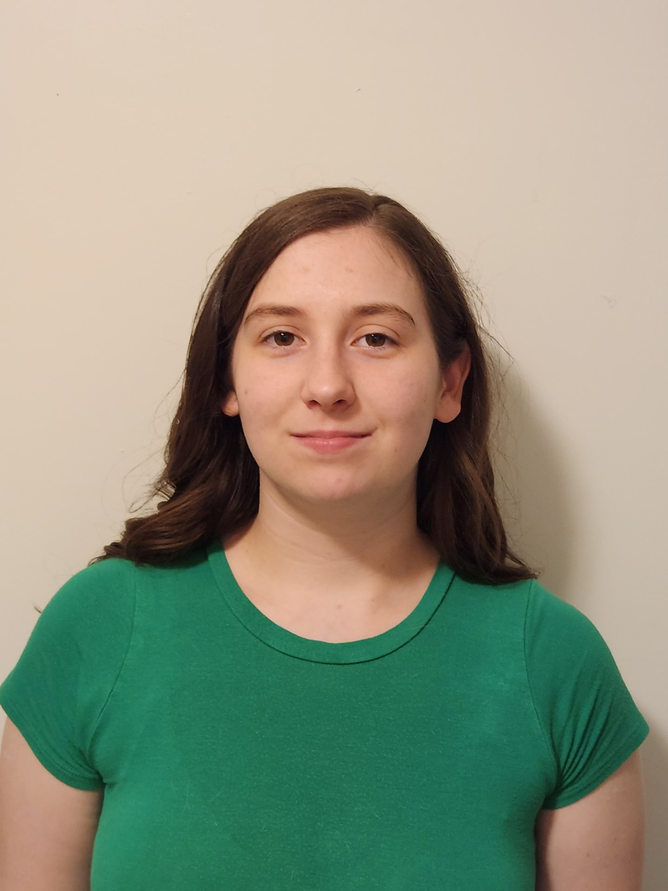
Erika L Kline
Flint Hills Phages - RiverRaider: the Saga of a Misfit
Elizabeth P Herrman, Ashley S Hine, Kyla L Hornback, Nathan R Jones, Erika L Kline, Lexi L Pitts, Rece W Buckmaster, Camille E Carrier, Dasik S Clouse, Marie R Dios, MacKenzie N Dunigan, Selah M Hageman, Maddy L Kang, Molly Z Kang, Aidan K Ozga, Madison N Sims, Landon S Taylor, Victoria A Thurm, Bailey M Wilson, Taz Zeigler, Chistopher D Herren, Martha Smith-Caldas
RiverRaider, a Siphoviridae bacteriophage, was directly isolated from a freshwater sample in the fall of 2023 using Gordonia terrae as host. DNA sequencing placed RiverRaider in the DE1 sub-cluster, which comprises 52 members, all of which are virulent phages that infect Gordonia. This sub-cluster has an average of 89 genes and a GC content of 67.7%. RiverRaider's genome was blasted on NCBI, and the first 100 highly similar sequences were analyzed, revealing an assortment of genome structures and organizations among the members of the DE1 sub-cluster and closely related sub-clusters. Additionally, a discrepancy in the evolutionary history was observed among the members of the DE1 sub-cluster, with RiverRaider appearing genetically isolated from his sub-cluster and the other sub-clusters included in the analysis. Genome structure analysis involved assessing frame orientation, and upon noticing that, for several of the bacteriophages with only one reverse gene, the only gene on the reverse frame was the HNH endonuclease, an evaluation of this gene and the terminase gene was conducted. Endonuclease is a well-conserved feature among bacteriophages, typically occurring closer to a terminase, and is hypothesized to play a role in homologous recombination by nicking and packaging DNA. RiverRaider does not have an endonuclease gene and its terminase is closer to a lipoprotein.

