DO NOT CONSIDER FOR TALK

2024 SEA Symposium Abstract

University of California, Los Angeles

Los Angeles CA

Corresponding Faculty Member: Amanda Freise (afreise@ucla.edu)

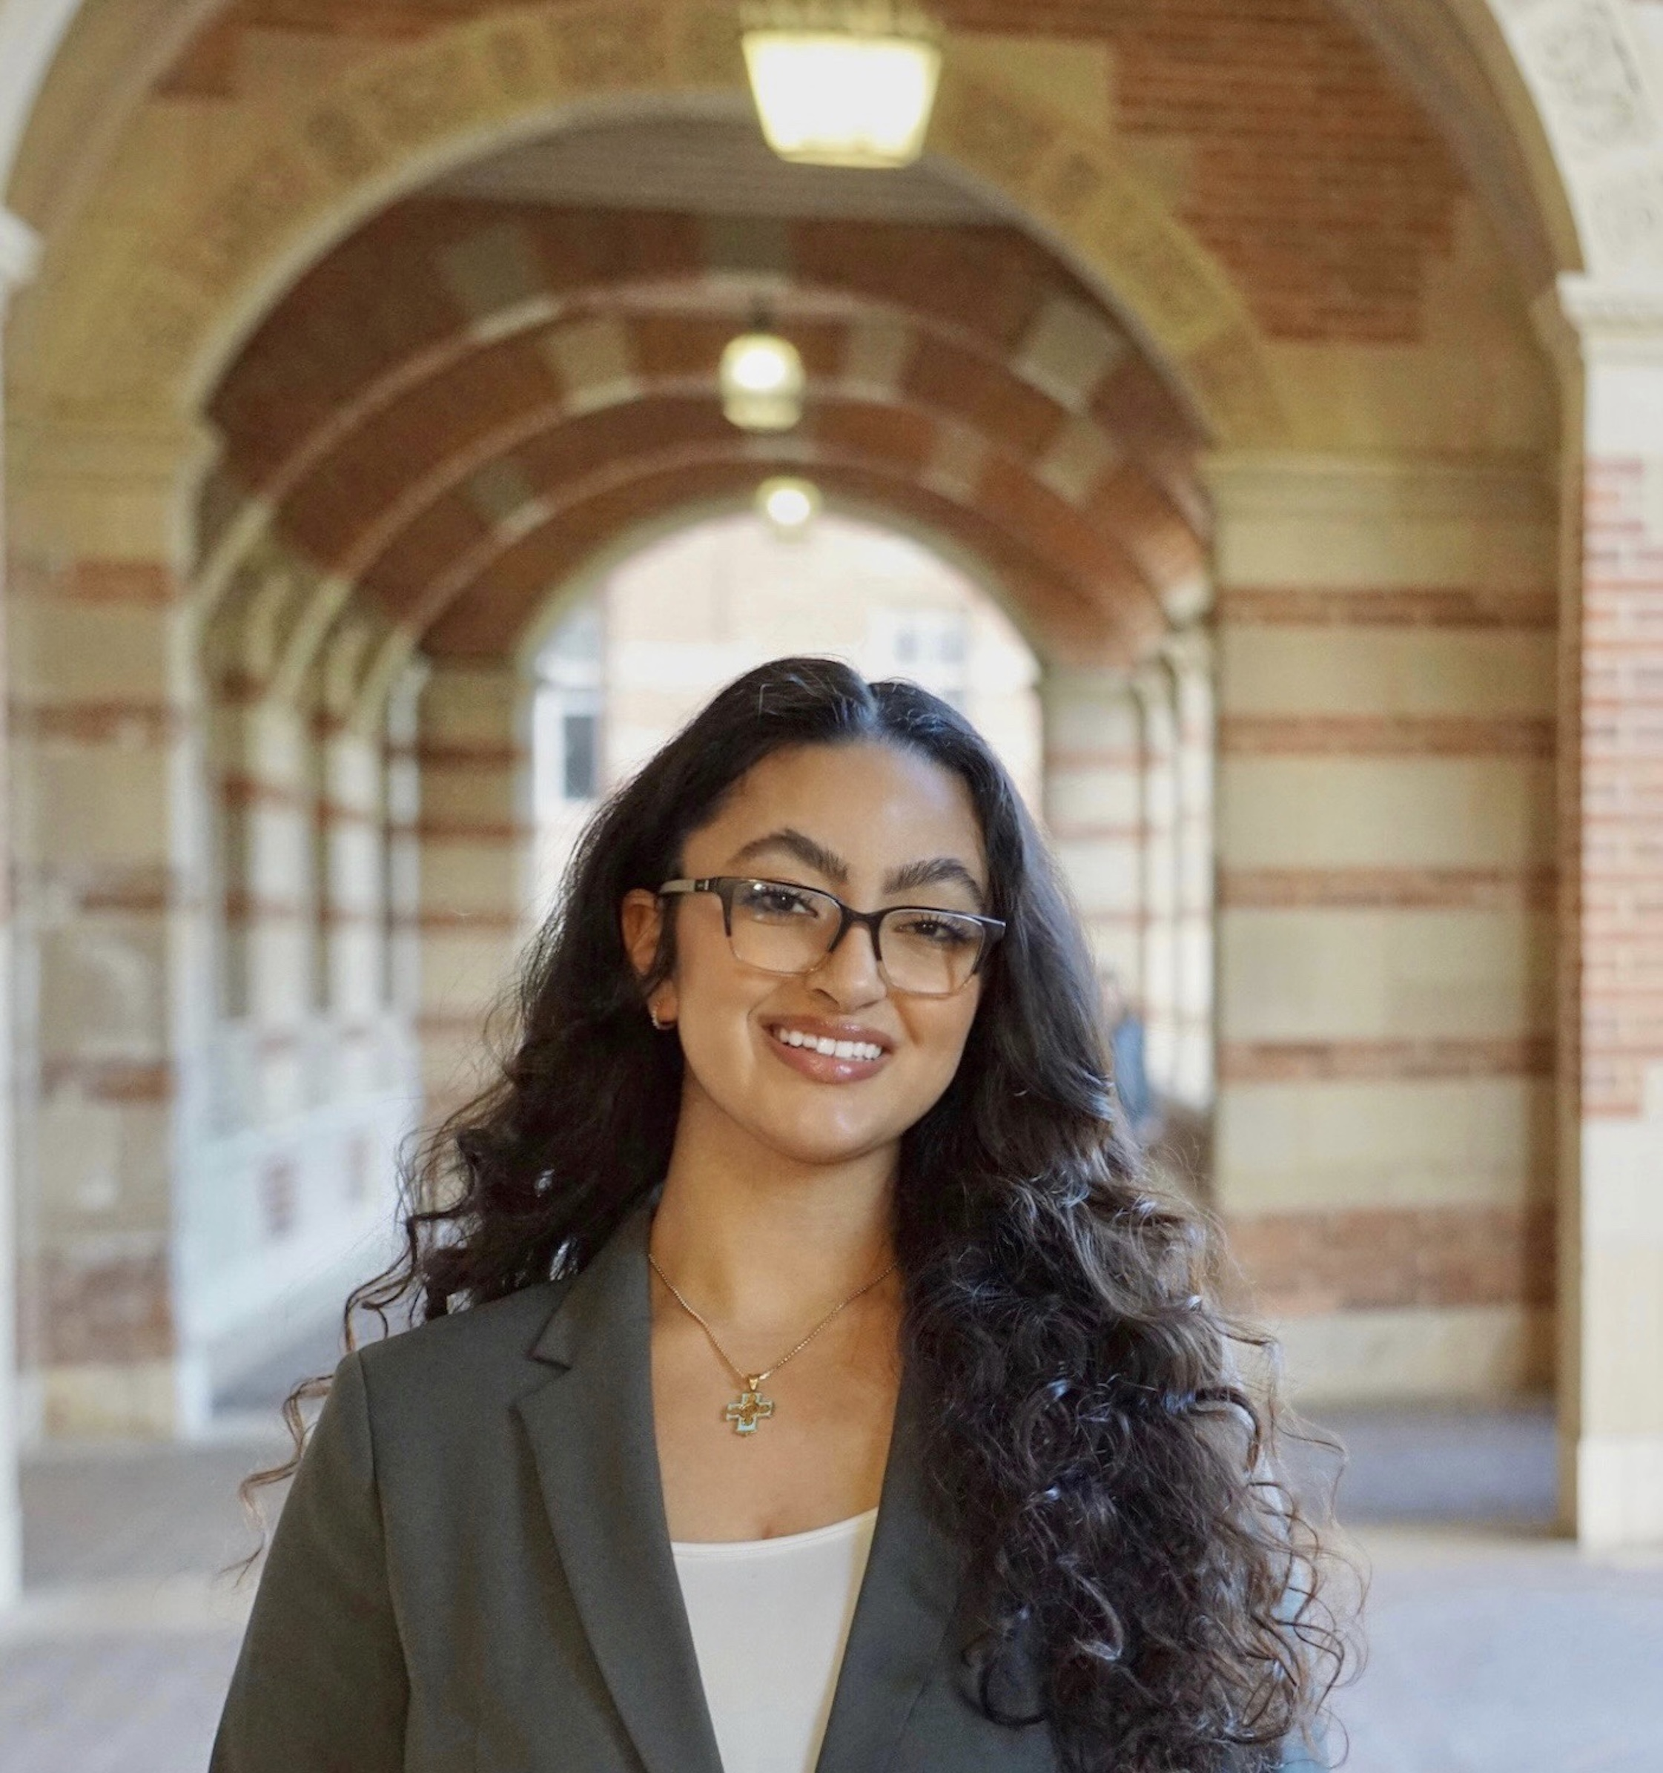

Youstina Labib

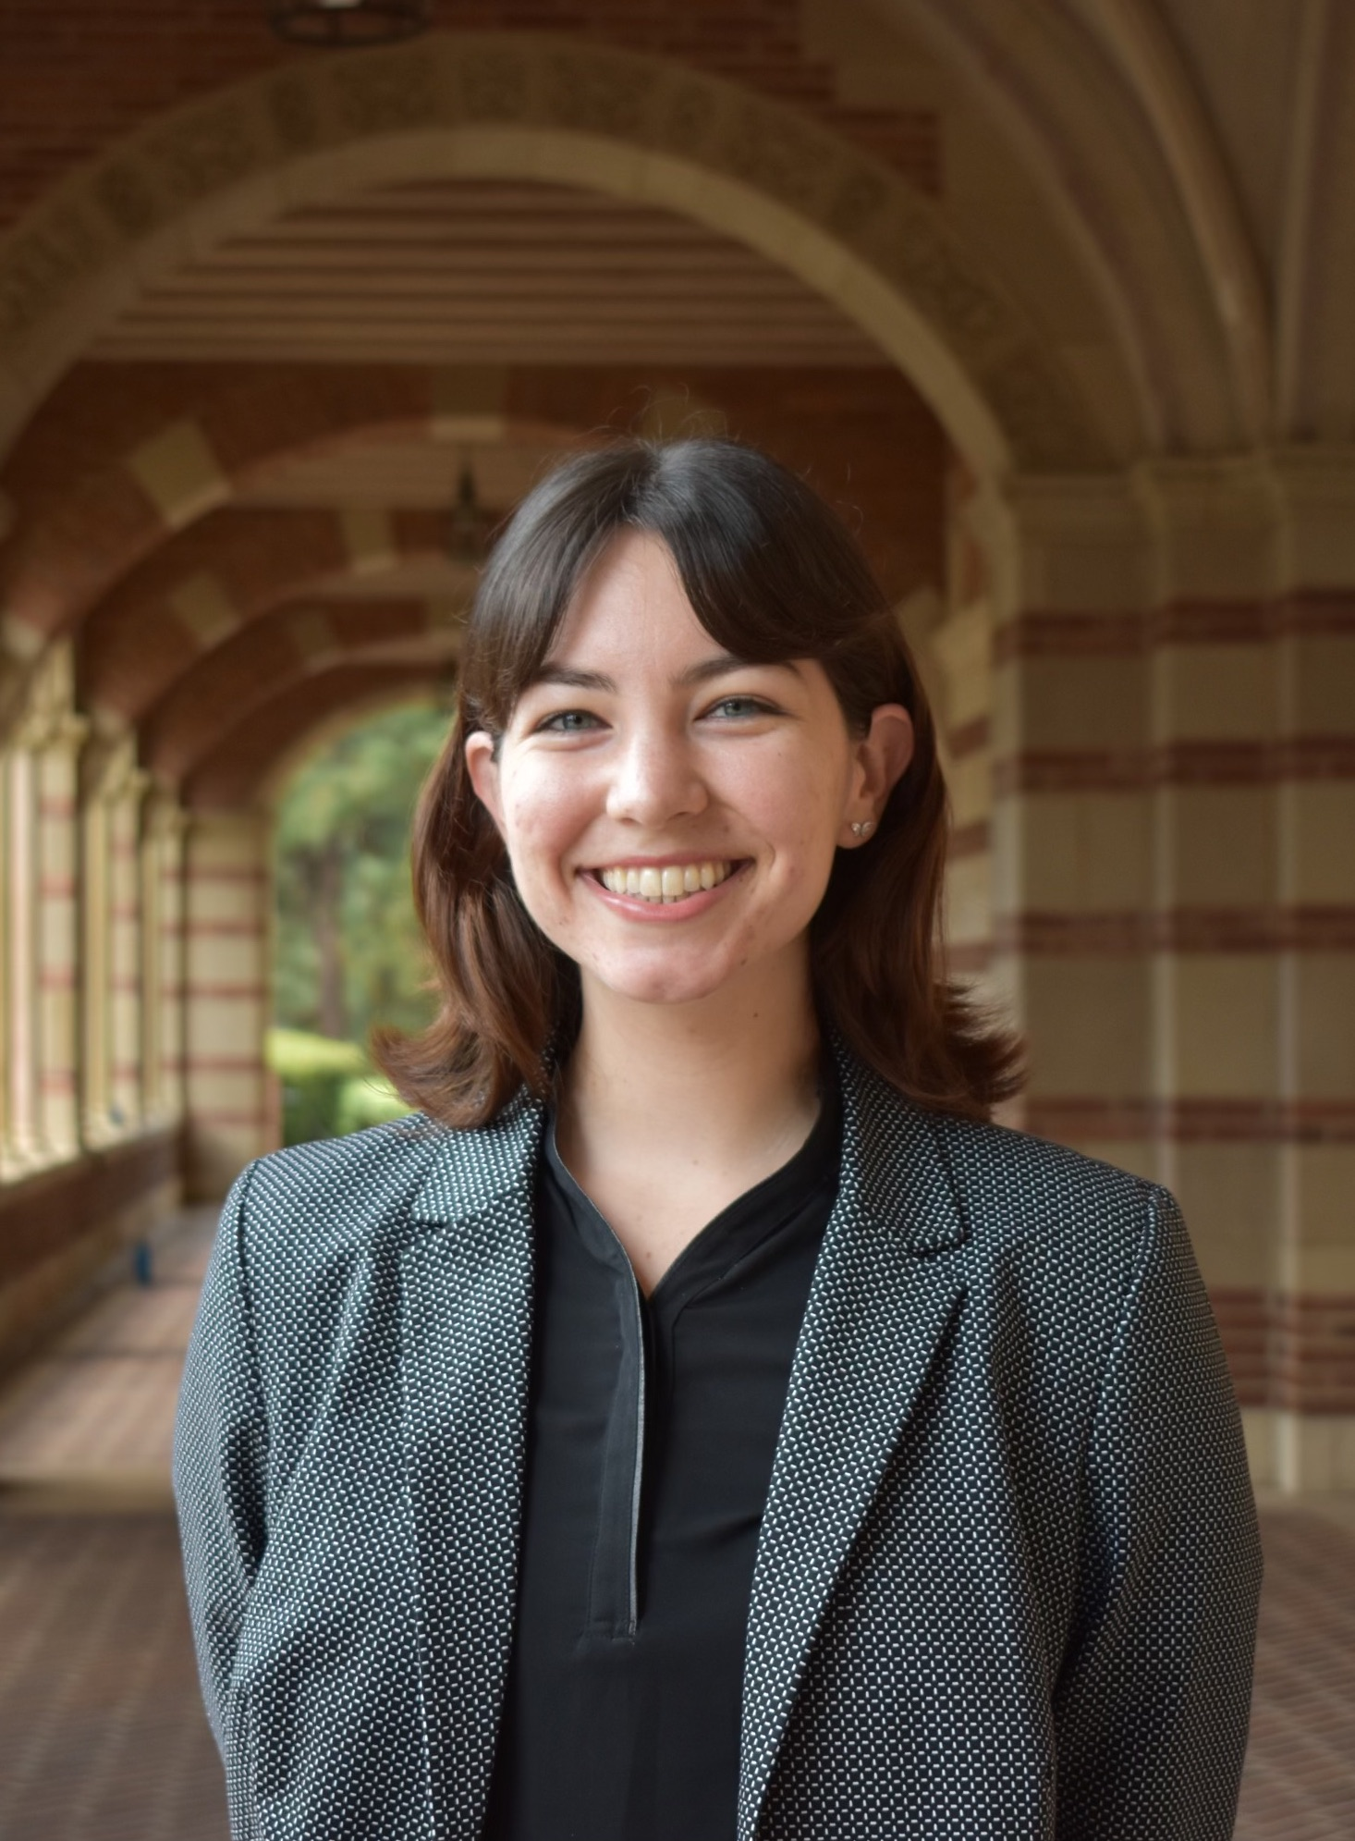

Lauren Woodward

Unveiling the Intercluster and Intracluster Dynamics of Mycobacterium, Rhodococcus, and Corynebacterium Phages Through Bioinformatic Analysis

Youstina Labib, Lauren Woodward, Julianne Carnes, Marco Chamorro, Jarod Olay, Juliet Stephenson, Krisanavane Reddi, Tejas Bouklas, Daniel Velez-Ramirez, Amanda C Freise

Actinobacteria are found in abundance across terrestrial environments and play an important role in soil and forest ecosystems across the globe. Bacteriophages infecting bacteria in this phylum are involved in regulating these communities through lysis, integration, and gene transfer. This study aimed to investigate intercluster and intracluster dynamics of certain clusters of *Mycobacterium*, *Rhodococcus*, and *Corynebacterium* phages, and examines interhost relationships to further describe host-specificity and establish a better understanding of host-phage coevolution dynamics. Genomic comparisons of these phages were conducted using bioinformatic tools including PhagesDB’s gene content similarity (GCS) function, SplitsTree, Gepard, and Clinker. *Mycobacterium*, *Rhodococcus*, and *Corynebacterium* phages demonstrated low intercluster similarity, even when isolated on the same host, and generally high intracluster similarity. Additional findings revealed a few exceptions with high similarity amongst clusters with phages from multiple hosts, particularly between *Rhodococcus* cluster CR and *Corynebacterium* cluster EN whose phages average 20.2% intercluster GCS. Clusters with high inter-host GCS shared phams encoding structural and replicative proteins, and on average 22% of shared phams were exclusive to those clusters. This expands the understanding of the intracluster and intercluster relationships of soil bacteriophages and introduces fascinating insights into cluster dynamics and phage genetic mosaicism. Further investigation of phages with high intercluster and inter-host similarity could expand knowledge of host-specificity and potential methods for modulating soil bacteria populations.