DO NOT CONSIDER FOR TALK
2024 SEA Symposium Abstract
Saint Leo University
Saint Leo FL
Corresponding Faculty Member: Iain Duffy (iain.duffy@saintleo.edu)
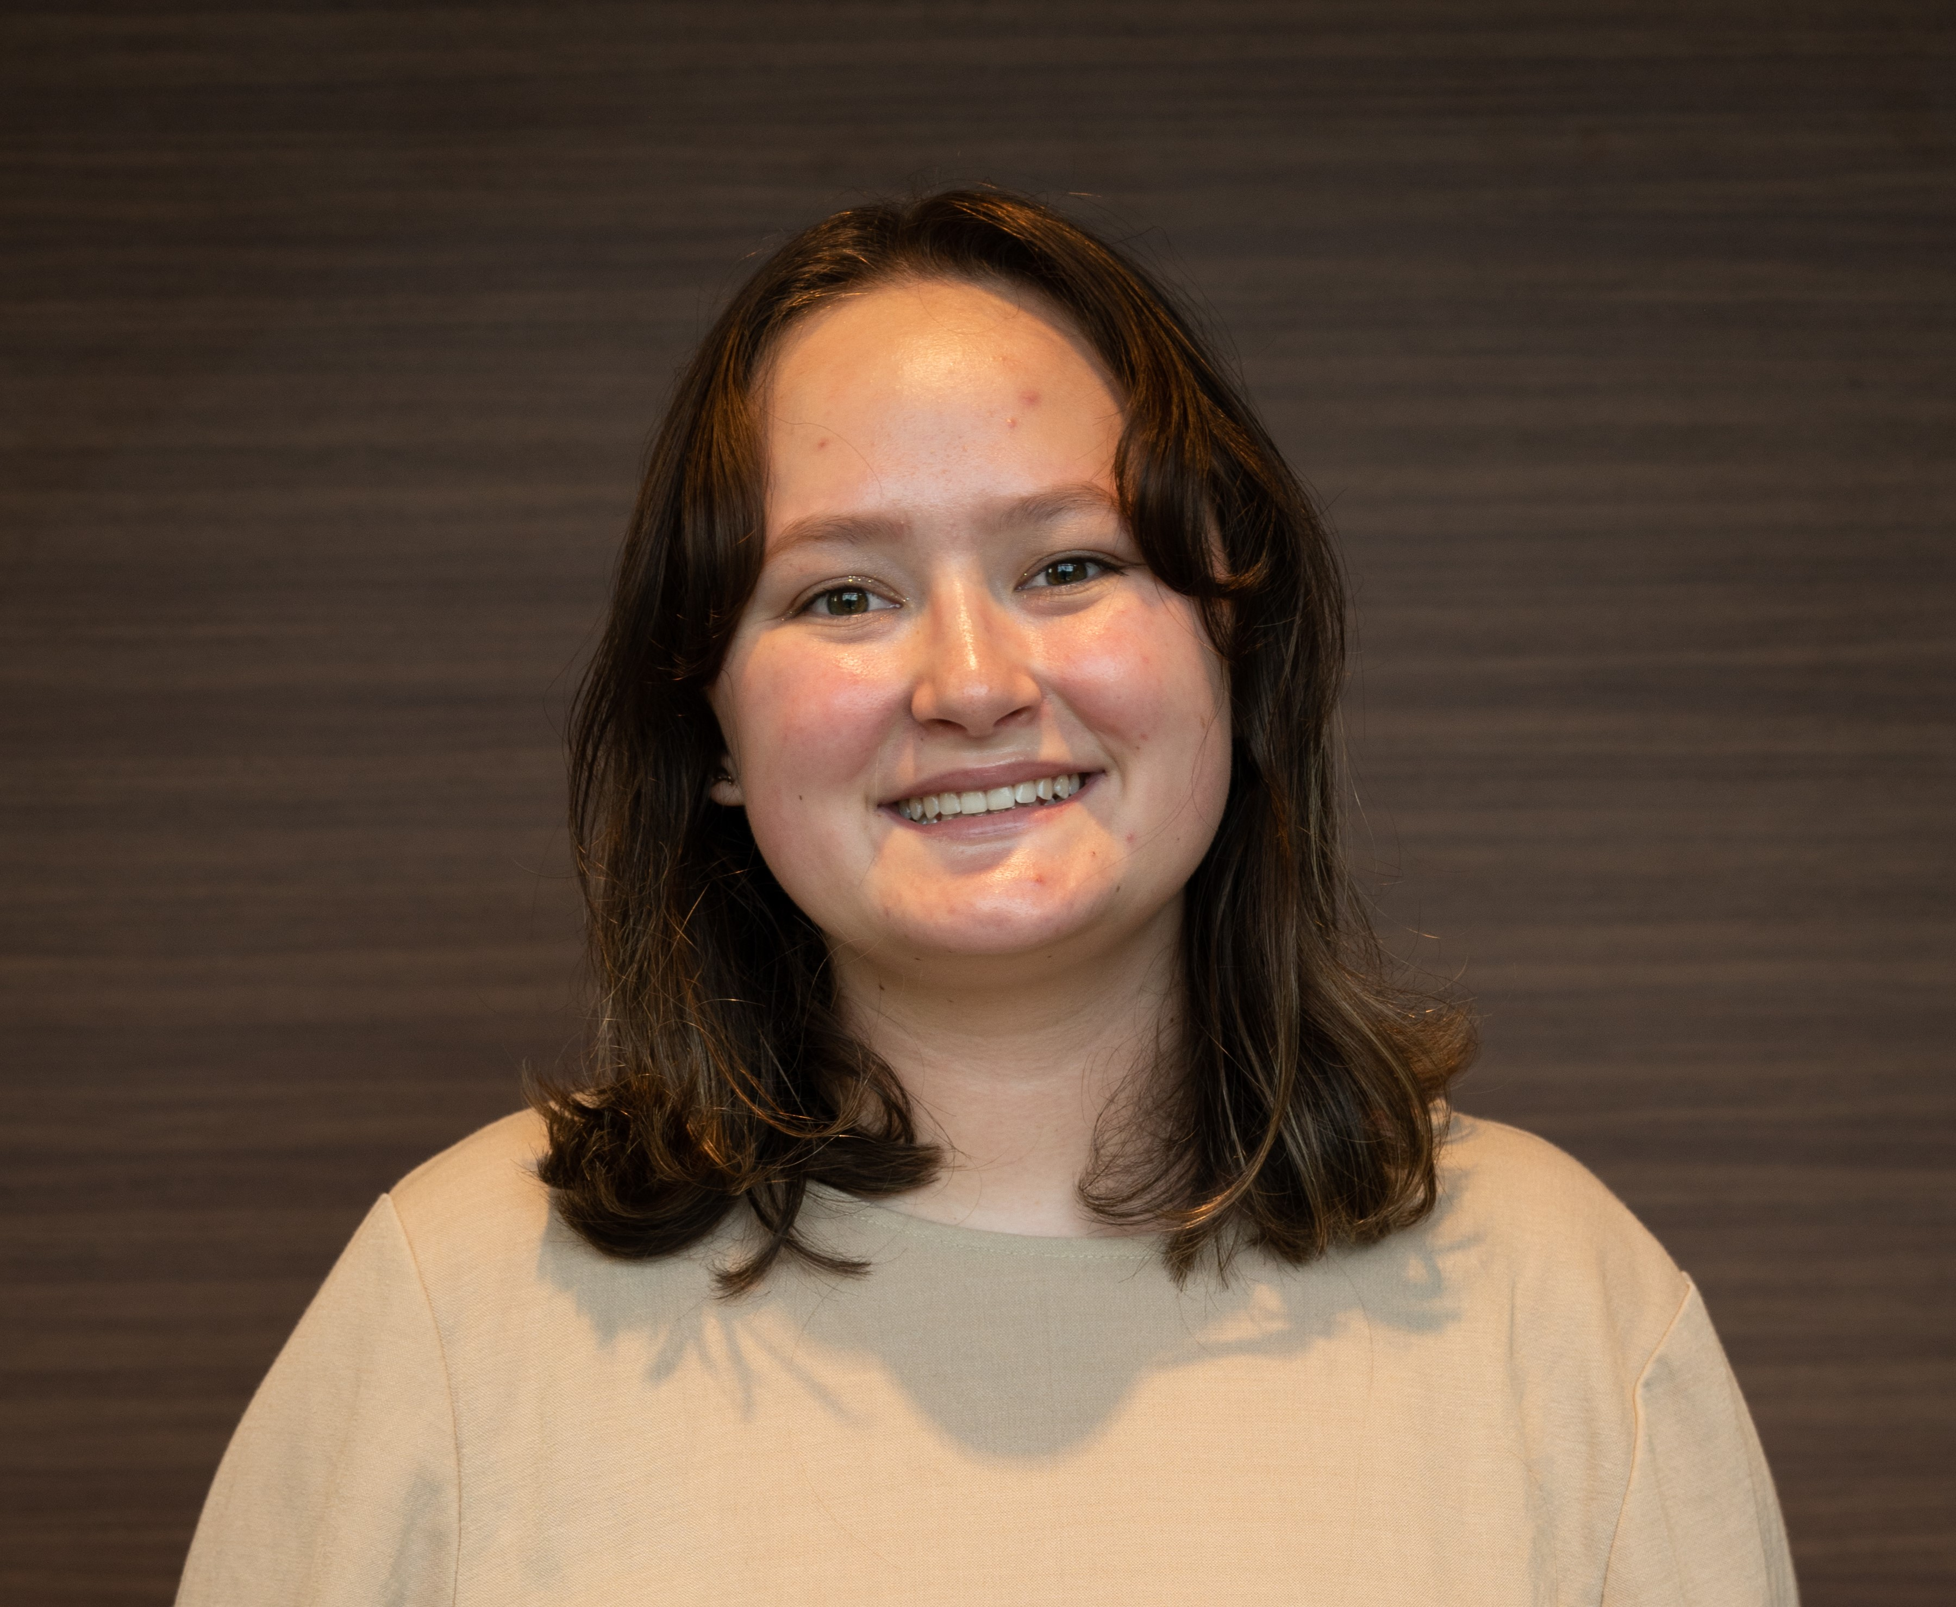
Alexa Keeler
CytoGenes: Deciphering the Potentially Cytotoxic Gene of Mycobacteriophage TootsiePop.
Alexa Keeler, Aliya Fredette-Huffman, Juan Contreras Jimenez
In 2021, Saint Leo University joined Cohort III of the HHMI SEA-GENES program. The latest generation of Saint Leo students continue their research on F1 cluster mycobacterium phage TootsiePop, discovered at Worcester Polytechnic Institute, and sequenced in 2017.The TootsiePop genome is comprised of 93 genes of which 30 have a known function. This research focused on cloning the TootsiePop genes into the pExTra plasmid and subsequently expressing them in the original host bacterium Mycobacterium smegmatis. The genes that demonstrate a potentially cytotoxic effect on the host bacterium will undergo sub-cloning into a secondary plasmid, p2Hα, for further analysis of their biochemical interactions within the bacterium. To date we have successfully cloned 83 genes into the pExTra plasmid and electroporated into M. smegmatis. These genes were then assessed for potential cytotoxicity against M. smegmatis. From this we discovered that there are 9 potentially cytotoxic genes in the TootsiePop genome. We will be providing an overview of our current research progress, spanning from cloning of genes to conducting the cytotoxicity assay, while highlighting the 9 genes of the TootsiePop that show potential cytotoxicity to M. smegmatis.

