DO NOT CONSIDER FOR TALK
2024 SEA Symposium Abstract
James Madison University
Harrisonburg VA
Corresponding Faculty Member: Steven Cresawn (cresawsg@jmu.edu)
Emily P Allder
Alicia B Bare
Treyden M Campbell
Celia I Cooley
Jaylan A Garcia Martinez
Caroline H Grotos
Kayla S Neal
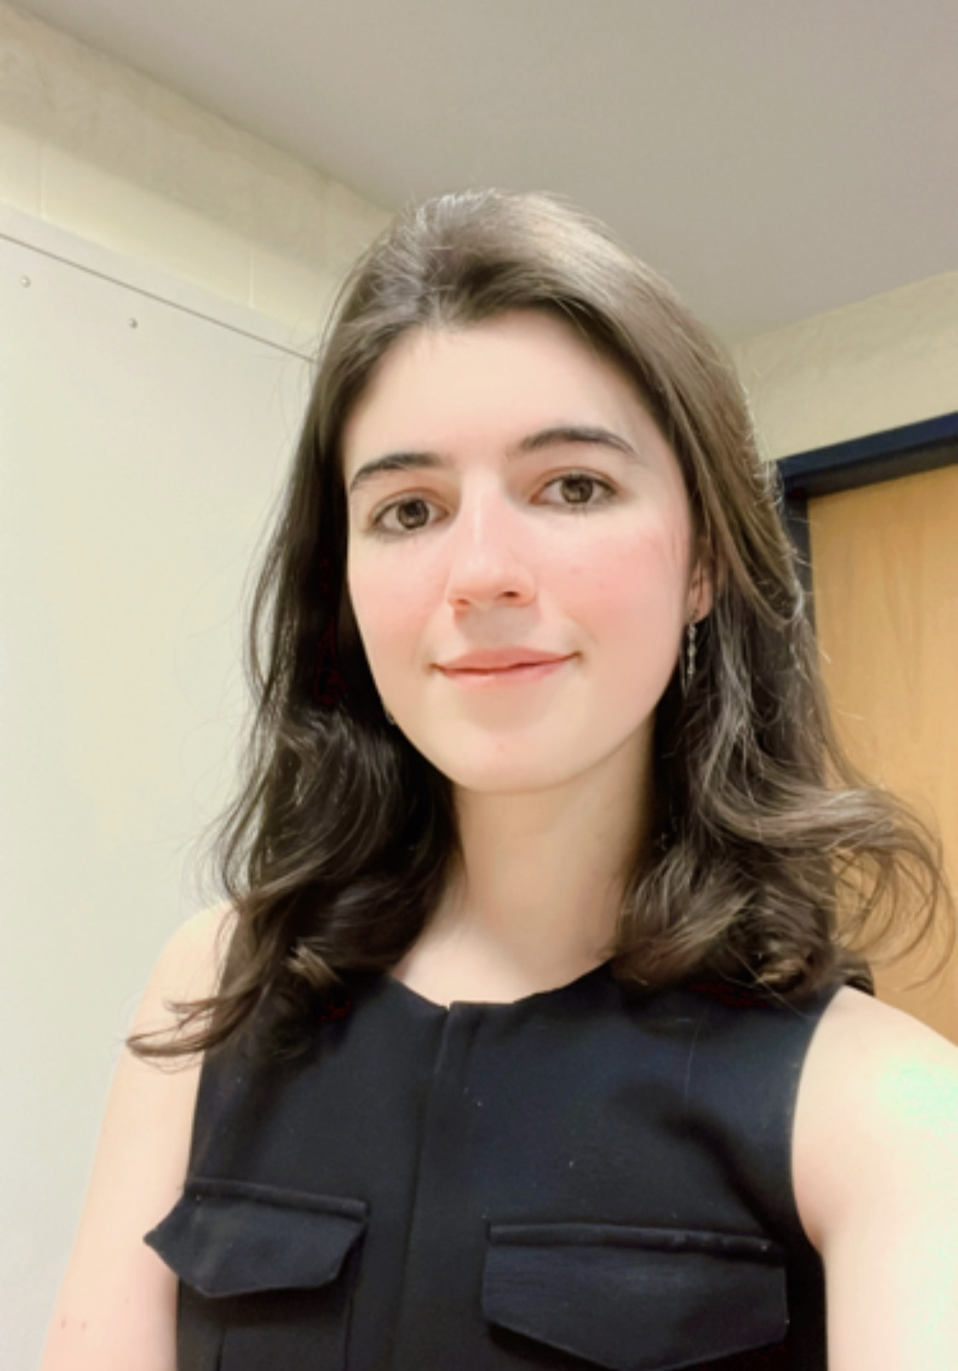
Eleanor R Walsh
Conservation of gap and overlap sizes between adjacent genes
Emily P Allder, Alicia B Bare, Treyden M Campbell, Celia I Cooley, Michael G Daamash, Alexis N Estes, Edmond Fitzgerald, Jaylan A Garcia Martinez, Caroline H Grotos, Thomas M Jones, Kayla S Neal, Nicholas D Sahadak, Eleanor R Walsh, Steven G Cresawn
Bacteriophage genomes are relatively small, and the genes in their genomes are tightly packed in order to maximize their coding capacity. While most intergenic regions are short, in many cases adjacent genes overlap. For the genes within any given phamily, these gaps or overlaps between their start codon and the nearest portion of the upstream gene are well conserved features. Our own analysis of two Mycobacterium phage genomes belonging to clusters B and F demonstrated evidence of gap size conservation for many genes in these clusters with an overlap of four base pairs being the most conserved size. We are expanding our study of this phenomenon to phages of other clusters and will explore the relationship of conserved gap/overlap sizes with gene function and phamily size.

