CONSIDER FOR TALK
2024 SEA Symposium Abstract
Hampden-Sydney College
Hampden-Sydney VA
Corresponding Faculty Member: Mike Wolyniak (mwolyniak@hsc.edu)
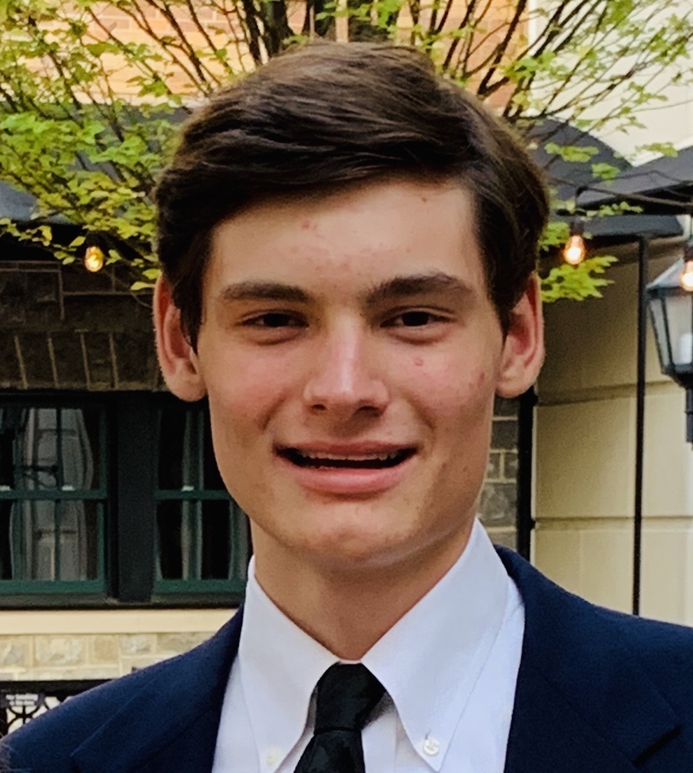
Robert H Frazier
Bosection 6: A novel Cluster N Mycobacterium smegmatis bacteriophage
Robert H Frazier, Michael J Wolyniak
Bacteriophages, also known as phages, are viruses that infect bacteria hosts to replicate. Consisting primarily of a head and a tail, phages are the most abundant form of virus on planet Earth. Phages only have one function they are capable of to reproduce. The head of a phage contains the DNA while the tail acts as both the binding mechanism and pathway of DNA between the head to the cytoplasm of the attacked bacteria cell. The most novel feature of phages is that the virus attacks and kills only bacteria specific to the individual phage. This feature has given rise to what is known as “phage therapy”, where a specific phage is introduced to an organism to stop illness caused by the bacteria specific to the given phage. For phage therapy to continue, and their effectiveness in stopping human infections and side effects on the human body, further phages are needed to be identified and characterized (Sparks). This project, using the procedures and guidance of the SEA-PHAGES program, sought to identify and characterized multiple bacteriophages that infect Mycobacterium smegmatis. M. smegmatis was specifically used as the species’ DNA genome is over 90% identical to M. tuberculosis, a pathogen that is labelled a public health crisis according to the World Health Organization.

