CONSIDER FOR TALK
2024 SEA Symposium Abstract
Lehigh University
Bethlehem PA
Corresponding Faculty Member: Vassie Ware (vcw0@lehigh.edu)
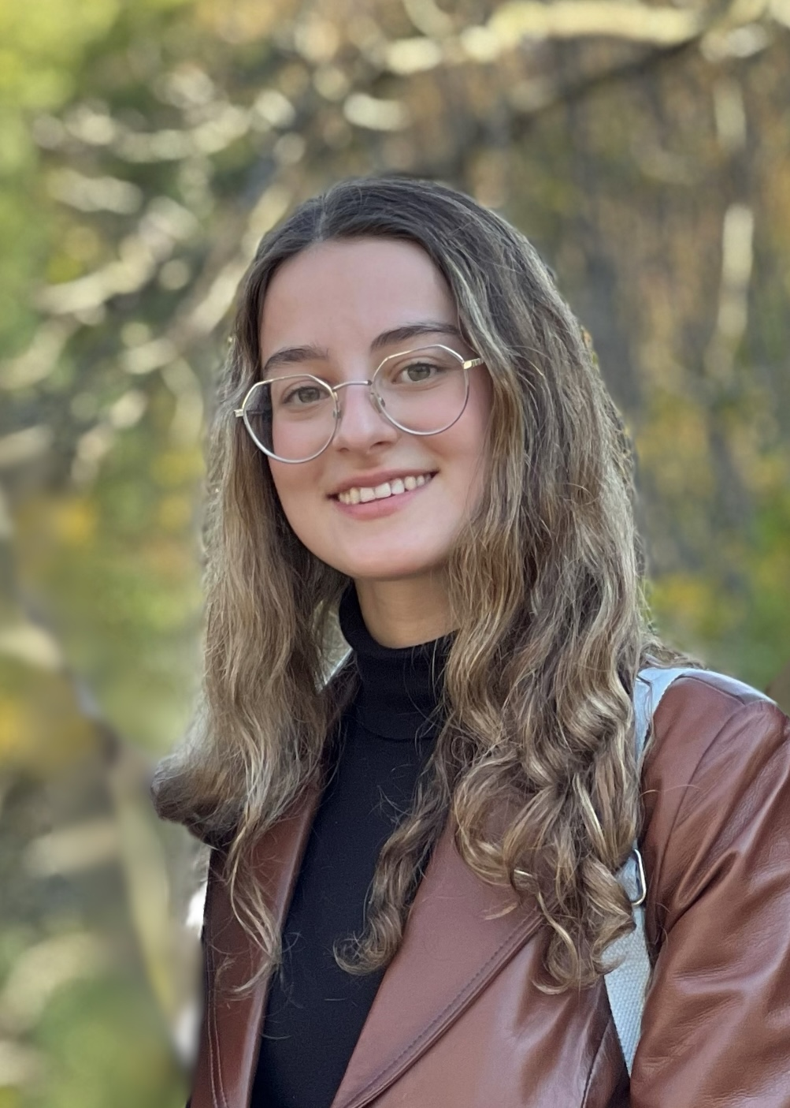
Kevser Dayi
SEA Expeditions in an Advanced Phage Research Course at Lehigh University
Kevser Dayi, Lake Palmeri, Aidan Singer, Luis Caceres, Brandon Huddy, Odinakachukwu Dibor, DeAndrea Daughtry, Sruthvika Kandru, Dagmara Jakubowska, Kelsey Corbett, Stephen Mensah, Vassie Ware
Lehigh’s SEA-PHAGES and SEA-GENES programs provides opportunities for first year and advanced undergraduates to extend their discoveries and investigations about Actinobacter phage genome structural diversity, host-phage interactions, phage gene structure/function, and phage biology into multiple courses throughout their academic career. Advanced phage research students are involved in a diverse set of projects, including mycobacteriophage genome annotations and comparative genome analyses, investigations of phage gene functions and phage-host interactions, and exploring immunity mechanisms governed by prophage-mediated gene expression within cluster N lysogens. Projects included are: 1) Functional analysis of cluster N phage Kevin1 genes 30 (a functionally annotated AAA-ATPase) and 31 (an orpham) both predicted to be expressed in the prophage. Gene 30 is cytotoxic when overexpressed in M. smegmatis whereas a gene 30 mutant lacking the AAA-ATPase domain is not cytotoxic, suggesting that cytotoxicity is mediated through the AAA-ATPase domain. We also hypothesize that genes 30 and 31 constitute a toxin-antitoxin pair expressed in the lysogenic state. Experiments are underway to construct a gene 31 deletion mutant and to test cytotoxicity of gene 30 in the presence of gene 31. 2) Confirmation of cytotoxicity of cluster W Taptic gene 73 and cluster N Butters genes 44, and 59 as a prelude to uncovering host protein interactors via bacterial two hybrid analyses. 3) Investigation of singleton Kumao lysogen establishment and genome annotation updates. Kumao gene functions are under investigation in Lehigh’s SEA-GENES Program. 4) Annotation of newly discovered cluster N mycobacteriophage Journey. 5) Investigation of genetic exchanges between temperate cluster AD mycobacteriophage Dori and a Butters prophage. Collectively, these ongoing research projects highlight research undertaken by advanced phage research students at Lehigh University.

