DO NOT CONSIDER FOR TALK
2024 SEA Symposium Abstract
Lehigh University
Bethlehem PA
Corresponding Faculty Member: Margaret Kenna (makg@lehigh.edu)
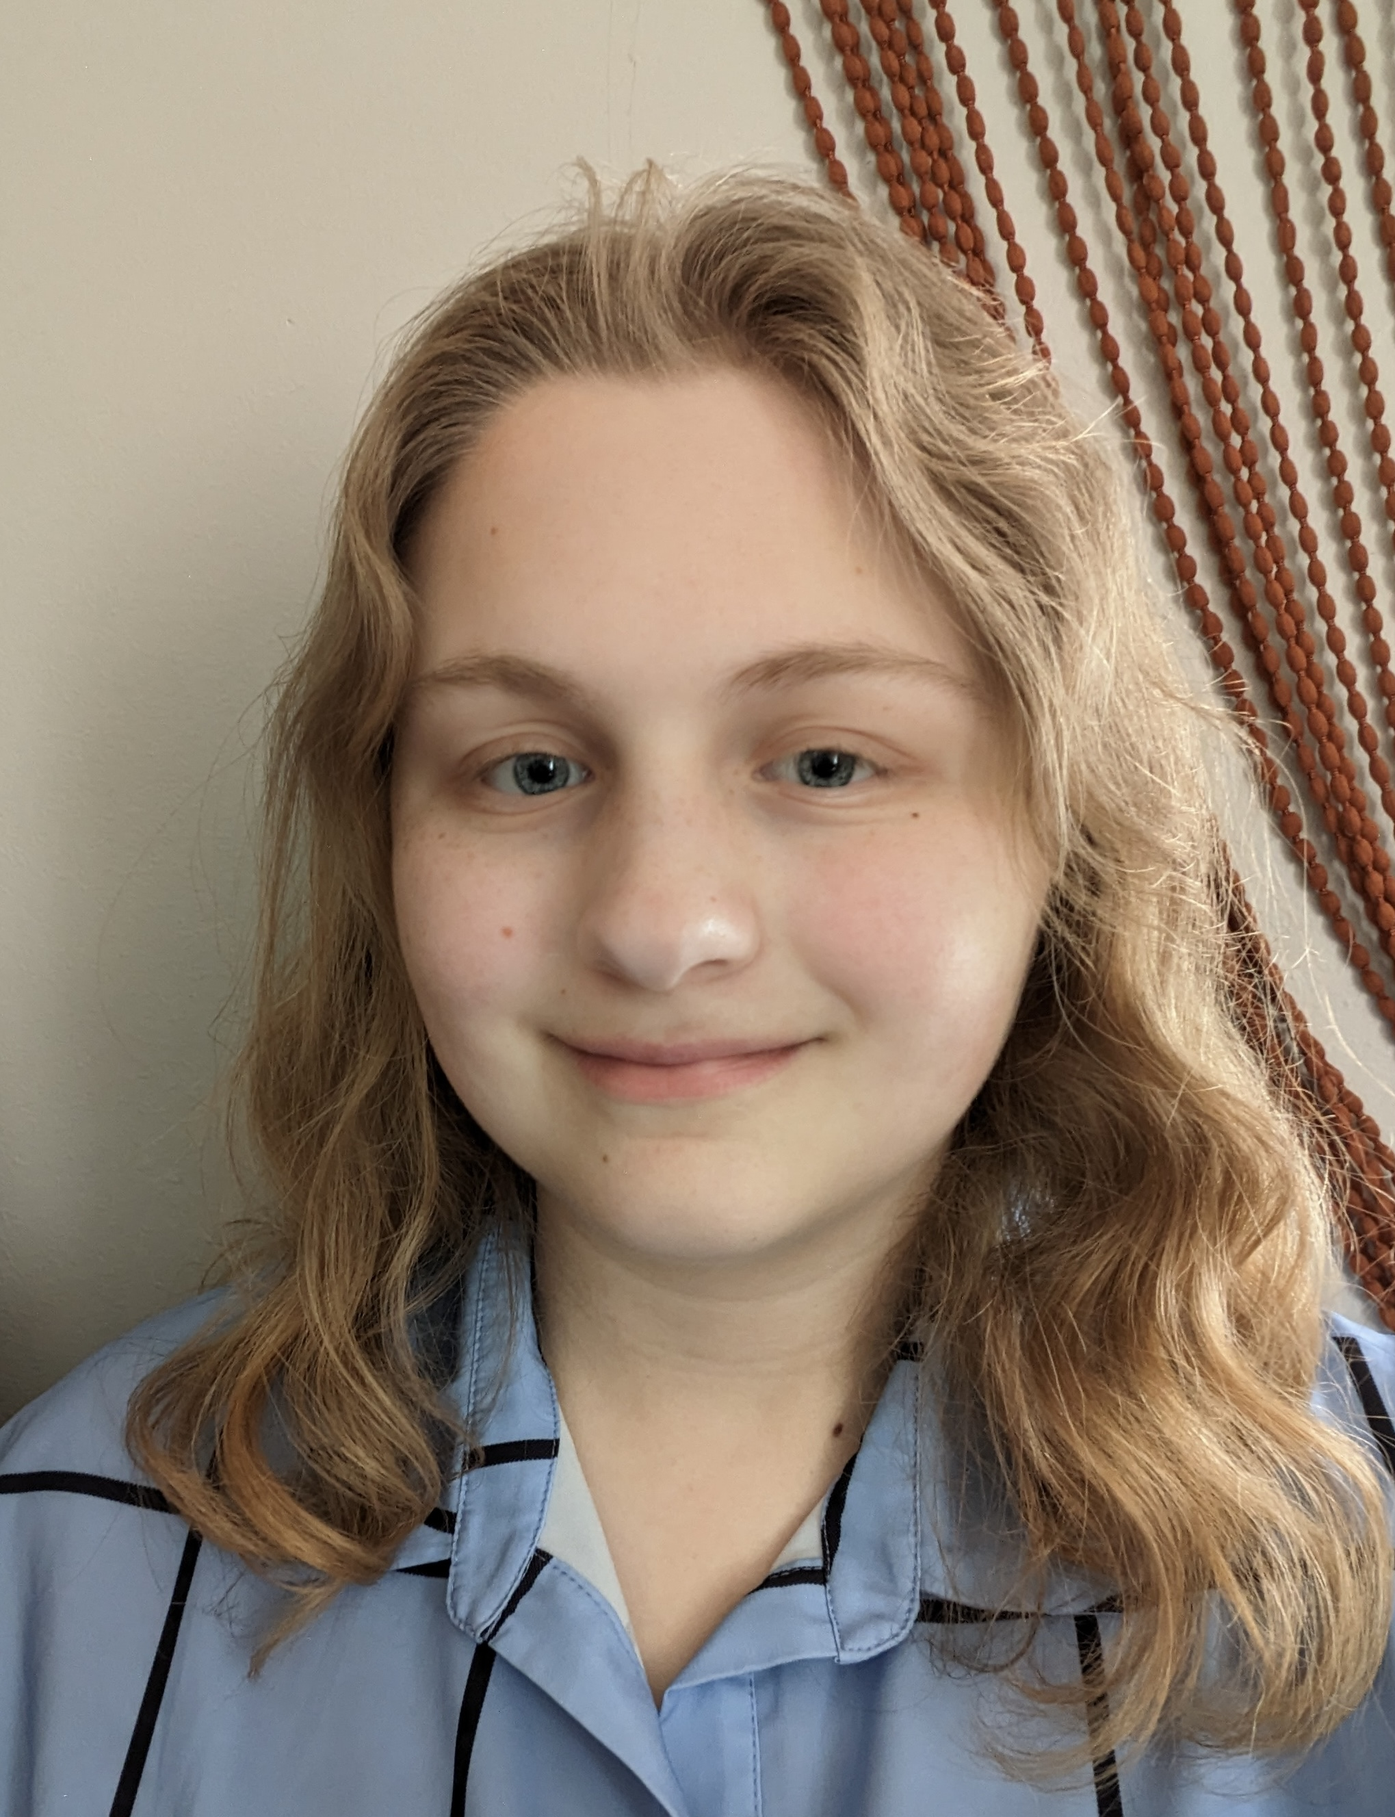
Claire Wilson
Investigating Mycobacteriophage Genomic Relationships and Immunity Patterns
Claire Wilson, Zoe Broker, Audrey Chobar, DeAndrea Daughtry, Odinakachukwu Dibor, Annly John, Maddie Hult, Rhema Hooper, Sruthvika Kandru, Mokhinur Kodirova, Mackenzie Lehman, Constance Mulligan, Ellen Murray, Petra Organovich, Chelse Owate, Olivia Pistone, Sophia Smith, Sarah Teitelman, Samantha Victor, Stephen Mensah, Margaret Kenna, Vassie Ware
Lehigh University’s SEA-Phages program (15th class) isolated and characterized 18 novel Mycobacterium smegmatis phages in 2023, among which phages Dorothea (A6), LappeleDuVide (A4) and Journey (N) were sequenced and annotated. Mycobacterium phage OrlaJr was hypothesized to be a member of Cluster C, based on its myoviridae EM morphotype. DOGEMS sequencing confirmed OrlaJr to be a member of Cluster C1, and contig specific PCR analyses identified two more phage clusters members: MrsKipling (K2) and Etoile (P). Comparative genomics of Dorothea and LappeleDuVide will be presented here. Annotation of Phage Journey’s genome will be presented elsewhere (Lehigh's Advanced Phage Research Course poster). Temperate phages were identified using plaque morphologies and bacterial lysogens were isolated by halo testing and supernatant release assays. Immunity relationships between phages were investigated, informing cluster predictions for uncharacterized phages.

