DO NOT CONSIDER FOR TALK
2024 SEA Symposium Abstract
Montclair State University
Montclair NJ
Corresponding Faculty Member: Kirsten Monsen-Collar (monsenk@mail.montclair.edu)
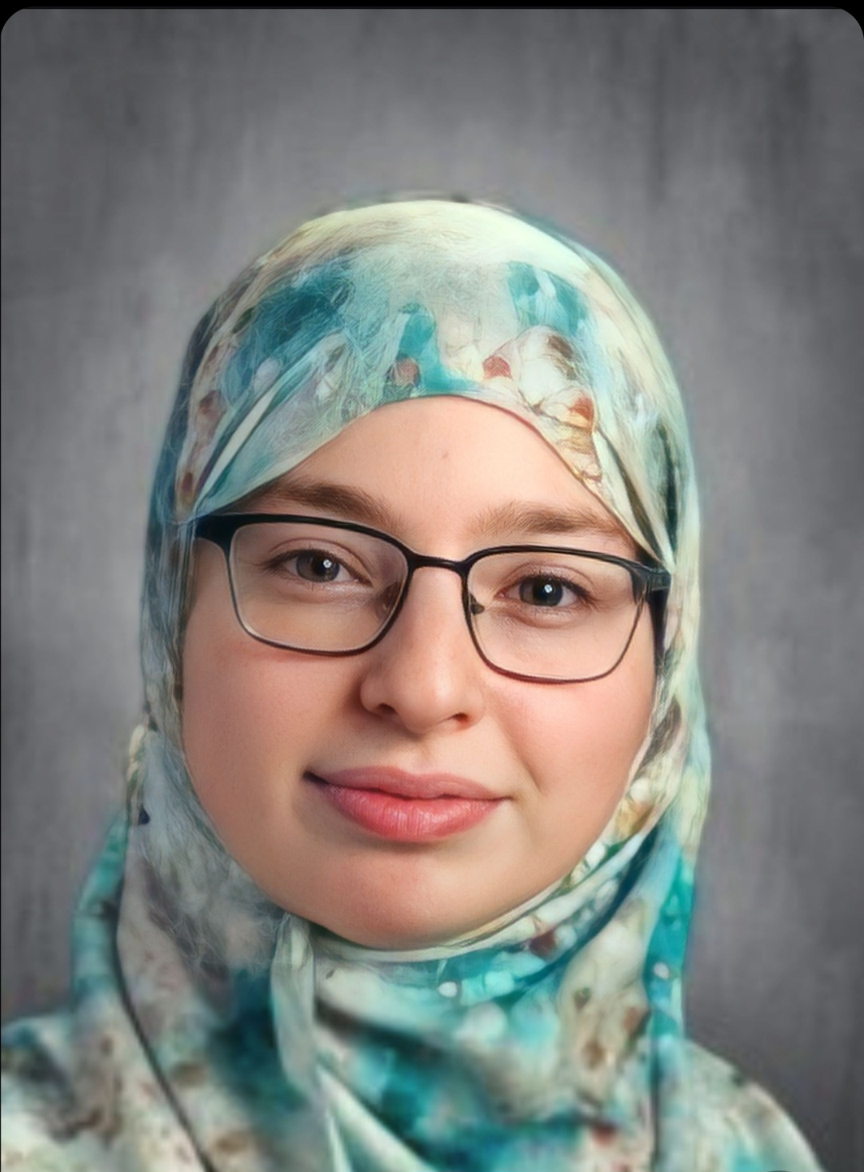
Amina Abada
MiniBagel and Mooshroom: Two Novel Arthrobacter phage
Amina Abada, Noor Abdelal, Tanya Abu Kamal, Wilmary Acosta, Sandra D Adams, Olivia Barnabei, Himani Batham, Alissa Blanco, Jayla Brown, Campos Campos, Tiziana Castillo, Vicente Contreras, Luca Contursi, Jessica Davrayev, Nory Derius, Alexander Diaz, Liyah Evans, Alexander Fenton, Ethan Ferrer, James Galapate, Brayan Gutierrez, Stephannie Gutierrez, Kristen Guzman, Reem Hajjar, Zarifa Hamdan, Jayla Harris, Christian Huilotl, Julia Iwinski, Yara Jamhour, Deborah Jean Louis, Alexander Kuzmich, Angel Mejia, Litzy Mejia, Gihany Melendez, Kirsten Monsen-Collar, Esteban Ocana, Sara Orzechowski, Jhorleny Padilla Garcia, Jose Perez, Fatima Perez-Sosa, Daniela Ramos, Araceli Rivera, Brielle Rodriguez, Madelyn Roque, Nyasia Scott, Amanda Speno, Kayla Swaka, Annmarie Thomas, Isabella Tramontana, Quinn Vega, Ethan Woroniecki, Dunia Zawahreh
To date, students at Montclair State University have isolated 283 phage using Mycobacterium smegmatis, and Arthrobacter sp. as hosts. Of these 283 phage, 28 have been sequenced and 22 have been deposited in GenBank (with three currently in review). During the spring of 2024, MSU students are working to annotate the genomes of two novel Arthrobacter phage: MiniBagel and Mooshroom. MiniBagel is a cluster AM phage with approximately 100 coding genes, and Mooshroom is a cluster AU phage with approximately 96 coding genes. Surprisingly, there were approximately 15 genes in each genome that were not called by DNA Master in the initial auto-annotation that had to be added manually. Pairwise alignments between genomes shows a 54.09% identity between MiniBagel and Mooshroom. Work on these annotations is ongoing and the students at MSU anticipate their annotations to be complete by May 1, 2023.

