DO NOT CONSIDER FOR TALK
2024 SEA Symposium Abstract
College of Charleston
Charleston SC
Corresponding Faculty Member: Christine Byrum (byrumc@cofc.edu)
J Christian Herring
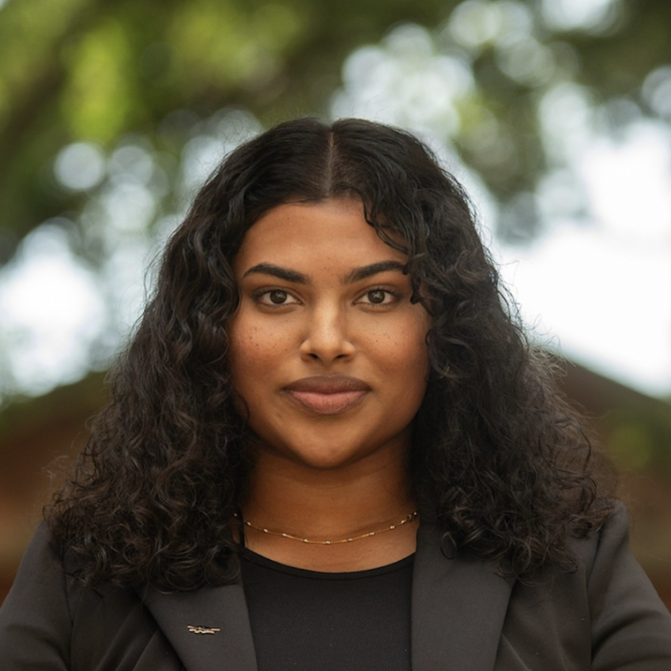
Christa P Joby
Isolation and Genomic Annotation of the L-Cluster Mycobacterium Bacteriophage Jobypre
J Christian Herring, Christa P Joby
Through the Science Education Alliance-Phage Hunters Advancing Genomics and Evolutionary Science (SEA-PHAGES) program, student investigators at various research institutions have isolated, sequenced, and annotated bacteriophage genomes, allowing sequence comparisons. Using soil from the base of a palmetto tree at College of Charleston, students isolated the L cluster/L3 subcluster virus Jobypre using the host Mycobacterium smegmatis mc^2 155. Jobypre’s genome was sequenced and characterized using bioinformatic programs in the workflow tool PECAAN. Afterwards, Phamerator was utilized to compare Jobypre’s genome to other bacteriophages. Jobypre’s genome is 75,624 bp long (GC content 59.3%) containing 129 predicted protein sequences, 10 tRNAs, and no tmRNAs. Like other L cluster bacteriophages, Jobypre includes sequences for the Ro-like RNA binding protein, a DnaB-like dsDNA helicase, and 2 WhiB family transcription factors. Jobypre’s genome is nearly identical to that of Snenia, another L3 virus from Durban, South Africa, sharing 99.97% identity (100% coverage) in a BLASTn comparison.

