DO NOT CONSIDER FOR TALK
2024 SEA Symposium Abstract
College of Charleston
Charleston SC
Corresponding Faculty Member: Christine Byrum (byrumc@cofc.edu)
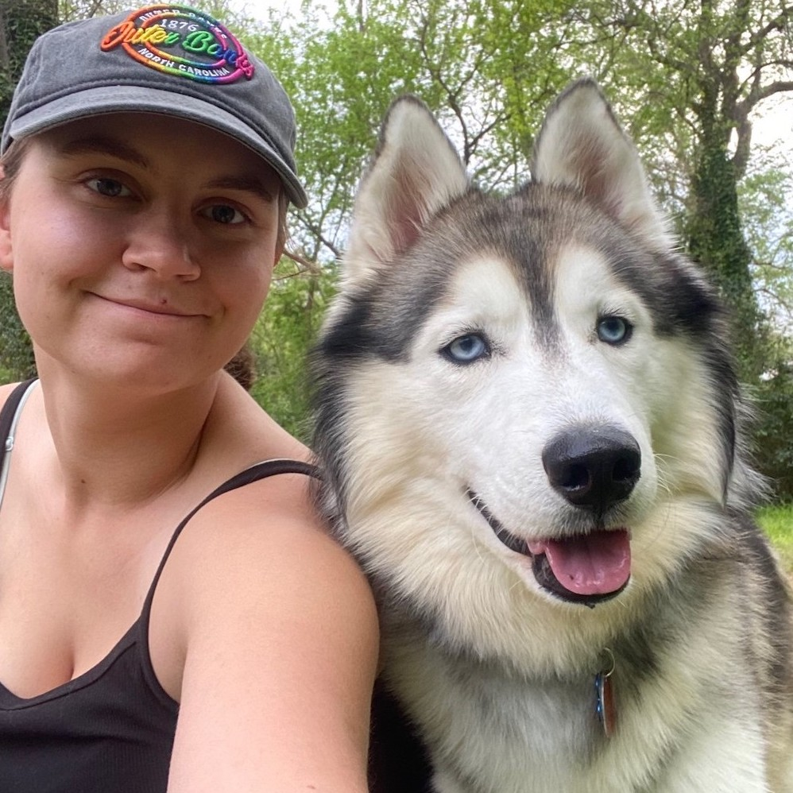
Isabella E Gustafson
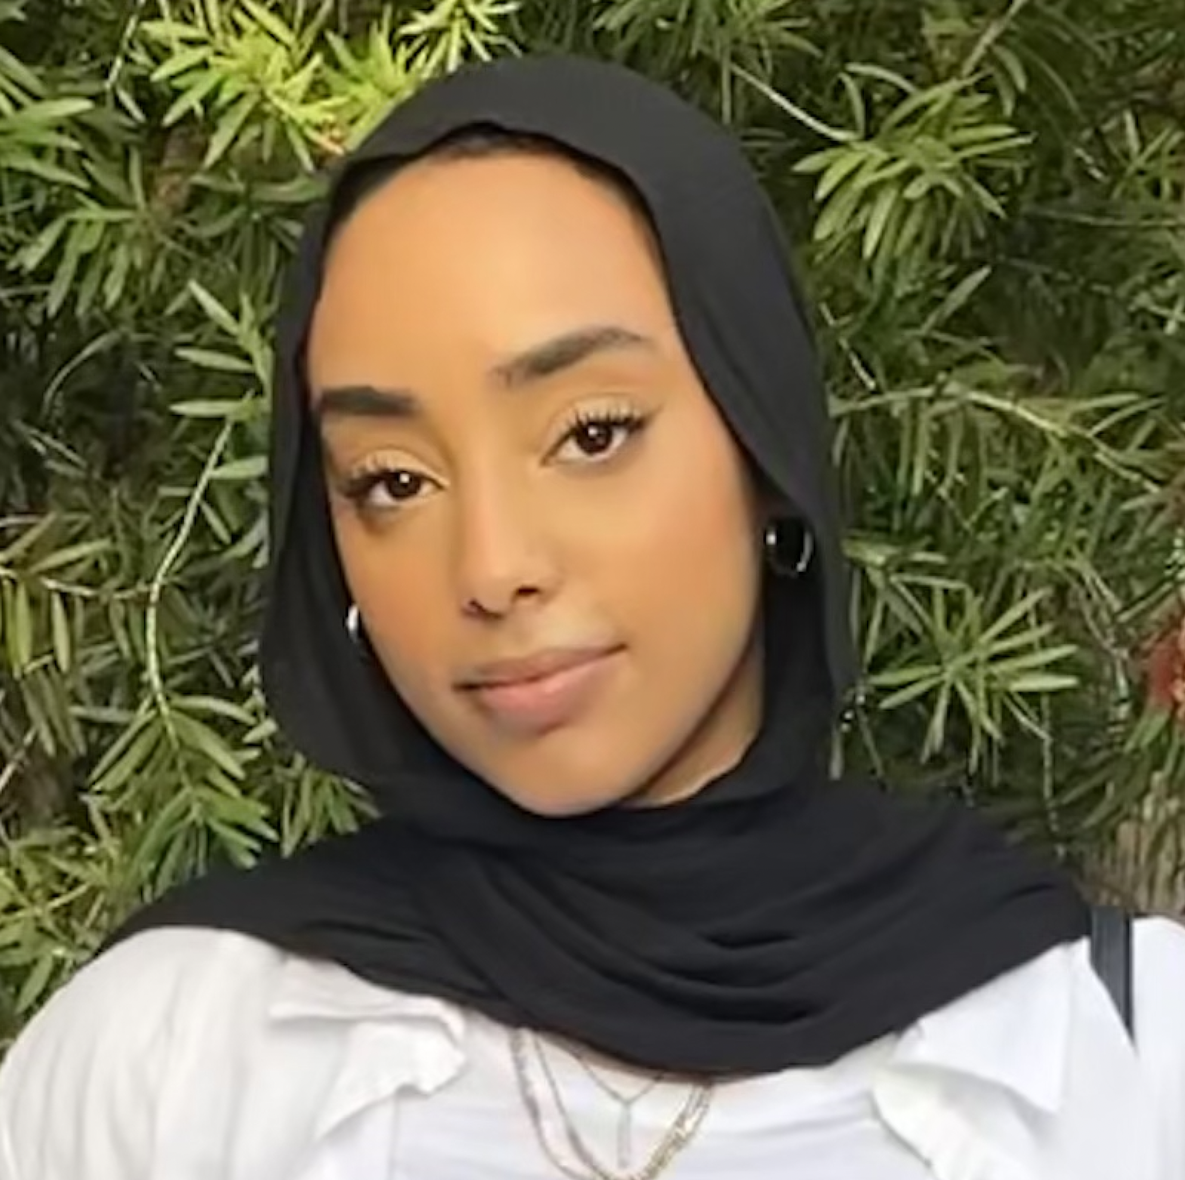
Hams A Kamil
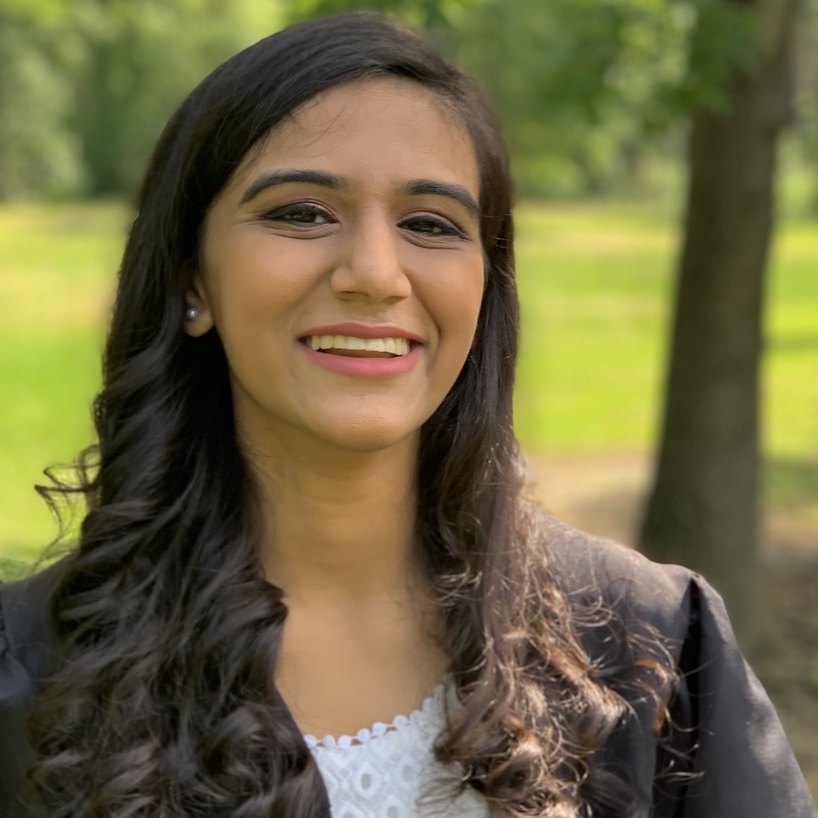
Dhruvi B Patel
Complete Genome Sequence of the Subcluster B13 Mycobacteriophage Hashim76
Isabella E Gustafson, Hams A Kamil, Dhruvi B Patel
The siphovirus Hashim76 was isolated using enrichment from a mud soil sample collected in Hanahan, SC in 2022 and was examined in collaboration with the HHMI SEA-PHAGES program. The bacteriophage infects Mycobacterium smegmatis mc^2 155. With a 70,230 bp genome and 102 predicted protein coding genes (32 assigned putative functions), it is the latest B13 subcluster phage. Its morphology, determined via electron microscopy, features a 70 nm capsid and a 300 nm tail. Genome analysis using Illumina sequencing revealed a circularly permuted structure with 70.1% GC content. BLAST comparisons indicate over 99% similarity to the other B13 phages, BirdsNest and Zenteno07. Functional assignments revealed genes related to capsid and tail assembly, a lysinA/holin/lysinB complex, and membrane proteins, with no predicted tRNA confirmed using ARAGORN and tRNAscan-SE. Other structural genes encountered code for RuvC-like resolvase and a HicA-like toxin in toxin/antitoxin system protein, both also conserved in other B13 cluster viruses.

