DO NOT CONSIDER FOR TALK
2024 SEA Symposium Abstract
University of Southern California
Los Angeles CA
Corresponding Faculty Member: Christa Bancroft (cbancrof@usc.edu)
Arib Ahsan
Josie Crosthwait
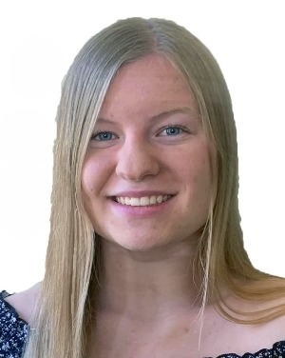
Ruby Crosthwait
Srilekha Davuluri
Omoye Ehimare
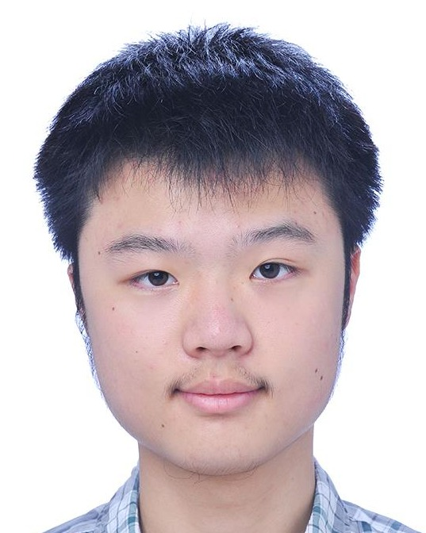
Aldous Fan
Tiarra Joseph Philomen Raju
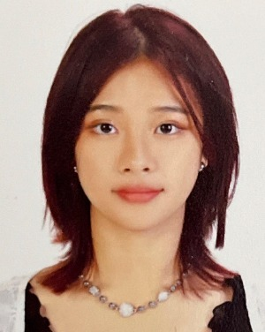
Jamie Kim
Xander Lee
Nick Adani
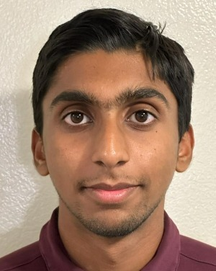
Mugil Shanmugam
Anmol Singhal
Alana Snyder
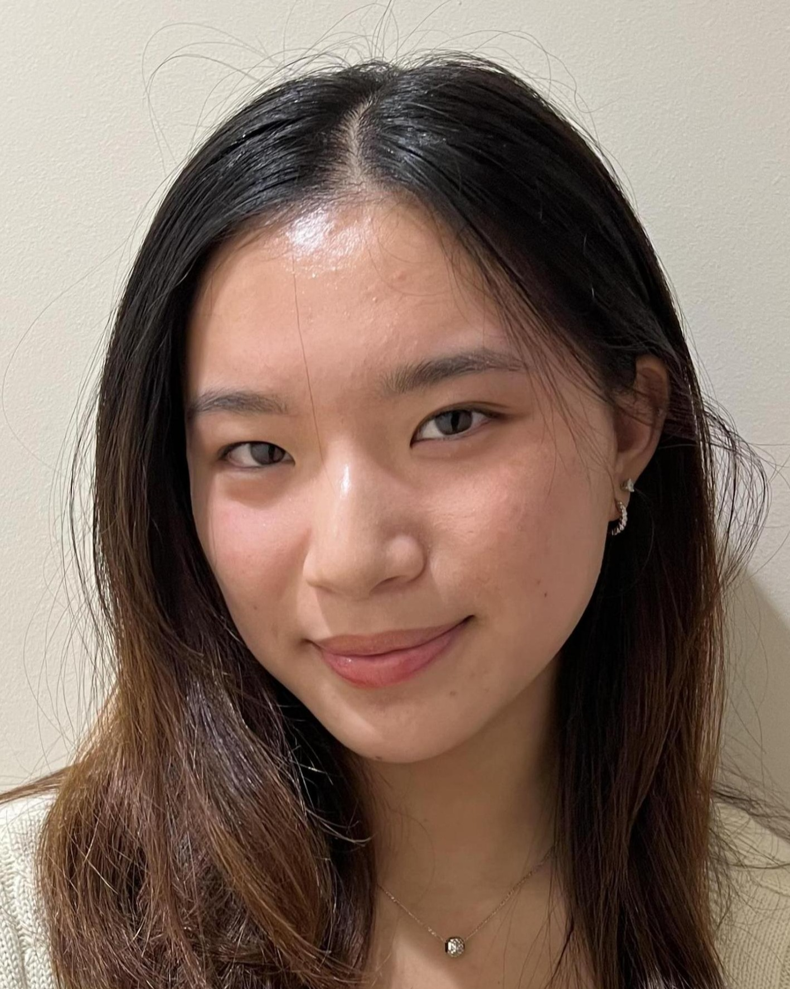
Jessica Sy
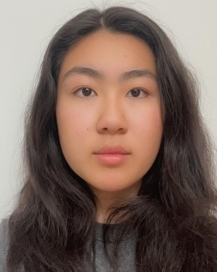
Grace Wang
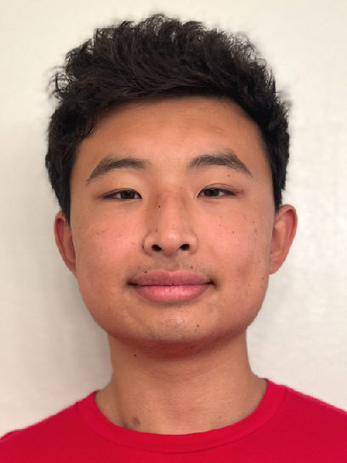
George Zhou
Using Phylogenetic Analysis to Compare FO cluster phage (JanetJ) to Phage in Other F Clusters
Arib Ahsan, Josie Crosthwait, Ruby Crosthwait, Srilekha Davuluri, Omoye Ehimare, Aldous Fan, Tiarra Joseph Philomen Raju, Jamie Kim, Xander Lee, Nick Adani, Mugil Shanmugam, Anmol Singhal, Alana Snyder, Jessica Sy, Grace Wang, George Zhou, Christa T Bancroft
Found abundantly in the world, bacteriophages, or phages, infect bacteria host cells to reproduce. During our lab’s 2023 fall semester, we isolated twelve putative temperate phages from the Los Angeles area using bacterial host Arthrobacter globiformis B-2979. After we isolated, purified and amplified the bacteriophage, we used Transmission Electron Microscopy (TEM) images to evaluate their specific structures. We then extracted and sequenced the DNA of phage JanetJ. The length of JanetJ’s genome, a cluster FO phage, is 36,986 base pairs. We used several software programs to predict the open reading frames (ORFs) and assign each gene a start codon, including DNA Master, Starterator, Phamerator, GeneMark, Glimmer, Phagesdb BLAST, and BLAST. We determined the putative function of each gene using evidence from HHPRED, NCBI BLAST, and Synteny. Our preliminary results show that JanetJ has 52 ORFs and 0 tRNAs.
Because there are currently only two other bacteriophage characterized and annotated in the FO cluster on the Actinobacteriophage database, Phages.db, we are interested in relatedness of FO phage to each other and other F clusters, such as FA and FB. To this end, we have conducted phylogenetic analysis of specific, highly conserved phage proteins to see if their amino acid relatedness within and between clusters mirror how closely-related they are at the genomic nucleotide level. We have used phylogenetic tools, Phylogeny.fr and Splitstree4, to compare amino acid sequence of the tape measure protein, tail assembly chaperones, minor tail proteins and the endonuclease between FO phage and clusters FA and FB. We have also analyzed genome nucleotide sequence similarity to determine if intra and inter cluster relatedness is consistent when comparing amino acid sequence of specific proteins and relatedness of the genomic sequence as a whole, at the nucleotide level.

