DO NOT CONSIDER FOR TALK
2024 SEA Symposium Abstract
Northwestern College
Orange City IA
Corresponding Faculty Member: Sara Tolsma (stolsma@nwciowa.edu)
Lauren N Fisk
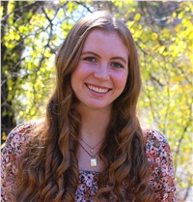
Kylie A Foss
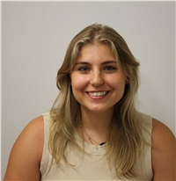
Khloe Hester
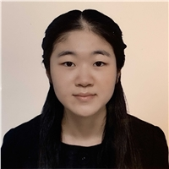
Yuki Kobayashi
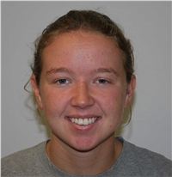
Madelin M Kvatek
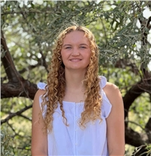
Elsie L Larson
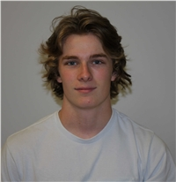
Joshua T Lewis
Madilyn L Manary
Laura F Nelson
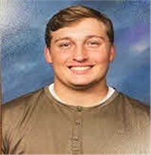
Thomas E Ostrem
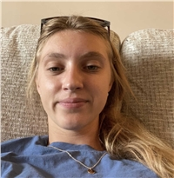
Cayli H Penner
Sydney M Rehmke
Taylor M Rentschler
Adriana Sandbult
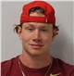
Dane D Shoenborn
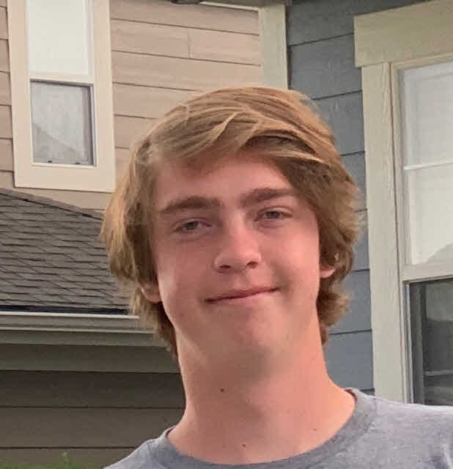
Jonas D Tiensvold
Shayler O VanGelder
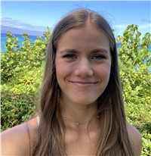
Kallie L VanKley
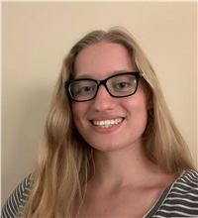
Megan VanGarven
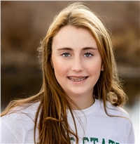
Brianna A Winford
Annotation of Three Actinobacteriophages: TukTuk, Shamu, and Megatron06
Lauren N Fisk, Kylie A Foss, Khloe Hester, Yuki Kobayashi, Madelin M Kvatek, Elsie L Larson, Joshua T Lewis, Madilyn L Manary, Laura F Nelson, Thomas E Ostrem, Cayli H Penner, Sydney M Rehmke, Taylor M Rentschler, Adriana Sandbult, Dane D Shoenborn, Jonas D Tiensvold, Shayler O VanGelder, Kallie L VanKley, Megan VanGarven, Brianna A Winford, Byron Noordewier, Sara S Tolsma
We annotated three newly discovered bacteriophages. TukTuk and Shamu were isolated on the host Microbacterium folorium and Megatron06 on Mycobacterium smegmatis. Based on gene-content similarity (GCS) of 35% or higher to sequenced bacteriophages present in the Actinobacteriophage database, phagesDB, TukTuk was assigned to cluster EB, Shamu to cluster EA, and Megatron06 to Cluster H1. Here we report a summary of our annotation findings along with an in-depth analysis of one aspect of our annotation for each phage.

