DO NOT CONSIDER FOR TALK
2024 SEA Symposium Abstract
Coastal Carolina University
Conway SC
Corresponding Faculty Member: Daniel Williams (dwilliams@coastal.edu)
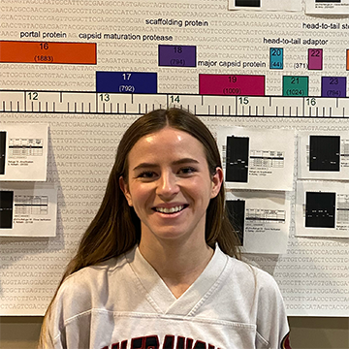
Madison Arno
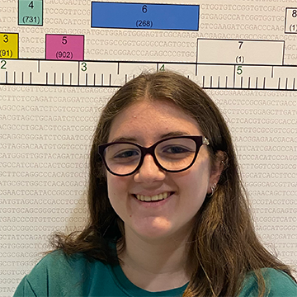
Alexandra Greco
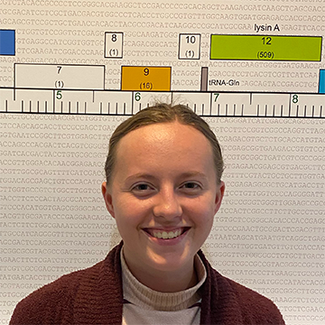
Emma Hofseth
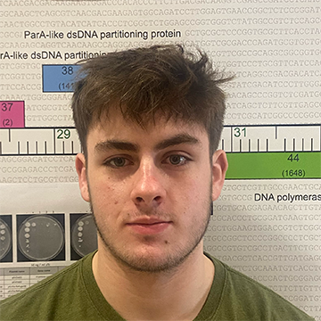
Brannon LaFrancis
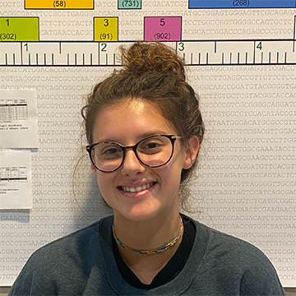
Rachel Veri
Molecular Characterization of mycobacteriophage Refuge
Madison Arno, Kyle Earley, Alexandra Greco, Emma Hofseth, Brannon LaFrancis, Kyla Thomas, Rachel Veri, Daniel C Williams
As part of SEA-GENEs, our lab has taken a systematic approach to examine the functional significance of individual phage gene products in vivo. Refuge is an A9 subcluster temperate bacteriophage. The genome of Refuge contains 92 predicted protein encoding genes, and like most phages, most of them lack functional assignment based on bioinformatic analysis. We are in the process of generating an expression plasmid library that consists of all Refuge genes. Individual genes were initially amplified using gene-specific forward and reverse primers. Amplified products were purified and inserted into the pExTra plasmid via isothermal assembly. The Refuge library is still a work in progress, but most of the genes have been cloned and verified. After purification, individual plasmids are transformed into M. smegmatis and the effect of phage gene expression on growth of host cells is analyzed to determine if individual genes are cytotoxic to host cells. Expression of Refuge gene product 38, which encodes a ParA-like DNA partitioning domain protein, strongly inhibited cell growth, indicating this gene product is very cytotoxic. In other phage genomes ParA-like DNA partitioning proteins are involved in maintenance of lysogeny. We are currently working towards the generation of a complete gene library and performing cytotoxic assays to further elucidate gene function.

