CONSIDER FOR TALK
8th Annual SEA-PHAGES Symposium Abstract
University of West Florida
Pensacola FL
Corresponding Faculty Member: Hui-Min Chung (hchung@uwf.edu)
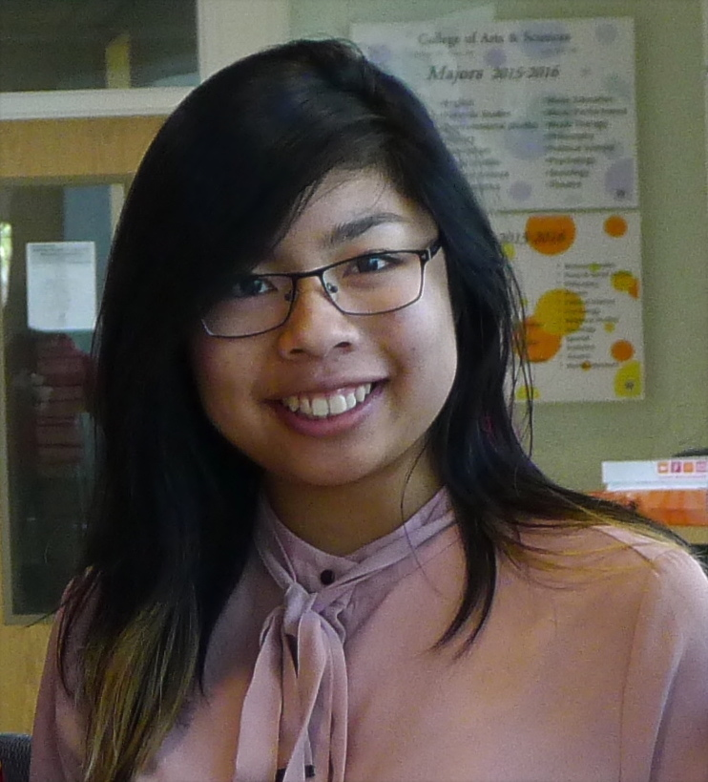
Sabina Cabrera
May Zaw
Who Ya Gonna Call? Phage Hunters!
Abigail Allgood, Kayla Bastin, Bayla Bessemer, Meaghan Boggs, Mallory Bouck, Hannah Bricker, Mariah Bush, Sabina Cabrera, Kendra Chandler, Rhianna Dalton, Amara Ejikemeuwa, Alexis Grammer, Leila Harris, Kristina Jacques, Emmalee McClain, Hoang Nguyen, Joseph Reidy, Sierra Spann, Ananda Wiwi, May Zaw, Pamela Tanner, Hui-Min Chung
Bacteriophages, viruses that infect bacteria, are going to be a topic that scientists focus more on in the coming years. These viruses can be used in a variety of ways, from killing bacteria to researching new methods of treating diseases. University of West Florida in Pensacola Florida joined the SEA-PHAGES program in 2015; we, eighteen freshman students, were enrolled for this undergraduate research experience as UWF SEA-PHAGES cohort 8.1. Using M. smegmatis as our host bacteria we isolated phages from soil collected from campus, and discovered 9 phages from soils collected at the UWF campus: Zanzibar, Marayla, Slimphazie, DarthP, Lexory, Kristannah, Xanthippeus, Phargo and Kindred. Ultimately we picked Slimphazie and DarthP phages to be sequenced in the end of 2015. The genome sequencing results showed that both Slimphazie and DarthP are cluster K phages. The Slimphazie genome is 60143 bp long, categorized in subcluster K1. The DarthP genome is 61594 bp long, categorized in sublcuster K6. We then jointly annotated the Slimphazie phage genome in the 2016 spring semester. While the annotation drafted by DNA Master predicts there are 98 genes in the Slimphazie genome, our annotation results suggest 97 genes. Upon doing genome annotation, we used genomes of another two K1 phages, BarrelRoll and Jaws, for comparison. The BarrelRoll phage genome is 59672 bp long composed of 96 genes; the Jaws genome is 59749 bp long composed of 94 genes. We discovered that while the Slimphazie genome shares very high level of nucleotide homology with that of BarrelRoll, the Slimphazie genome is 1922 bp longer than BarrelRoll’s in the area of genes 81-84 of Slimphazie. The BarrelRoll genome lacks Pham 14591 and Pham 2669. While Pham 14591 appears in about 22 different phage genomes, Pham 2669 appears only in the Slimpahzie and Jaws genomes. It is possible that the DAN of Pham 2669 area represents a hotspot for generating phage diversity.
Intrigued by the rich marine resource of Gulf coast, we are particularly interested in phage diversity derived from the marine environment. In the coming summer, a few students of Cohort 8.1 will continue phage hunting in the Santa Rosa Island using samples from the beach (side near gulf), dunes (vegetation that floods frequently), and salt marshes (marsh area near bay). The aims include: a) experimenting bacterial hosts favoring marine phages, b) isolating and characterizing marine phages, and c) comparing phages isolated from regular soils with those from beach sand/soil.

