CONSIDER FOR TALK
2024 SEA Symposium Abstract
College of William & Mary
Williamsburg VA
Corresponding Faculty Member: Margaret Saha (mssaha@wm.edu)
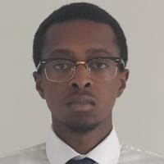
Zephaniah N Ansah
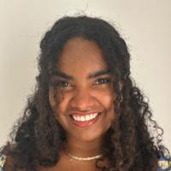
Gianna Dunn
Doc and Deb's Wild Adventure: A Tale of Two F1 Phages
Zephaniah N Ansah, Gianna Dunn, Deeka S Abdi, Ali Amin, Ethan W Bomersheim, Ali A Elfaki, Jordyn Foulk, Kate C Ingle, Avi D Lavu, Ved Pande, Vera Pande, Priya T Shan, Marie P Smithbey, Gunnar R Ternstrom, Olivia S Trager, David A Washington, Monica Xu, Victoria A Figgins, Marcus O Royster, Margaret S Saha
In the fall semester of 2023, the William and Mary SEA-PHAGES program conducted an in-person phage discovery class with 22 freshmen eager to conduct authentic research. Using Mycobacterium smegmatis as the host, each and every student isolated their own phage and was able to carry it through to purification, DNA isolation, gel electrophoresis analysis, and transmission electron microscopy! DNA was submitted to for sequencing at The University of Pittsburgh and two phages were selected for annotation. Interestingly, both phages were in the F1 subcluster, a large but diverse subcluster. Deb65 is temperate phage with a genome consisting of 55,767 base pairs and 97 genes. DocMcStuffins is also a temperate phage with 90 genes and a genome length of 58,159 base pairs. Both phages exhibit siphoviridae morphology. Our bioinformatic and annotation analysis revealed that Deb65 and DocMcStuffins share regions of conservation with other F1 phages yet also display some unique, significant differences. Bioinformatic analysis will focus on a detailed comparative analysis of both DocMcStuffins and Deb65 to each other as well as a broader genomic analysis of the F cluster phage genomes.

