CONSIDER FOR TALK
8th Annual SEA-PHAGES Symposium Abstract
Montclair State University
Montclair NJ
Corresponding Faculty Member: Sandra D. Adams (adamssa@mail.montclair.edu)
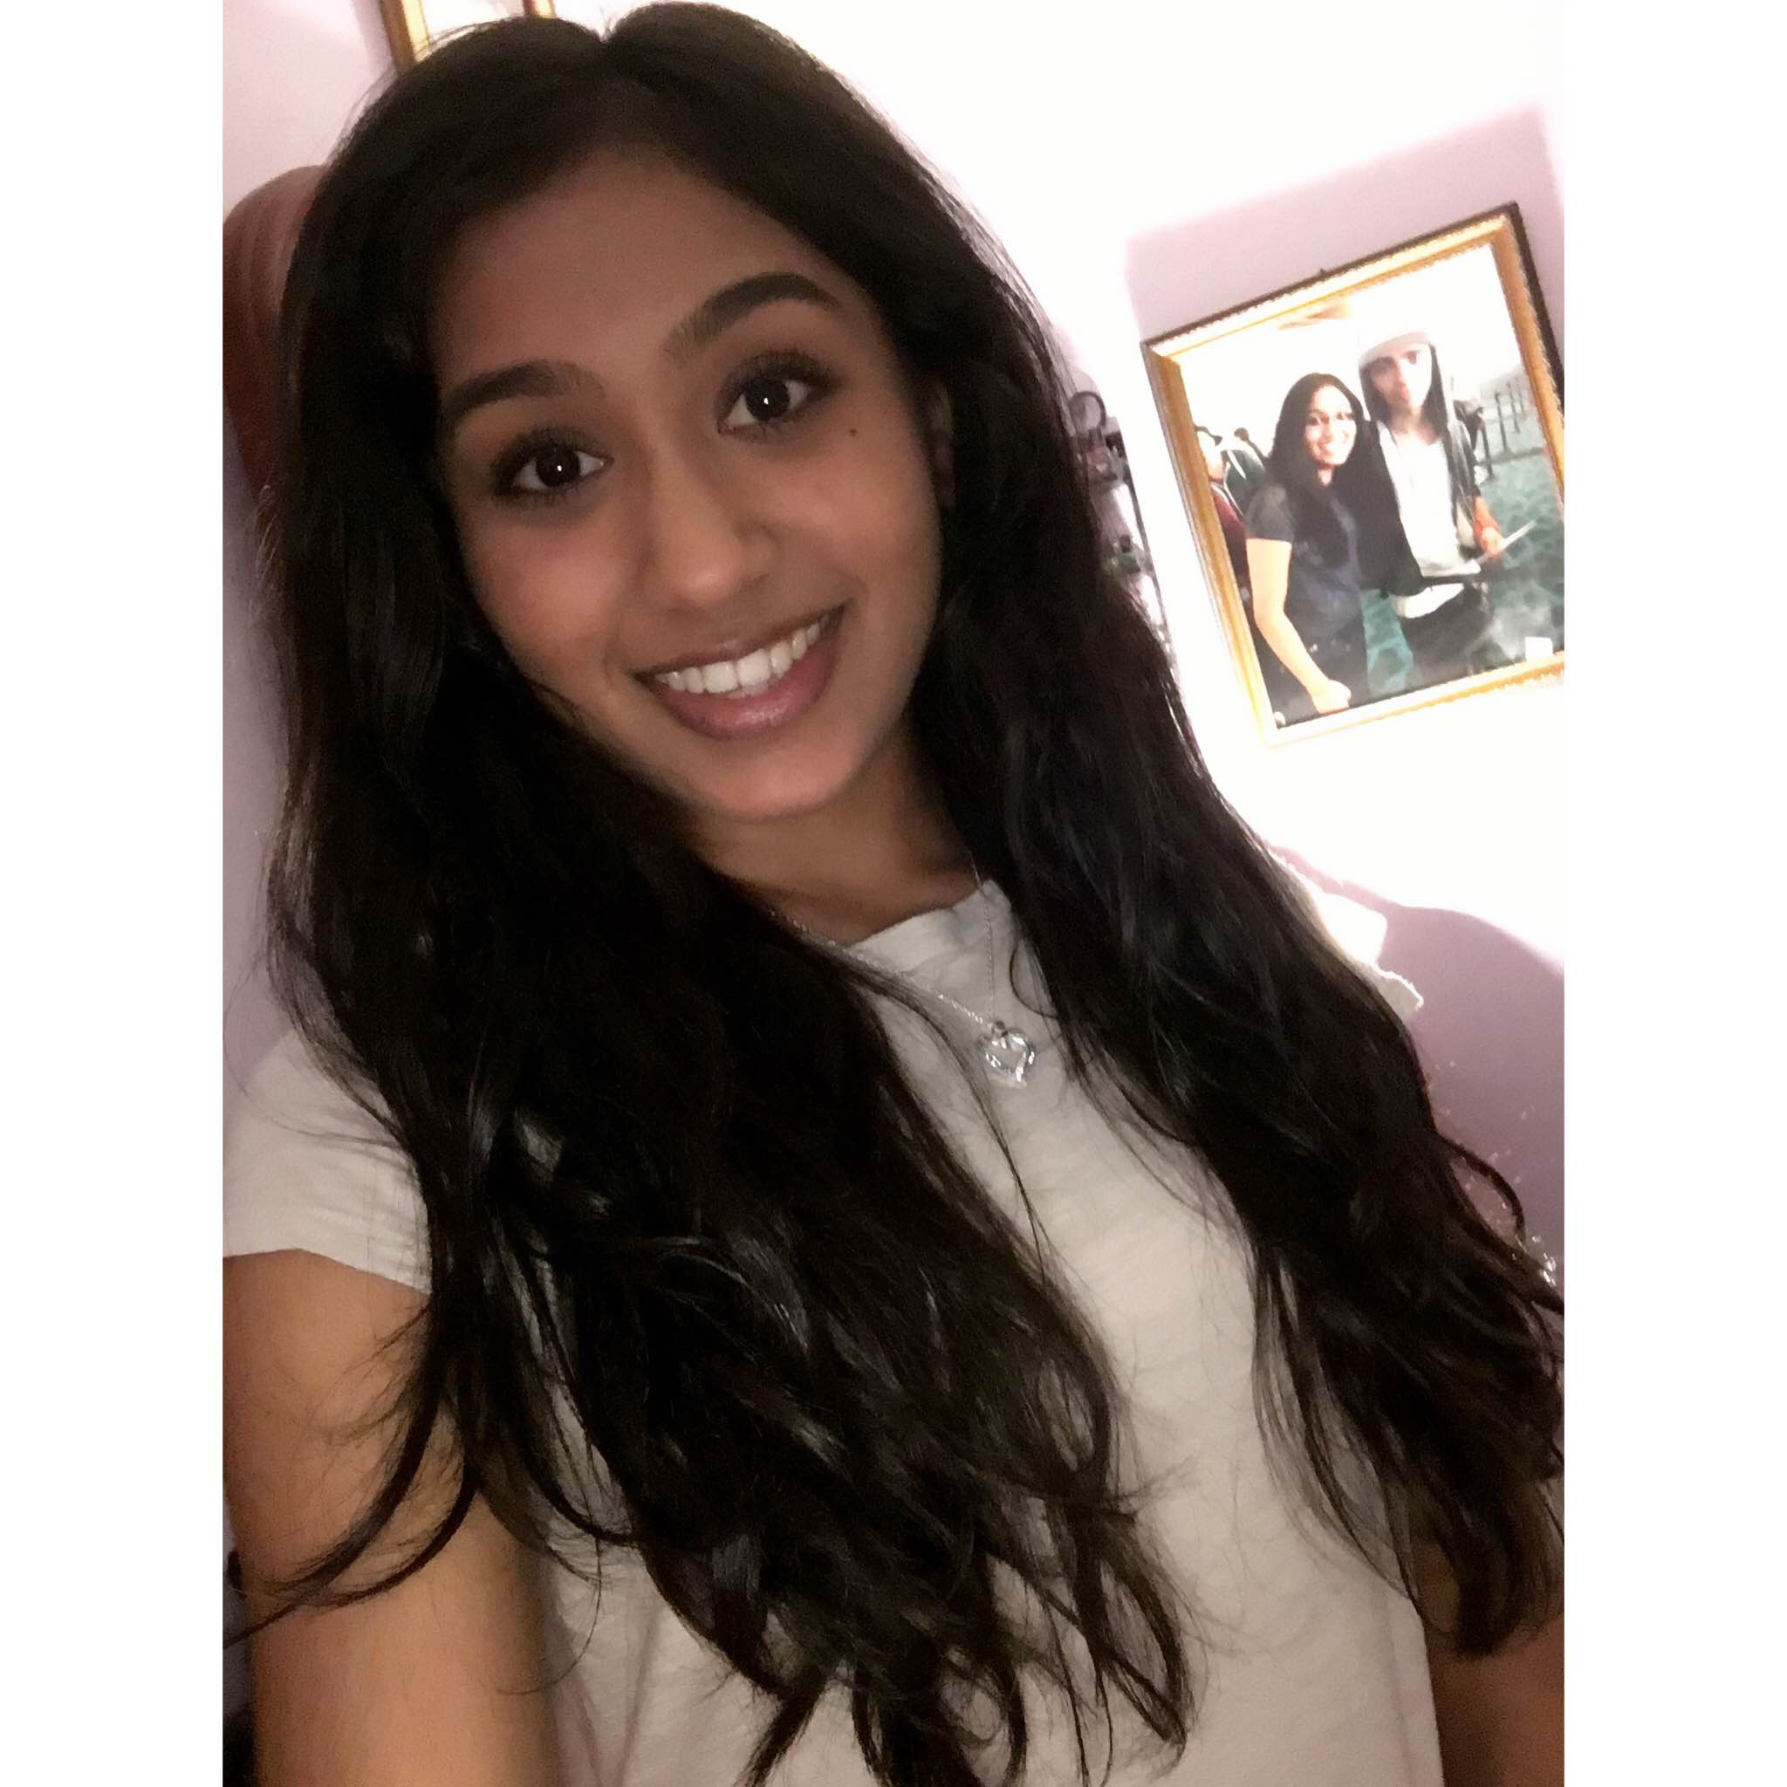
Kaide Udit
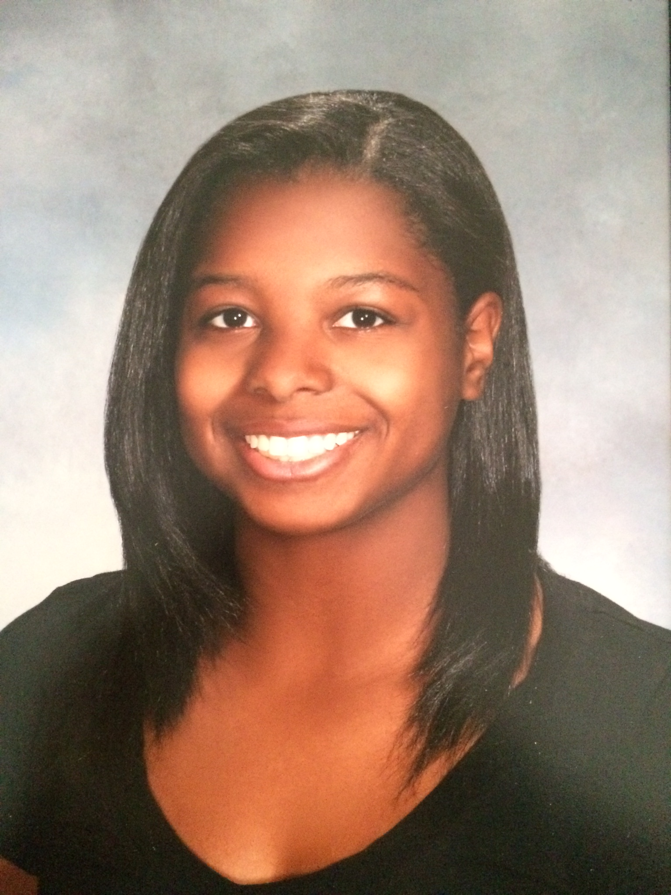
Kailyn Grant
Isolation and Characterization of LifeSavor and Abidatro
Kaide Udit, Kailyn Grant, Mohamed Abboud, Yesenia Acosta, Jennifer Aguirre, Omran Ahmadi, Anthony Ahmadi, Joshua Bacatan, Melissa Barua, Micaela Basualdo, Amaney Bidas, MarieAnge Charles, Danielle Crespo, Shadi Dahduli, Rana Darwiche, Faith De Vergara, Massimo Demetrio, Kevan Doyles, Tony Elias, Tony Feghali, Deion Fleetwood, Mihal Grinberg, Wedad Haddabeh, Georgette Hamwi, Thomas Hanf, Avat Hussain, Austin Jennis, Abdul Khalique, Kristy Kang, Natalia Majkut, Brenda Minto, Nusrat Mubarka, Gerard Nasser, Christian Navarro, Austin Oleksey, Naisargi Patel, Mitul Rana, Denys Sanchez, Angie Santrich, Lisa Sarpong, Reiko Sato-Balagot, Rajbir Singh, Alicia Tiozon, Kristen Tolentino-Uri, Oladeji Toyosi, Karla Vasquez, Derek Wright, Mondonna Zangeneh
The Montclair State University Phage Hunter class of 2015-2016 isolated both Mycobacteriophages from Mycobacterium smegmatis and Arthrobacteriophages from Arthrobacter sp. Isolation of the Arthrobacteriophages proved to be the most challenging. Approximately 48 soil samples using various media and protocols were screened; only three samples were successful in yielding Arthrobacteriophage. High titer lysates of the isolates were prepared and DNA was isolated for both the isolated Mycobacteriophage and Arthrobacteriophage. DNA from Mycobacteriophage LifeSavor and Arthrobacter phages Karlyn and Abidatro were submitted for sequencing. Upon sequencing, Karlyn was determined to be a clone of Abidatro.
Abidatro was isolated from soil obtained near the parking deck on the campus of Montclair State University. Abidatro is interesting because it is the second member of Arthrobacteriophage Cluster AS. The Abidatro genome contains 39,122 base pairs with 69 genes.
The LifeSavor genome contains 156,804 base pairs with 233 genes and belongs to cluster C (subcluster C1). LifeSavor had an astonishing 32 tRNA genes within the 233 genes that were read by DNAMaster. Having any tRNA genes in a phage genome is unique, but to have so many in one genome is remarkable, especially since several of them were repeated multiple times throughout the genome.

