CONSIDER FOR TALK
2023 SEA Symposium Abstract
University of Ottawa
Ottawa
Corresponding Faculty Member: Adam Rudner (arudner@uottawa.ca)
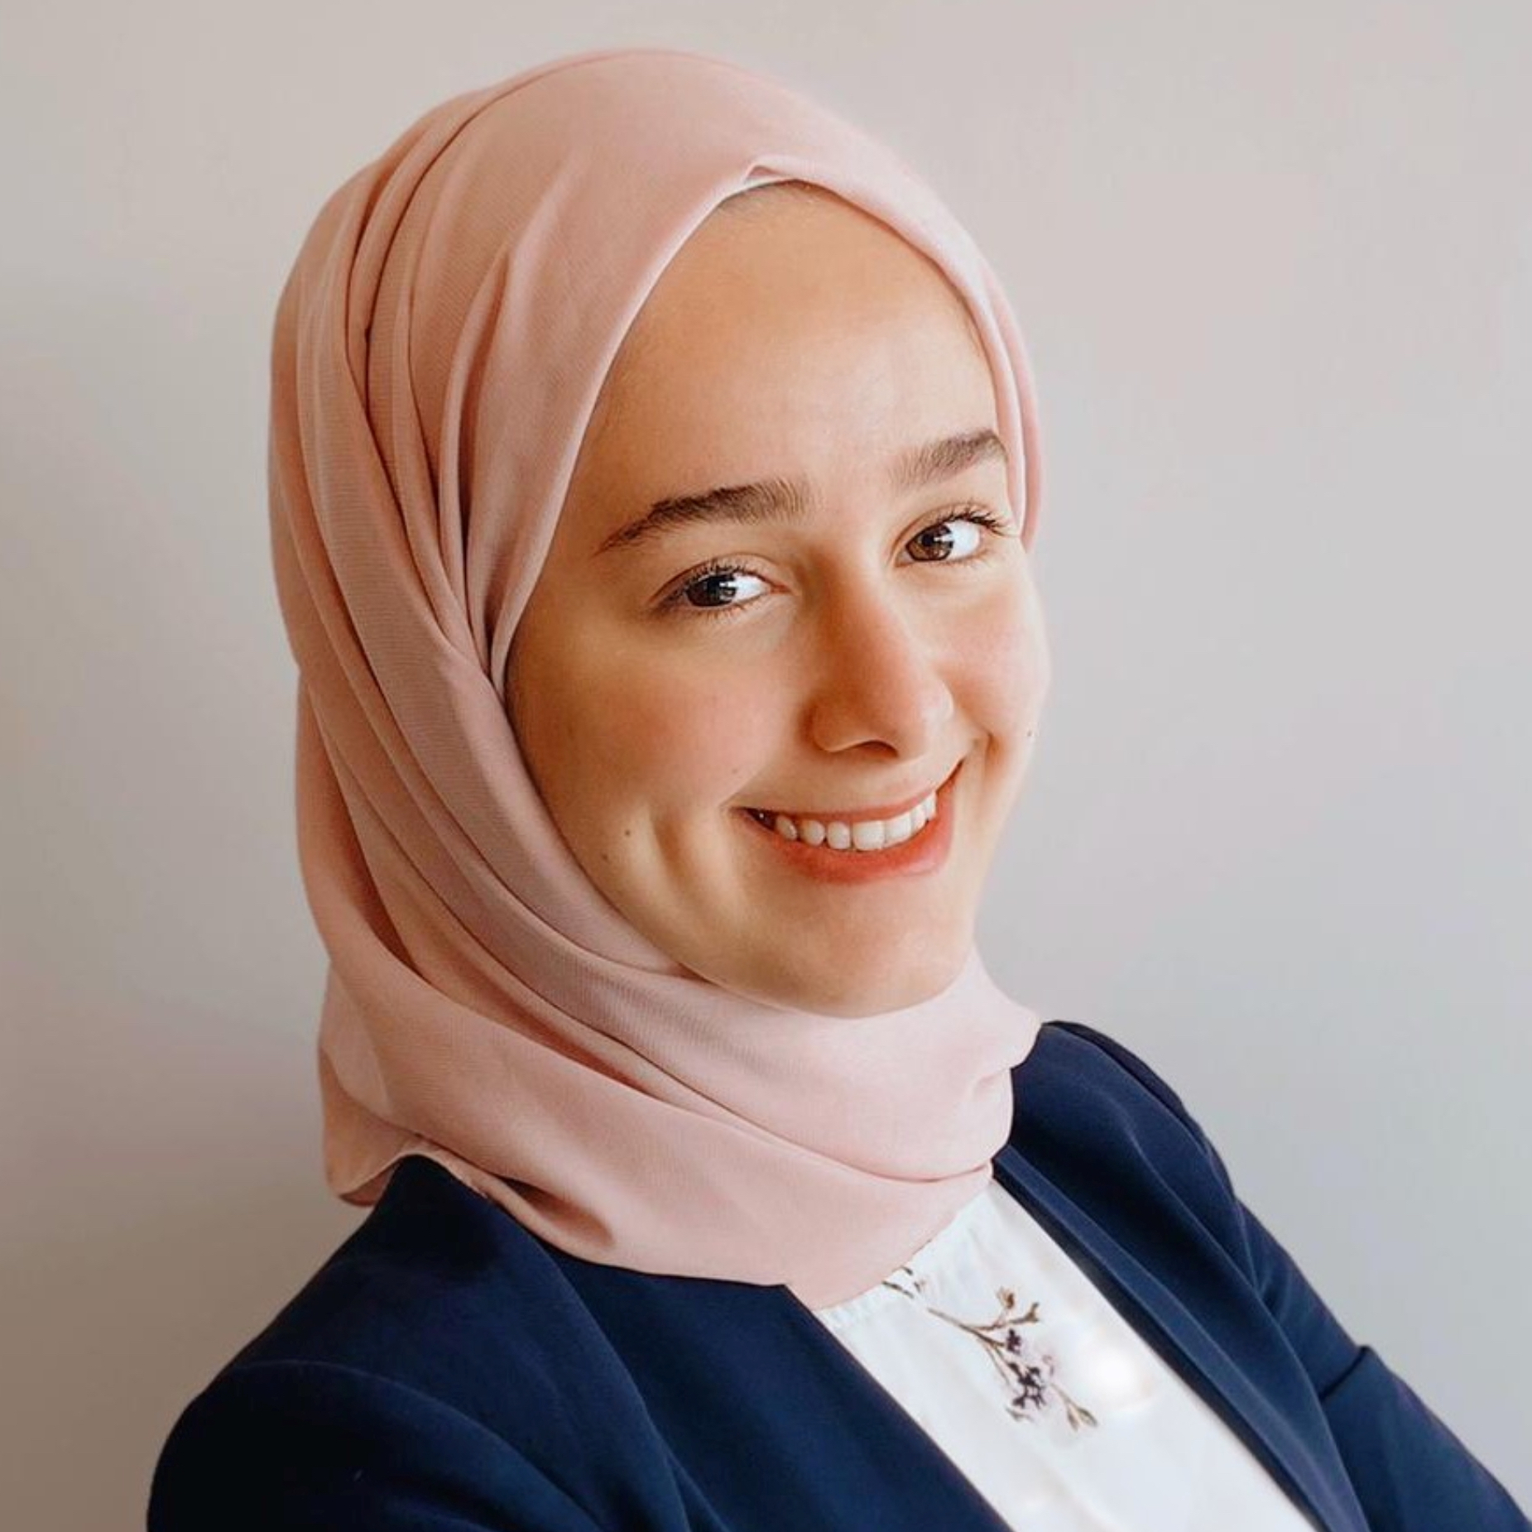
Leen Madani
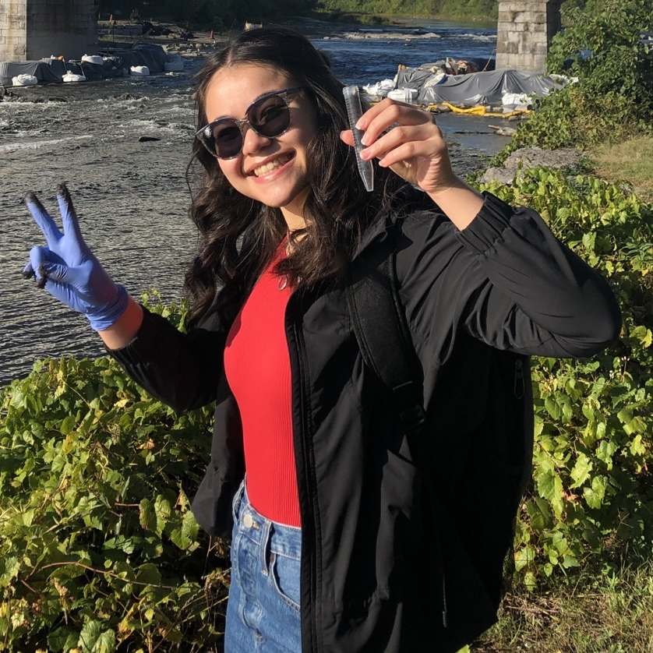
Katia Koziel Ly
uOttawa PhageHunters Unite: Discovering Defense Escape Mutants Who Outsmart Actinobacteria
Leen Madani, Katia Koziel Ly, Elizabeth C Williams, Adam D Rudner
uOttawa phage hunters have isolated and annotated eleven Arthrobacter globiformis phages in the AZ cluster. These phages readily form stable lysogens and we have examined super-infection immunity of eight lysogens to nine AZ cluster phages. A subset of these lysogens, for example a lysogen of Pixelle, provide super-infection immunity to many of the other AZ cluster phages. We noted that these phages rapidly acquire genetic mutations that allow them to bypass this super-infection immunity, and we have purified ten ObiToo and Crewmate defense escape mutants (DEMs) that can efficiently infect Amyev and Pixelle lysogens. We have sequenced the genomes of six of these DEMs using an Illumina platform and five contain mutations upstream of gp50. Gp50 encodes a DNA binding protein with a high probability matches on HHpred and Foldseek to the E. coli SigmaS factor. Our DEM mutants appear to be virulent as they also escape superinfection immunity of Crewmate and ObiToo lysogens. We are exploring the hypothesis that these mutants lie within the promoter of the immunity repressor for AZ cluster phages. We are examining gp50 and its upstream region in other AZ cluster phages and initiating experiments to test if gp50 functions as an immunity repressor.

