DO NOT CONSIDER FOR TALK
2023 SEA Symposium Abstract
University of Southern California
Los Angeles CA
Corresponding Faculty Member: Christa Bancroft (cbancrof@usc.edu)
Alexander Fazilat
Matthew Genchev
Sanguk Han
David Ho
Amisha Kumar
Brian Lam
Ryan Lin
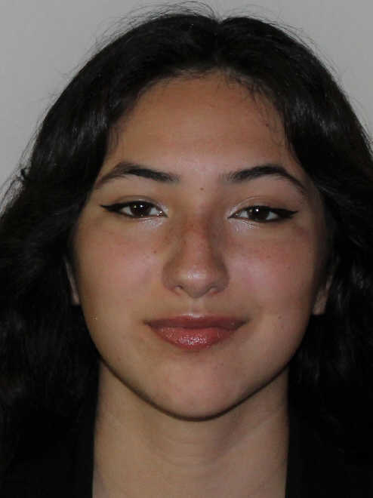
Amanda Lopez
Zainab Neemuchwala
William Seng
Jason Toliao
Christa Bancroft
Analysis of Gusanita (FF), MidnightRain (AY) and Tape Measure protein research
Alexander Fazilat, Matthew Genchev, Sanguk Han, David Ho, Amisha Kumar, Brian Lam, Ryan Lin, Amanda Lopez, Zainab Neemuchwala, William Seng, Jason Toliao, Christa Bancroft
Found abundantly in the world, bacteriophages, or phages, infect numerous bacteria host cells to reproduce. During our lab’s 2022 fall semester, we isolated fifteen individual temperate phages in both Los Angeles and the California Bay Area using bacterial host Arthrobacter globiformis. Of these phages, we chose to further analyze Gusanita and MidnightRain. After we isolated, purified and amplified the bacteriophages, we used Transmission Electron Microscopy (TEM) images to evaluate their specific structures. We then extracted and sequenced the DNA of both phages. The length of Gusanita’s genome, a cluster FF phage, is 42,742 base pairs and the length of MidnightRain’s genome, a cluster AY phage, is 53,674. We used several software programs to predict the open reading frames (ORFs) and assign each gene a start codon, including DNA Master, Starterator, Phamerator, GeneMark, Glimmer, Phagesdb BLAST, and BLAST. We determined the function of each gene using evidence from HHPRED, NCBI BLAST, and Synteny. Our preliminary results show that Gusanita has 68 ORFs and 2 tRNAs, whereas MidnightRain has 101 ORFs and 1 tRNA.
Our analysis focuses on the tail morphology of phages. Phage tail morphology can vary in length, flexibility, thickness, and contractility, and phages fall into three morphological categories. Siphoviridae have a long, flexible, noncontractile tail; Podoviridae have short, knoblike tail; and Myoviridae have a long, rigid, and contractile tail with a sheath around a central tube. Within these types, tail morphology depends on the tape measure proteins present in the genome. The genes that encode the tape measure protein of a bacteriophage are one of the longest genes in a bacteriophage’s genome, where the length of the gene sequence corresponds directly to the length of the tail. Of the several proteins that make up the tail, the tape measure protein is present in all tailed bacteriophages, allowing us to compare several different types of phages within and across hamerator families. Using the previously published annotated gene functions and tail morphotype on the Actinobacteriophage database, we ran a dot plot (a type of analysis that compares DNA sequences after alignment and displays their similarity) on the tape measure proteins of phages. We compared the tape measure proteins of phages inside of their respective tail morphotypes as well as laterally between the different morphotypes to examine their similarity.

