DO NOT CONSIDER FOR TALK
2023 SEA Symposium Abstract
University of California, Los Angeles
Los Angeles CA
Corresponding Faculty Member: Tejas Bouklas (tbouklas@mednet.ucla.edu)
Zoë Finch
Samantha Padilla
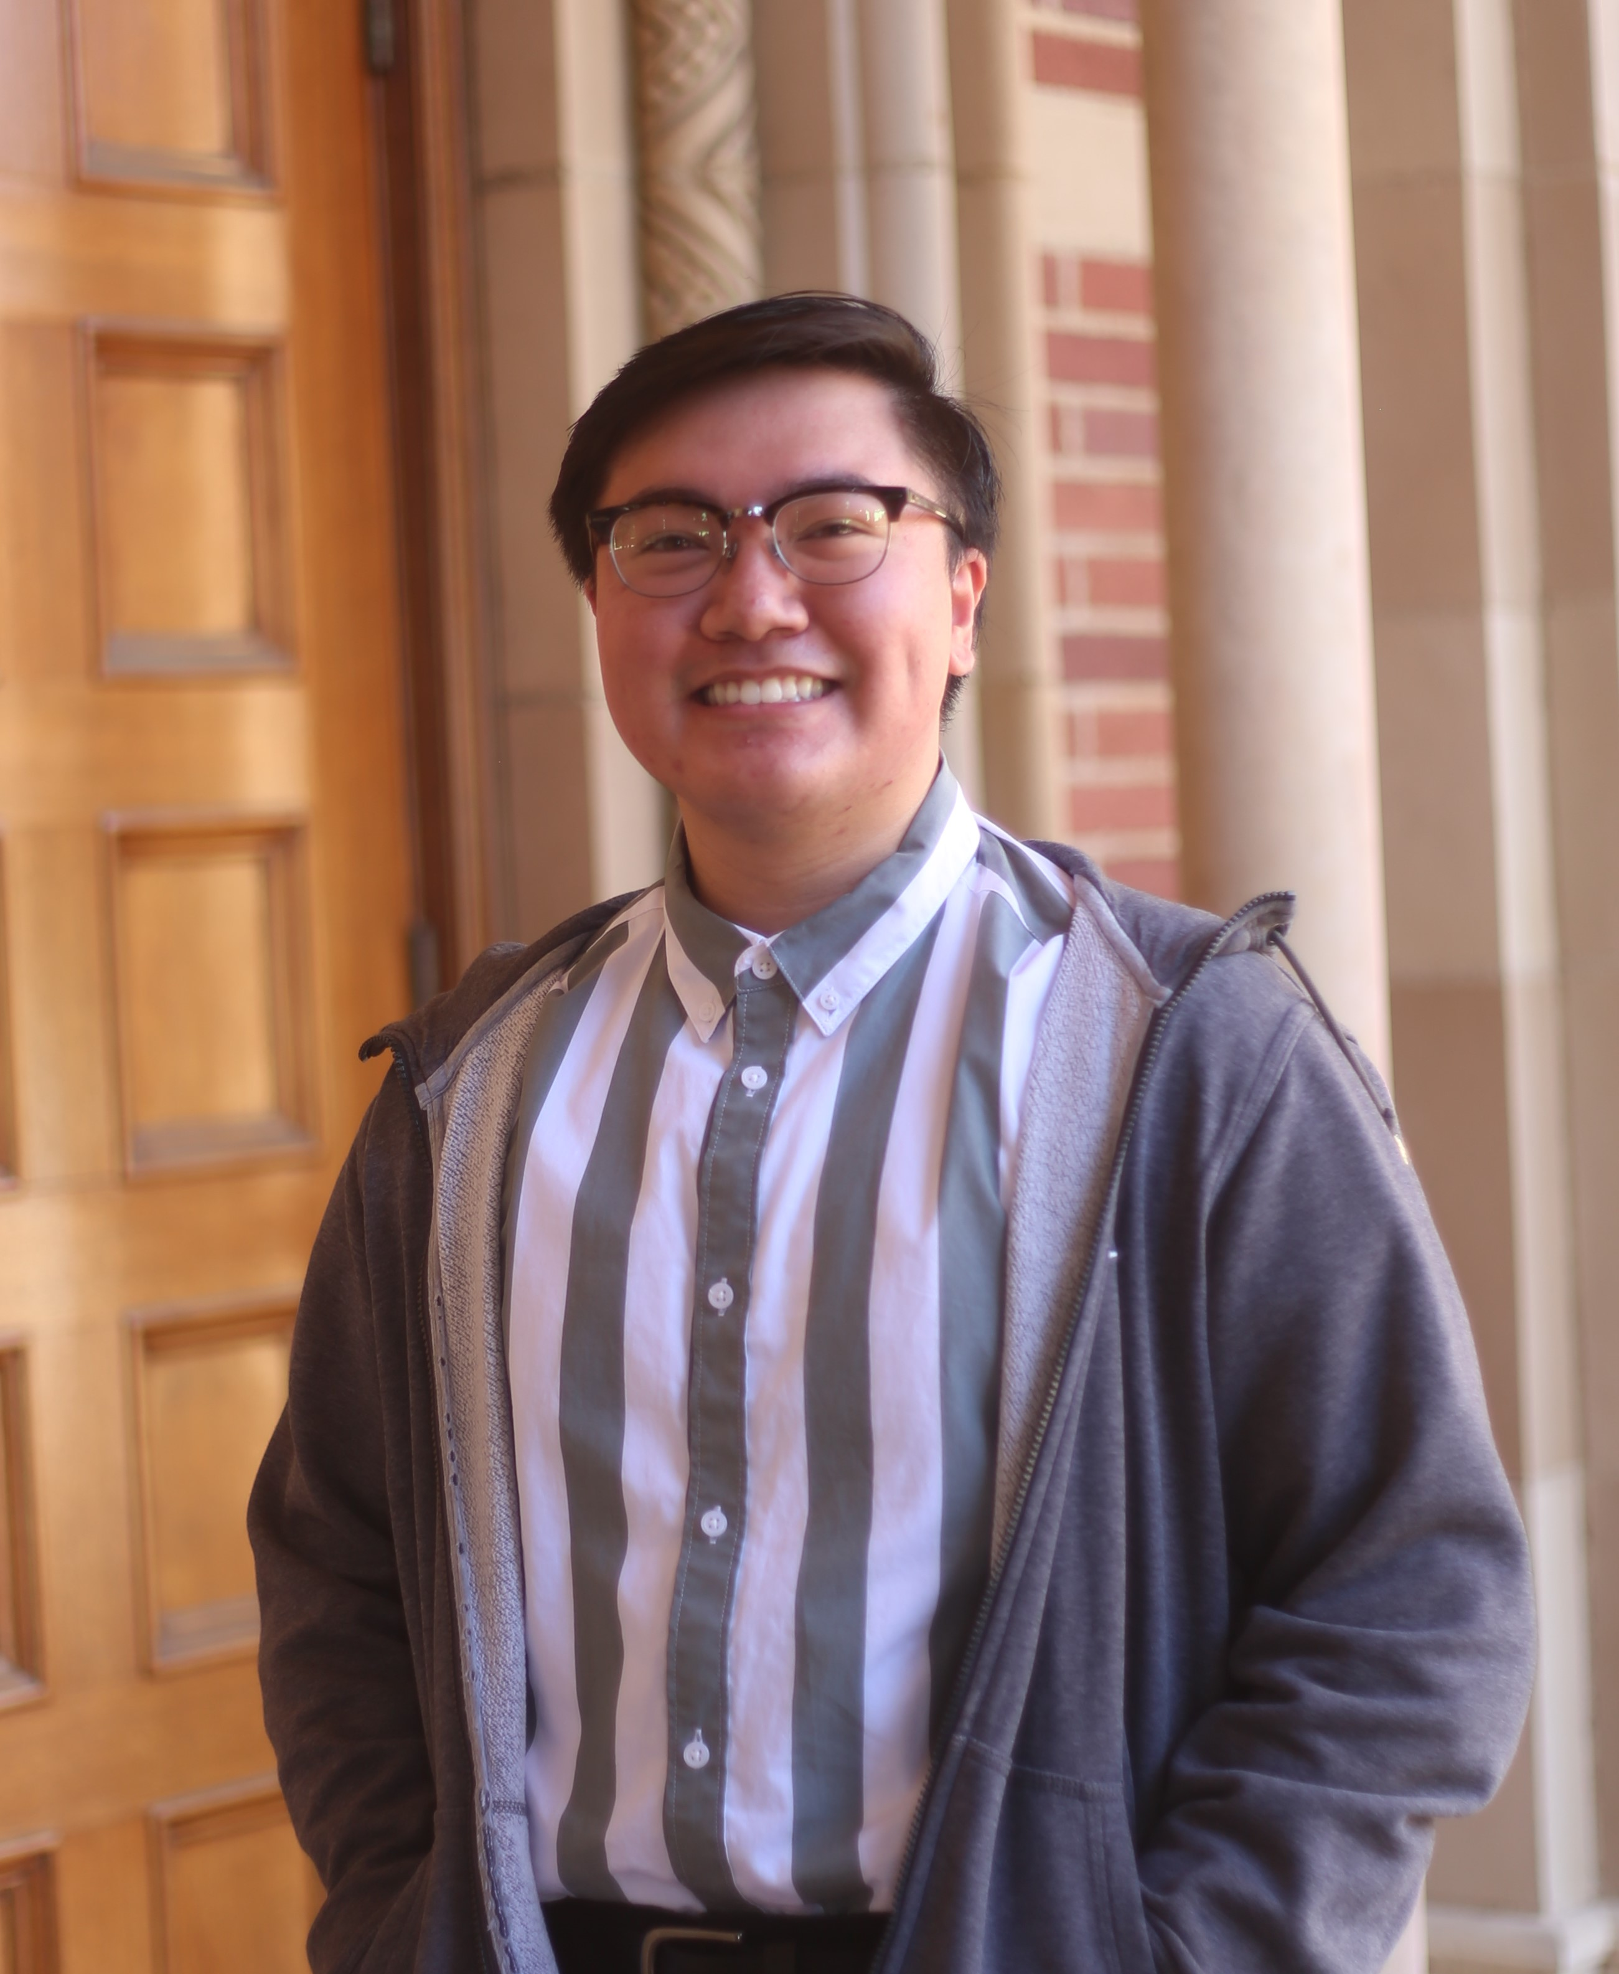
Melvin J Reputana
Shengze Xu
A Comparative Analysis Between Arthrobacter and Microbacterium Phages Reveals Their Close Genomic Relationships
Zoë Finch, Samantha Padilla, Melvin J Reputana, Shengze Xu, Juliet C Stephenson, Michelle Zorawik, Krisanavane Reddi, Amanda C Freise, Tejas Bouklas
Bacteriophages (phages) are viruses that infect bacteria and are defined by high diversity and abundance. Such diversity allows phages to adapt to different niches and infect a variety of bacterial hosts, including Microbacteria and Arthrobacter. Sequenced phages are grouped into clusters based on 35% gene content similarity, but the current range of phage clusters unveils the continuum of phage genomic diversity. Closely related phages within the same species often show genome mosaics, or alternating sequences of high similarity with phage-specific genes. This was only recently shown in Arthrobacter phages in the novel cluster AZ that showed close functional relationships with Microbacterium phages. Since little is known about such inter-host genomic relationships, it is necessary to delineate the diversity and evolutionary relationships of phages of related hosts. In order to expand on what is known of the evolutionary relationship of Microbacterium and Arthrobacter phages, several clusters were analyzed in this study to elucidate their evolutionary distance, sequence homology, gene content similarity, functional synteny, and evolutionary relationships, using various bioinformatic tools. Microbacterium cluster EE was found to have gene content similarities and functional synteny with Arthrobacter clusters AX, AN, and FE, but not for other Microbacterium clusters EM, EK, and GE, which supports our hypothesis that genome conservation was found between certain Microbacterium and Arthrobacter clusters. The inter-host similarity observed in this study provides a deeper understanding of the continuum of phage relationships between different hosts. However, the lack of nucleotide and amino acid similarity amidst gene content similarity and functional synteny highlights the complexity of phage evolution and gene transfer mechanisms, emphasizing how phage isolation efforts should continue to be expanded to further characterize this.

