DO NOT CONSIDER FOR TALK
2023 SEA Symposium Abstract
Coastal Carolina University
Conway SC
Corresponding Faculty Member: Daniel Williams (dwilliams@coastal.edu)
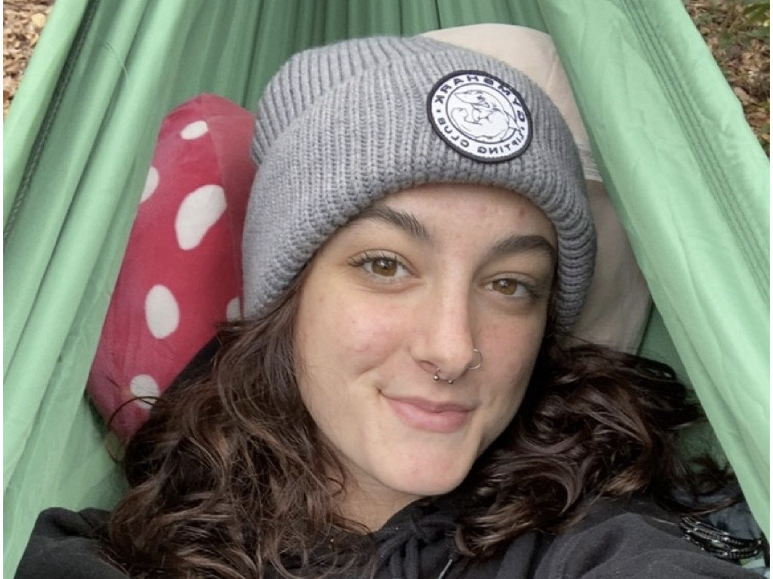
Emily Bishop
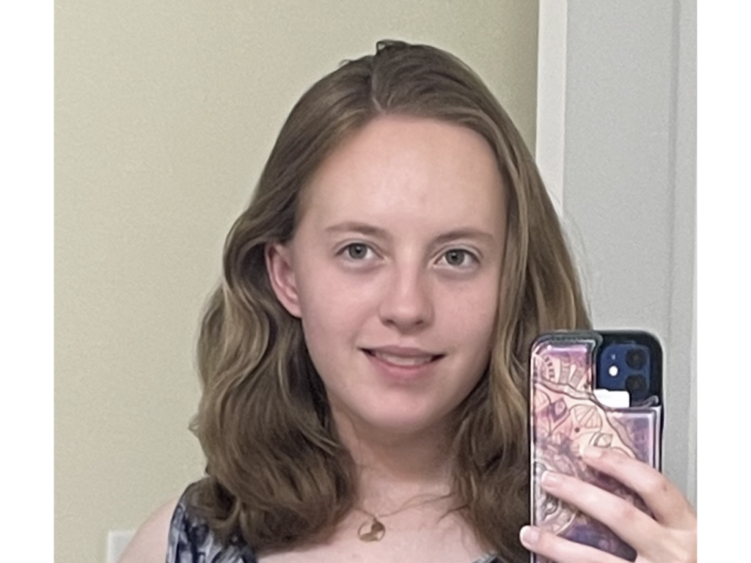
Alexandra Greco
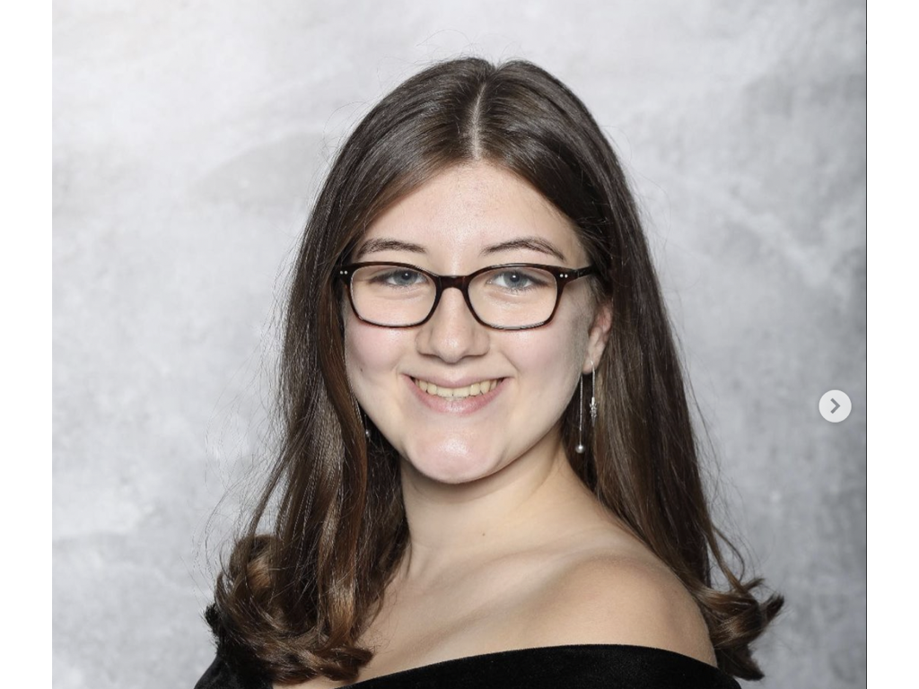
Emma Hofseth
Discovery and Characterization of Three Phages at Coastal Carolina University
Emily Bishop, Alexandra Greco, Emma Hofseth, Brandon Lafayette, Daniel C Williams
There is an increasing number of infectious bacteria that are evolving to become antibiotic resistant, which gives rise to prevalent medical issues. Thus, new approaches must be developed to treat antibiotic resistance diseases. Bacteriophages are abundant and robust viruses that infect bacteria. Because they specifically infect and kill bacteria, phages represent potential alternatives for antibiotic treatments. As part of Phage Discovery, a research-based lab at Coastal Carolina University, we isolated phages from individually collected soil samples found on and around campus in Conway, South Carolina. Throughout the semester, we isolated, purified, and amplified three phages that infect Mycobacterium smegmatis: Phayeta, GrecoEtereo, Clementines. Using the plaque assay technique, we observed these three phages produced distinct plaque morphologies, suggesting they belong to different clusters. Subsequent electron microscopy of these phages indicated Clemetine and GrecoEtereo have similar tail length, while Phayeta has a longer and more flexible tail. Both Phayeta and GrecoEtereo were sequenced, which demonstrated they belong to distinct clusters; Phayeta is a B3 phage and GrecoEtereo is an A1 phage. We are currently in the process of annotating their genomes using multiple bioinformatic platforms that include the Actinobacteriophage Database, GeneMark, DNA Master, and Phamerator. Collectively this analysis will result in the identification and functional assignment of all genes within the genome of our discovered phages. Ultimately, our work will contribute to a deeper understanding of phage biology and may give rise to tools for phage therapy treatments.

