DO NOT CONSIDER FOR TALK
2023 SEA Symposium Abstract
Saint Leo University
Saint Leo FL
Corresponding Faculty Member: Iain Duffy (iain.duffy@saintleo.edu)
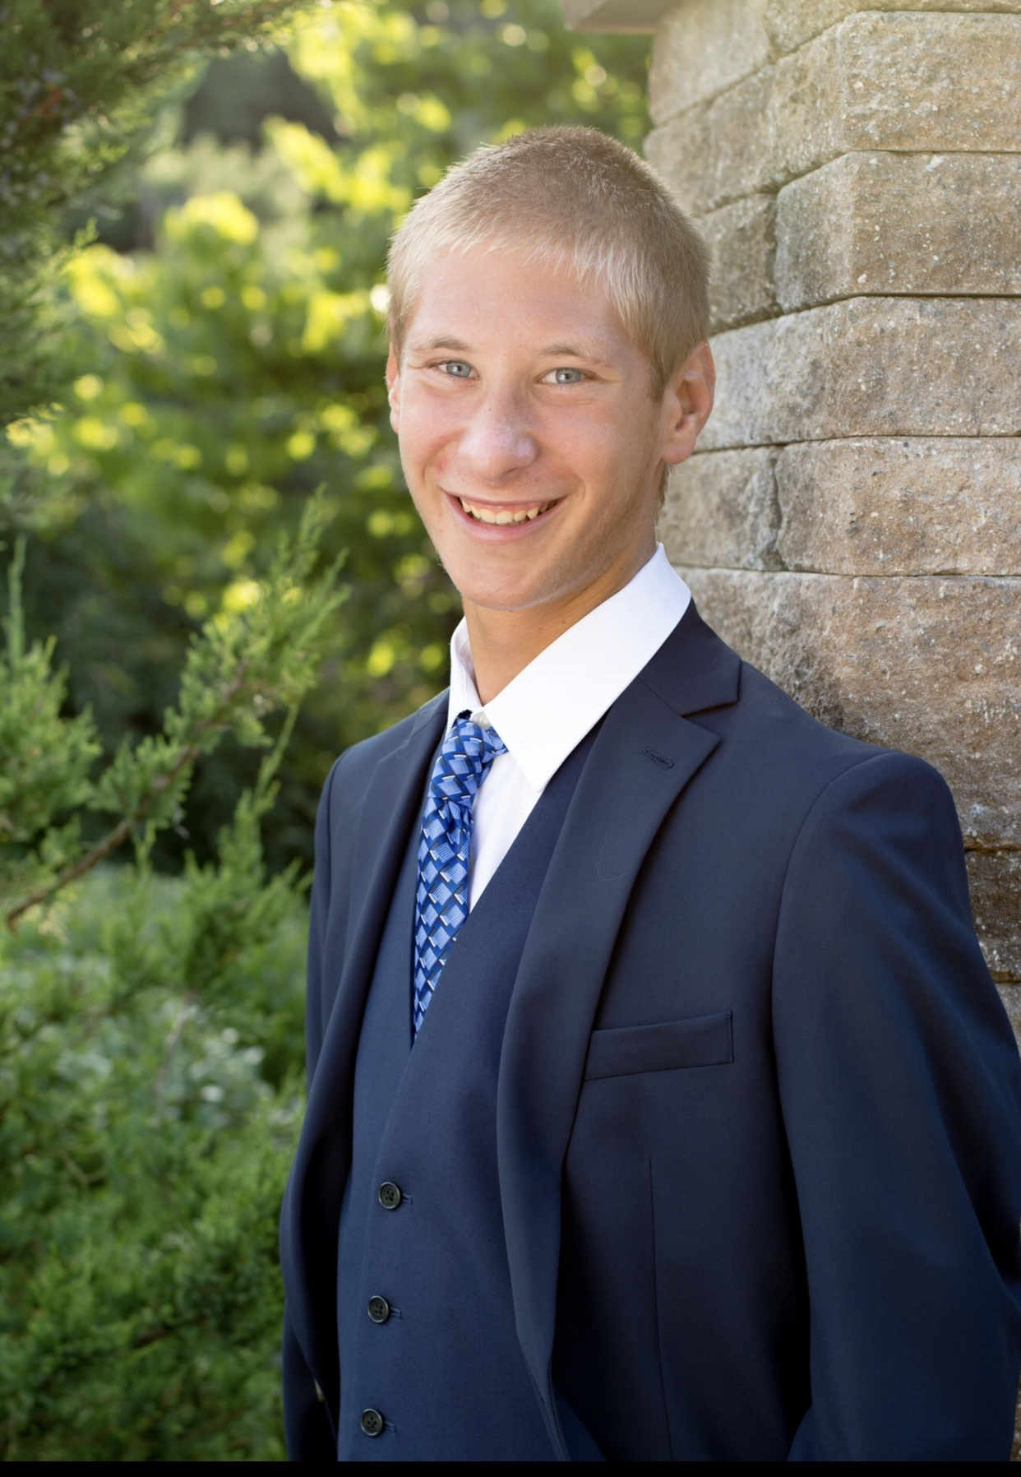
Mitchell E LaForge
How many cytotoxicity tests does it take to get to the center of the TootsiePop phage?
Mitchell E LaForge, Ashliegh S Ellis
Saint Leo University began its work in the SEA GENES program in 2021 as part of the third cohort of the HHMI SEA-GENES program. The second generation of Saint Leo University students are continuing work on the F1 cluster phage TootsiePop. TootsiePop was discovered at Worcester Polytechnic Institute in 2016, and its genome annotation was completed in 2017. It is a 93 gene phage with functions assigned to only 30 [32%] of those genes. This research involved cloning those genes into pExTra plasmid before expressing those genes in the original phage host, Mycobacterium smegmatis. Any genes identified as having a potential cytotoxic effect on the host bacterium will then be assigned to be sub-cloned into a second plasmid, p2Hα, to identify its biochemical interactions within the bacterium. Here, we present our research to date, from the effortlessly cloned genes to the more arduous cytotoxicity assays. We discuss those genes we designate as cytotoxic and those genes deemed worthy of further exploration.

