DO NOT CONSIDER FOR TALK
2023 SEA Symposium Abstract
Saint Leo University
Saint Leo FL
Corresponding Faculty Member: Iain Duffy (iain.duffy@saintleo.edu)
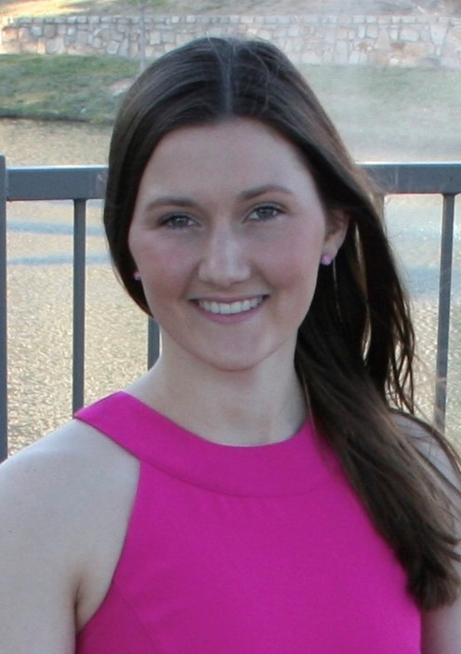
Hannah M Evers
Phages Unveiled: An Investigation into the Diversity of Newly Discovered Saint Leo Actinobacteriophages
Hannah M Evers, Gregory L Connelly, Ebony A Rolle, Briana D Pratt, Jeshua J Stephens
Saint Leo University has been a member of the SEA-PHAGES program since 2018. From the date of the university’s induction into the program to the present day, the students have successfully isolated over 70 bacteriophages from soil samples using Microbacterium foliorum as the host. Of the 70 bacteriophages that have been isolated, 10 have been sequenced; leading to 8 being annotated by students. Upon further exploration of the isolated bacteriophages, the most common distinct clusters sequenced include EB, EE, EK, and EF clustered phages. Despite being grouped by genomic similarity, all sequenced bacteriophages discovered at Saint Leo University express vast differences not only between differing clusters, but within each respective cluster as well. This research denotes the significant diversity using comparative analysis techniques including a genome-wide comparison through annotations, investigation of host specificity, examination of restriction enzyme digestion, and evaluation of plaque morphology. This research has received support from Saint Leo University, the HHMI Science Education Alliance-Phage Hunters Advancing Genomics and Evolutionary Science program, the Hatfull Laboratory at the University of Pittsburgh, the ARS Culture Collection (NRRL), and the Transmission Electron Microscopy Facility at the University of South Florida.

