CONSIDER FOR TALK
8th Annual SEA-PHAGES Symposium Abstract
University of Kansas
Lawrence KS
Corresponding Faculty Member: Rob Ward (rew130@case.edu)
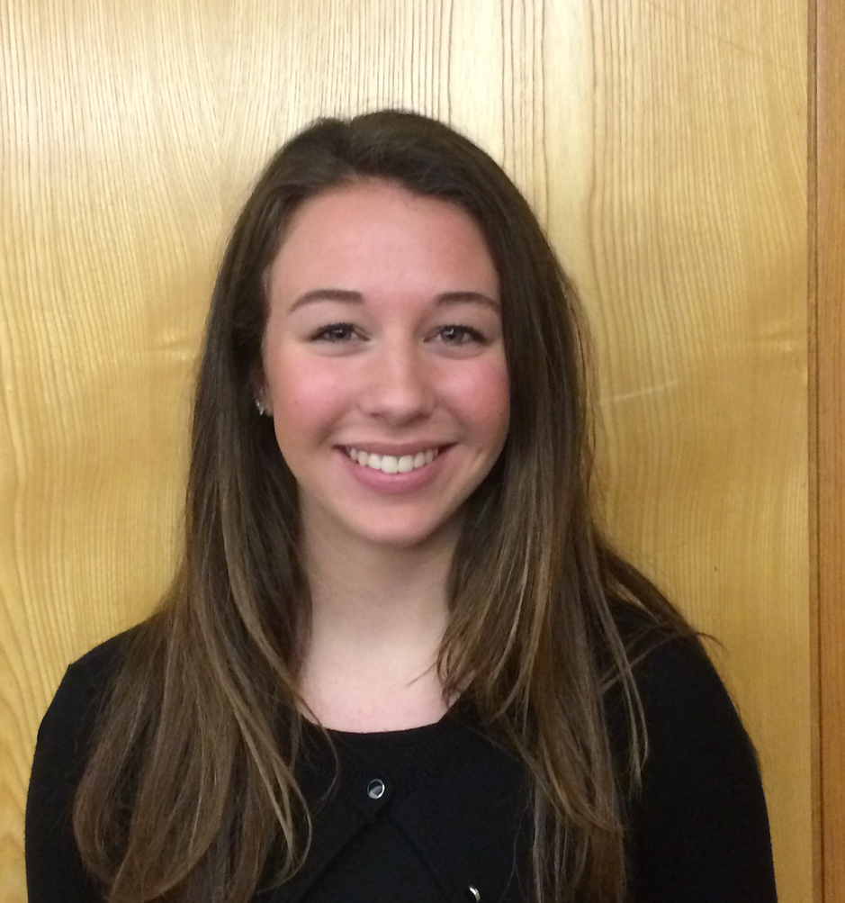
Chloe Ortbals
Avery Roe
Isolation and characterization, including host range, immunity, excision and potential splicing in the lysogenic J-cluster mycobacteriophage HokkenD
Chloe Ortbals, Avery Roe, Letty Beltran, Dane Brunner, Gabriel Church, Camille Claro, Madison Cline, Haley Flickinger, Rachel Hammond, Amanda Harra, Aletha Loeb, Meagan Murray, Erin Rigdon, Amira Rin, Aubrie Stricker, Lindsay Ussher, Erin Suderman , Robert Ward
During the 2015–16 academic year, the University of Kansas SEA-PHAGES class isolated and characterized 14 unique bacteriophages capable of infecting the soil bacterium Mycobacterium smegmatis. The University of Pittsburg sequenced the genomes of three of these phages for annotation and further study. One of these phages, HokkenD, is a lysogenic phage that belongs to cluster J mycobacteriophages. Altogether, HokkenD encodes 246 potential protein-coding genes and one tRNA (glycine). Interestingly, the GC content of HokkenD is 60.8%, whereas the GC content of Mycobacterium smegmatis is 67.4% indicating that M. smeg is unlikely to be the natural host of HokkenD, or any other J cluster phages, all of which have similar GC content to HokkenD. We reasoned that any of the J cluster phages may retain genome signatures of its host and so used BLAST to compare the genomes of four different J cluster phages against the microbial database. The bacterial genera that were most representative in the top 100 hits were Nocardia and Xanthobacter. We therefore obtained Nocardia and Xanthobacter species from NRRL and ATCC and tested whether HokkenD, three other J cluster phages, an A cluster phage, a B cluster phage, a C cluster phage or an F cluster phage could infect them. Whereas all of these phages were capable of infecting M. smeg, none of them could infect Nocardia or Xanthobacter. We generated a HokkenD lysogen bacterial strain and tested the same set of bacteriophages to investigate its immunity. We found that the HokkenD lysogen is immune to HokkenD, Baka and Courthouse (all J cluster phages), but not the J cluster phage Thibault, or any of the other phages. We also tested several conditions that have been shown previously to excise phage from a lysogen. We found that UV irradiation (at 1,200 and 6,000 kJ) and higher temperatures (43°C) were not capable of excising the phage, but 50μg/ml Ampicillin and 0.5μg/ml Ciprofloxacin were able to excise HokkenD from the lysogen. Finally, we found that the minor tail protein of HokkenD was divided into two gene products with a space of 287 bp. This same gene was found to have an intron in the related phage Baka, and to be encoded by one continuous gene sequence in Thibault. We therefore designed primers that would amplify an ~1000 bp fragment spanning the intron in the genomic DNA of Baka (and of HokkenD), but only ~750 bp in Thibault. After confirming these results, we infected M. smeg with each phage for two hours, isolated RNA from the infected bacteria, generated cDNAs from these samples and used PCR to investigate the size of the transcribed genes. Although the size of the fragment in Baka and Thibault was ~750 bp consistent with the splicing of exonic sequences in Baka, we were unable to obtain a PCR product in HokkenD. To distinguish whether cDNA was made properly from the HokkenD infection we are designing new primers to amplify other HokkenD genes from the cDNA.

