DO NOT CONSIDER FOR TALK
2023 SEA Symposium Abstract
University of Puerto Rico at Cayey
Cayey PR
Corresponding Faculty Member: Edwin Vazquez (edwin.vazquez4@upr.edu)
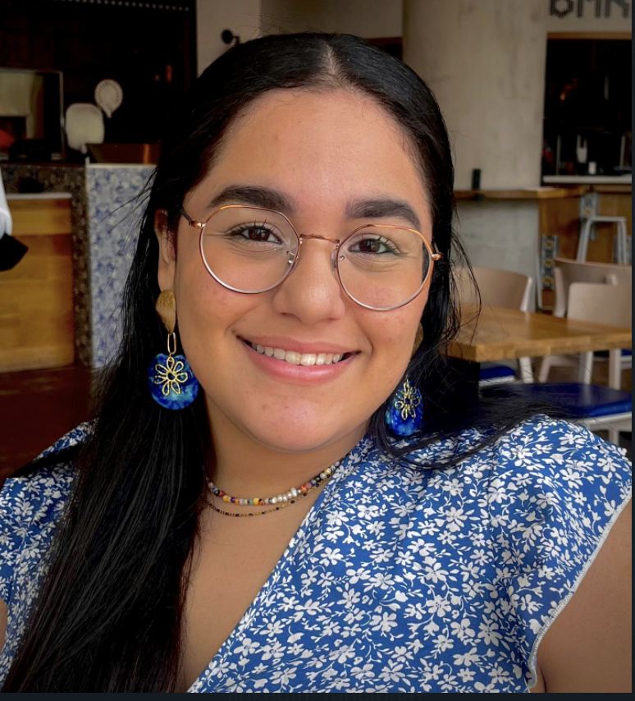
Paola Díaz-Batista
Genomic Comparison of Novel Microbacterium foliorum Bacteriophages Isolated from Tropical Soils in Puerto Rico
Paola Díaz-Batista, Edwin Vázquez
Puerto Rico is a small island in the Caribbean (approximately 100 x 35 miles) that exhibits a rich diversity of ecosystems, such as salt marshes, bioluminescent bays, a karst region, a rainforest, and a dry forest, among others. This makes the island an ideal place to study bacteriophages since these life forms represent one of the most diverse and vast populations in the planet. This diversity is reflected at the microbial level by the different phages isolated from bacterial hosts Mycobacterium smegmatis, Gordonia terrae, and Microbacterium foliorum. Here we report on a genomic comparison of five M. foliorum phages, two from cluster EH (Mabodamaca and Cen1621), two from cluster EA (Juanyo and Zayuliv), and one from cluster EJ (Zanella). We compared their genomes based on synteny, genomic size, GC content, number of open reading frames, and other criteria. As expected, in terms of synteny phages Zayuliv and Juanyo showed a close relationship since they belong to the same cluster, as was the case between Mabodamaca and Cen1621. No synteny was observed amongst phages from different clusters, but genome size and GC content were fairly similar between the five bacteriophages. Based on the results, an evolutionary relationship can be established, but it’s highly probable that they diverged as a response to a rich ecosystem which could explain the similar genomic architectures but diverse compositions.

