DO NOT CONSIDER FOR TALK
2023 SEA Symposium Abstract
Xavier University of Louisiana
New Orleans LA
Corresponding Faculty Member: Harris McFerrin (hmcferri@xula.edu)
Ahmed J Dahlia
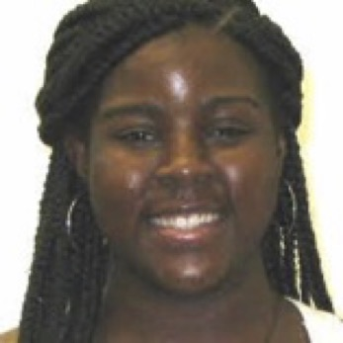
Justice D Austin
Baker M Classie
Kennedy A Drake
Genomic characterization of Microbacterium bacteriophage Babydotz
Ahmed J Dahlia, Justice D Austin, Baker M Classie, Kennedy A Drake, Skyler J Brown, Kaionah L Cooper, Liyah D Galbert, Jillian G Harris, Nora I Herrera, Gerald A Jones, Michael K Khalil, Camerin E Kimble, Alicia J Lewis, Shaundessy A Perry, Leianna M Yancey
The study of bacteriophages, or viruses that infect bacteria, is essential for understanding the interactions between viruses and their hosts and may also be useful for the development of novel therapeutic strategies against bacterial infections. In this context, the present study aims to annotate the genes of the Microbacteriophage Babydotz, providing insights into its genetic makeup and potential applications. BabyDotz was discovered by Ethan Dotzler and Jonathan Nyandu Kanyinda in 2020 at the Minnesota State University Moorhead. It is in the Siphoviridae family having an icosahedral head and tail morphology, is a lytic phage and has a genome length of 63706 base pairs with 105 genes identified by autoannotation. Further annotation of the Babydotz bacteriophage genes will increase our knowledge of its biology and that of other EG cluster phages.

