DO NOT CONSIDER FOR TALK
2023 SEA Symposium Abstract
Virginia Tech
Blacksburg VA
Corresponding Faculty Member: Stephanie Voshell (svoshell@vt.edu)
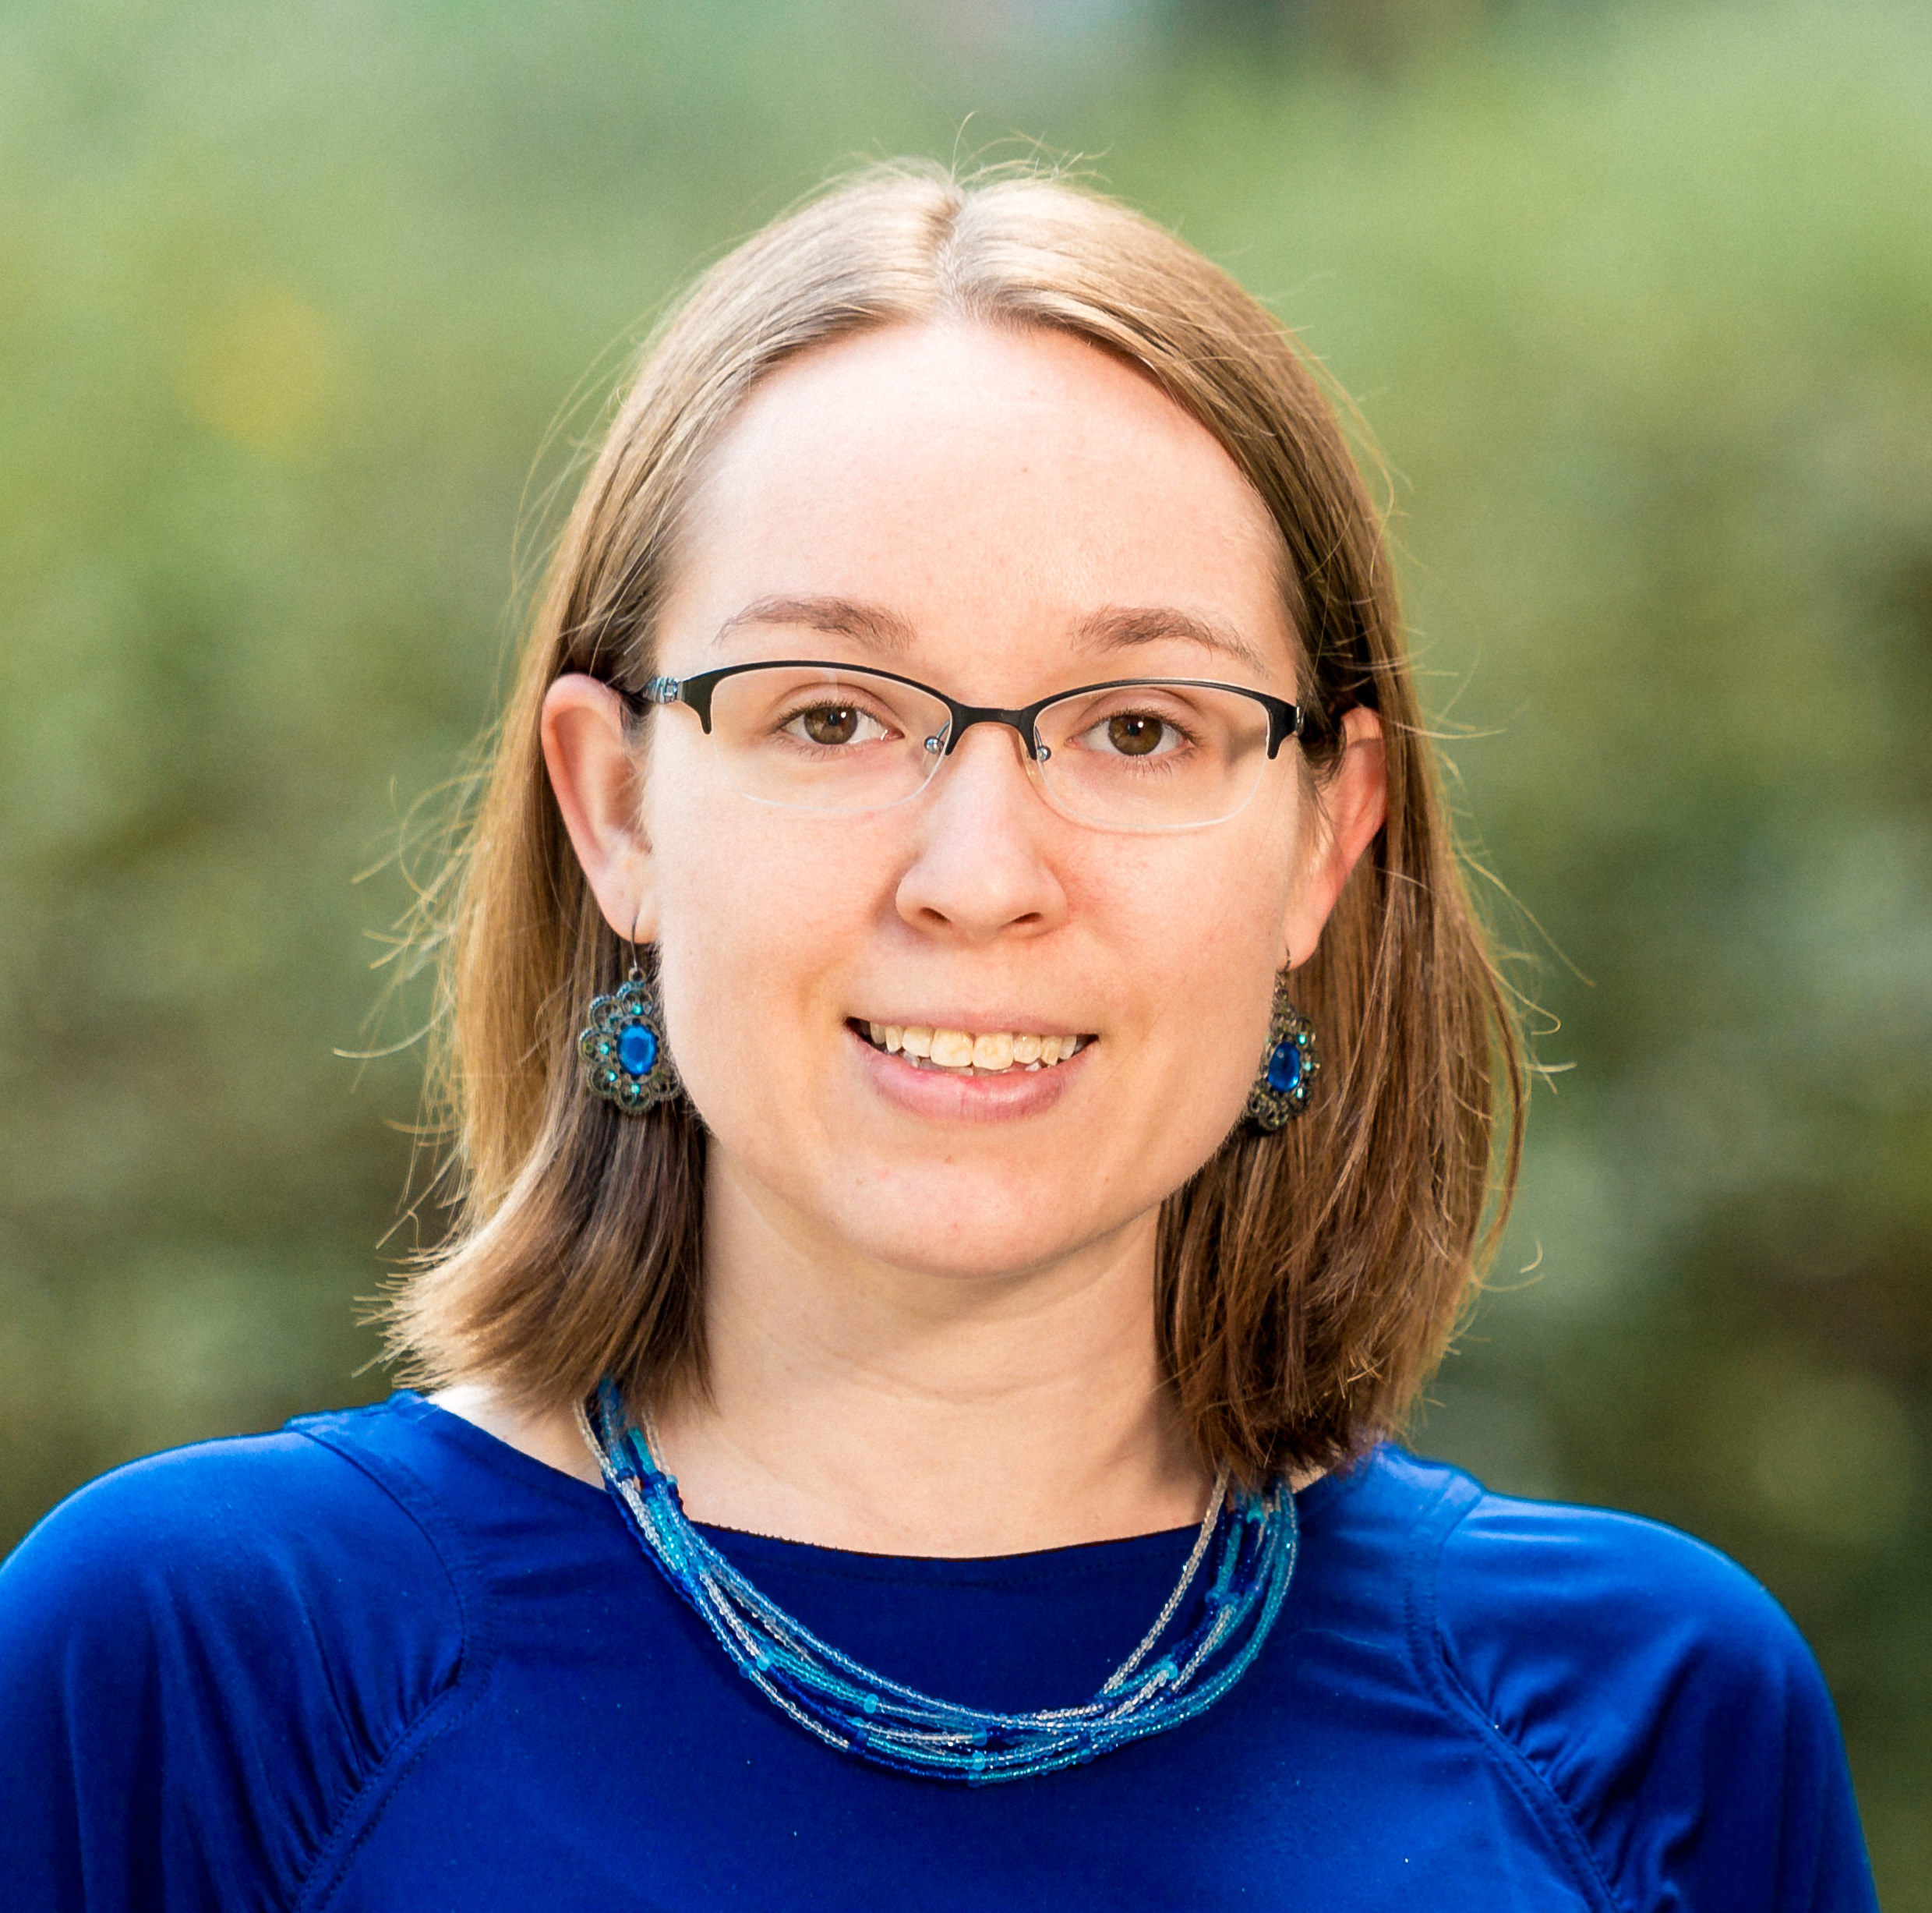
Stephanie M Voshell
SlimJimmy: A unique addition to the M1 subcluster of Mycobacteriophages
Stephanie M Voshell, Kofi Asiedu-Agyei, Michael B Bradley, Madeline J Brown, Paige C Chenoweth, Tessa M Dickens, Wenhao Fu, Sayzana Gebreselassie, Lindsey M Goad, Hannah M Hille, Yifeng Huang, Naya D Hunter, Quinton D Jackson, Kayvon Jafarzadeh, Diego Jaques, Davis P Kubovcik, Paige Kramer, Victoria Le, Annmarie C Leake, Joshua S Lovejoy, Jack Maloney, Evan J Miller, Thea Z Mills, Douglas K Miln, Caleb M Mincheff, Carter S Mondy, Uraius B Obey, Ella J Pommett, Megan Prochaska, Baylee A Rainer, Anthony T Roach, Alex J Rosser, Emma Szymanowski, Abigail M Smith, Bridget S Spruill, Kassidy L Taylor, Joshua W White, Zhenyuan Wu, Zhenfan Zhao
SlimJimmy, a novel mycobacteriophage, was discovered in local soil and annotated by students in the SEA-PHAGES program at Virginia Tech during the 2022-2023 academic year. The class was unable to formulate a subcluster hypothesis for SlimJimmy during the discovery portion of the course, but sequencing revealed the phage to be a member of the M1 subcluster. Numerous adjustments to the original auto-annotation were required. SlimJimmy contains several regions in the genome that differ significantly from those of the closest relatives. Like other M1 phages, SlimJimmy contains a considerable number of tRNA genes.

