CONSIDER FOR TALK
2023 SEA Symposium Abstract
University of California, Los Angeles
Los Angeles CA
Corresponding Faculty Member: Amanda Freise (afreise@ucla.edu)
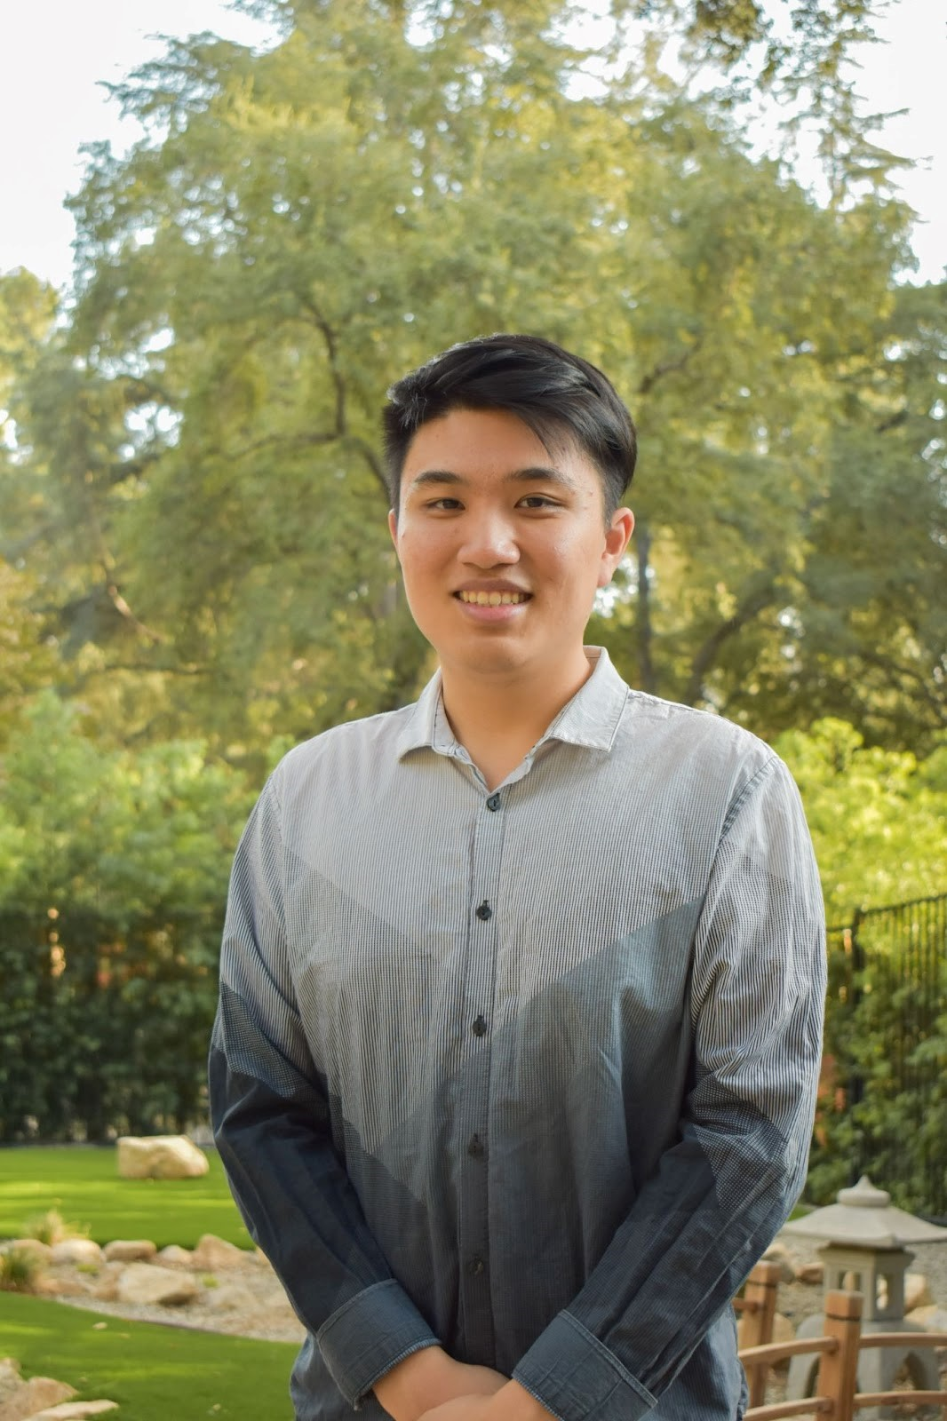
Angus Wu
Efficient and Accessible Analysis of Phage Genomes with Helper Functions: A Web-Based Suite of Tools
Angus Wu, Tejas Bouklas, Amanda C Freise
Bacteriophages, or simply phages, are ubiquitous and genetically diverse viruses that infect bacteria. With the SEA-PHAGES program sequencing and annotating hundreds of phage genomes annually, phages have garnered increased attention due to the expanding volume of genomics data that is becoming available. The sheer volume of data presents both an opportunity and a challenge to researchers seeking to generate novel biological insights through genomic and bioinformatic analyses. Here, we present Helper Functions, a user-friendly suite of tools to provide additional capabilities to analyze phage genomes. The suite includes tools to quickly generate large scale Gene Content Similarity heatmaps, compile full genome amino acid sequences, and visualize codon usage biases. Additionally, Helper Functions requires no software installation but instead utilizes a web-based interactive environment with a graphical user interface, making it user-friendly and easily accessible from any browser-capable device. Unlike many existing tools that require extensive user compilation and generation of custom FASTA files or sequences, Helper Functions requires minimal user input, only requiring a list of phage names to be analyzed, and no other information or files. All necessary data is retrieved from the PhagesDB Application Programming Interface (API), a significant improvement in user experience and efficiency over manual compilation. Overall, our work provides a powerful new tool for phage genomics research in a simple, user-friendly manner.

