DO NOT CONSIDER FOR TALK
2023 SEA Symposium Abstract
Northwestern College
Orange City IA
Corresponding Faculty Member: Sara Tolsma (stolsma@nwciowa.edu)
Grace Anderson
Olivia Anderson
Clayton Bosma
Erin Brouwer
Kleyton DeGroot
Owen Hede
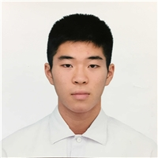
Daiki Jonouchi
Dylan Kirkeby
Jayron Klinghagen
Kate Kralik
Julia Kutz
Olivia Lott
Maegan Olsen
Victoria Pavik
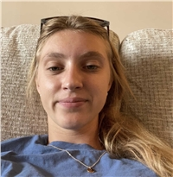
Cayli Penner
Leah Rozeboom
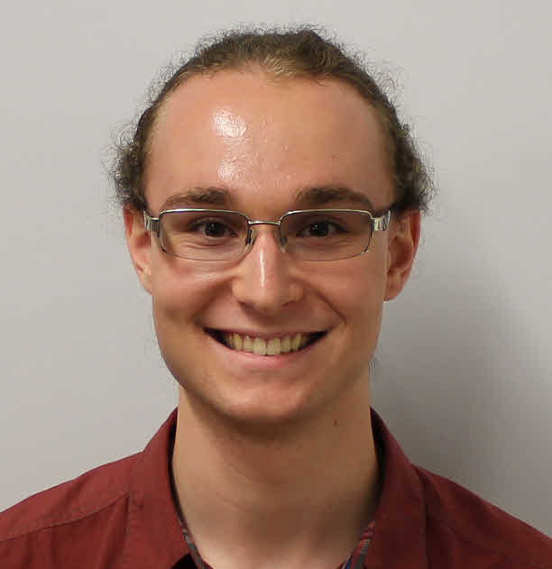
Jett Skrien
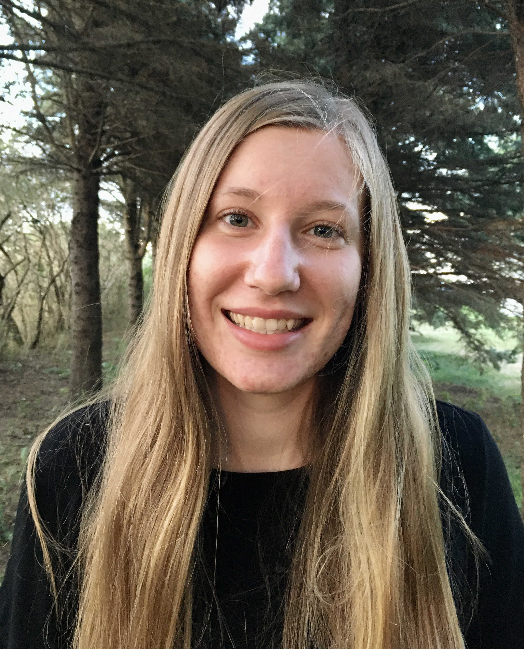
Jessica Slight
Jonas Tiensvold
Kyra Wajer
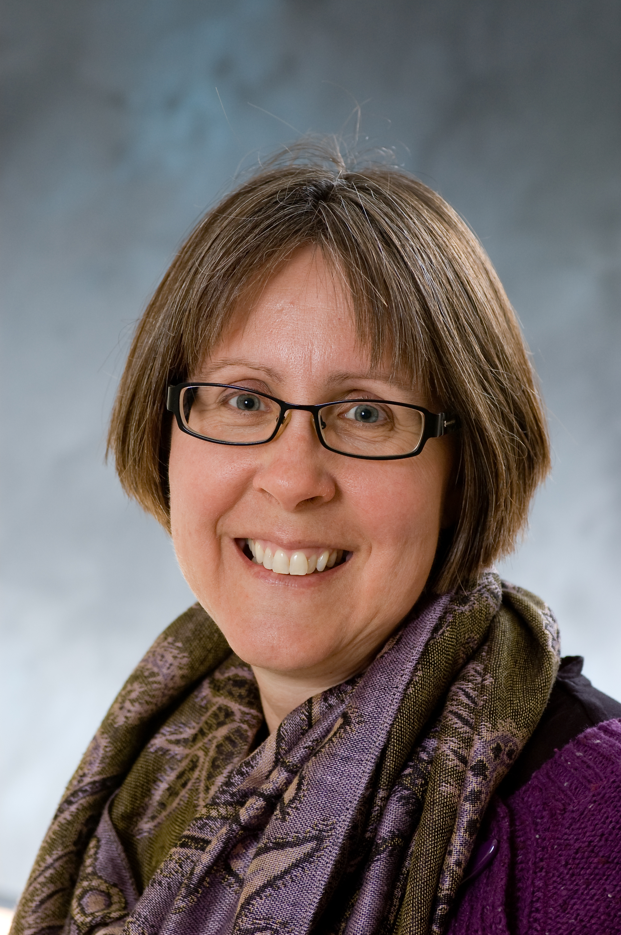
Sara S Tolsma
Discovery and Annotation of Two Phages that Infect Microbacterium foliorum: Tedro and BAjuniper
Grace Anderson, Olivia Anderson, Clayton Bosma, Erin Brouwer, Kleyton DeGroot, Owen Hede, Daiki Jonouchi, Dylan Kirkeby, Jayron Klinghagen, Kate Kralik, Julia Kutz, Olivia Lott, Maegan Olsen, Victoria Pavik, Cayli Penner, Leah Rozeboom, Jett Skrien, Jessica Slight, Jonas Tiensvold, Kyra Wajer, Byron Noordewier, Sara S Tolsma
We isolated and purified Tedro and BAjuniper which infect the host Microbacterium foliorium. Tedro is a lytic, cluster EF phage isolated from soil collected in Hawarden, Iowa. Its genome is 56,197 bp long, circularly permuted, and includes 83 protein-coding genes and no tRNA genes. We are examining two of Tedro’s genes, genes 56 and 57, both of which are predicted to encode a DnaE-like DNA polymerase III (alpha) in more detail. Tedro_57 is twice as large as Tedro_56 so we are using additional bioinformatic tools to understand these genes. BAjuniper was isolated from soil collected in a garden in Orange City, Iowa. Its genome is 41,985 bp long. It was assigned to cluster EB. BAjuniper’s genome includes one tRNA gene and we will finalize BAjuniper’s annotation shortly.

