DO NOT CONSIDER FOR TALK
2023 SEA Symposium Abstract
University of Maryland, Baltimore County
Baltimore MD
Corresponding Faculty Member: Steve Caruso (scaruso@umbc.edu)
Mukundh Anandkrishnan
Devon Baker
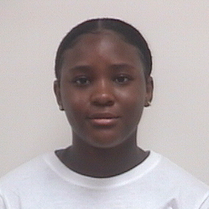
Kayla Fomengia
Julie Galo
Eden Neka
Anjali Sodhi
Isolation, Characterization, and Genome Annotation of the Novel Streptomyces Bacteriophage Patelgo
Mukundh Anandkrishnan, Devon Baker, Kayla Fomengia, Julie Galo, Eden Neka, Anjali Sodhi, Ivan Erill, Steven M Caruso
Bacteriophage Patelgo was isolated from a soil sample located in Catonsville, Maryland, and was purified using the Gram-positive bacterium Streptomyces mirabilis NRRL B-2400. Patelgo displays siphoviral morphology and has been assigned to the Actinobacteriophage Database subcluster BK1. The phage has a large linear genome of 130,302 base pairs with 712 base pair direct terminal repeats and encodes 242 protein-coding genes and 33 tRNAs. All BK1 cluster phages encode a large number of tRNAs, and it has been postulated that this provides the phage access to a wider variety of hosts and ensures a higher survivability rate. This model suggests that the phage provides the tRNAs necessary for the efficient translation of phage genes. Patelgo has a GC content of 47.17%, significantly lower than that of its isolation host, S. mirabilis, which has a GC content of 70%. Likely due to this misaligned GC content, Patelgo failed to show any coding potential when tested with GenMark.hmm trained on Streptomyces spp. This suggests that Patelgo may have recently gained the ability to infect this family of hosts. We hope to investigate a host with a higher coding potential that could implicate a more closely related bacterial host to Patelgo, as well as further investigate Patelgo's genome to more accurately determine its evolutionary history.

