DO NOT CONSIDER FOR TALK
2023 SEA Symposium Abstract
Lehigh University
Bethlehem PA
Corresponding Faculty Member: Margaret Kenna (makg@lehigh.edu)
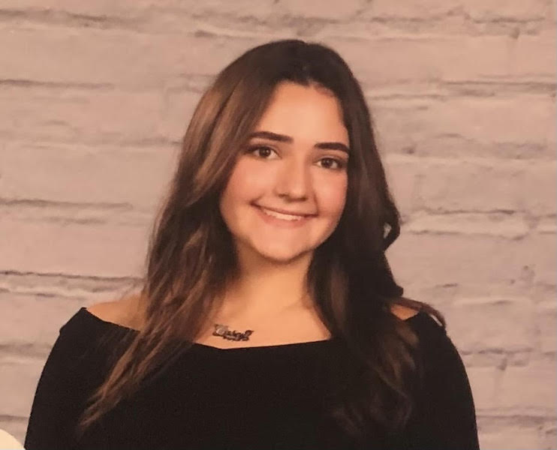
Casey Conboy
Investigating Mycobacteriophage Genomic Relationships and Immunity Patterns
Nina Bautista, Catherine Bigenho, Alice Chen, Casey Conboy, Mary-Evelina Cordova, Matthew Diaz, Lauren Hamamoto, Rachel Joh, Sam Jones, Brooke Lee, Kai-Lin Liang, Maeve McGowan, Mia Miranda, Lake Palmeri, Nikki Pasterczyk, Nader Rifai, Cal Shutack, Akari Takahashi, Stephen Mensah, Margaret Kenna, Vassie Ware
During the Spring and Fall of 2022, Lehigh University’s 16th consecutive SEA-Phages cohort discovered 18 new phages that infect Mycobacterium smegmatis and sequenced and annotated Phage Cullens (A3) and Phage BlueCrab (F). From a DOGEMS analysis, we identified Mycobacterium Phage Doughnut as a Cluster K2 phage by designing primers specific to sequences within one of the full length contigs. Phage Pescara, hypothesized to be a C1 cluster based on a myoviridae morphotype, was also identified as a complete sequence within this DOGEMS pool. Comparative genome analysis and functional annotation of Cullens and BlueCrab will be presented. Phages hypothesized to be temperate based on plaque characteristics were identified and putative lysogens were isolated using halo assays, supernatant release assays, and efficiency of lysogeny measurements. Immunity relationships were investigated using the 2022 purified phage lysates to uncover putative cluster relationships between phages and/or to identify phages impacted by prophage mediated defenses. BlueCrab and Cullens annotation data, combined with Immunity studies, helped inform hypotheses about cluster predictions of other phages in our DOGEMS pool.

