Phosphoribosyl transferase new function: Phelipe_64 and Bosnia_40.
Evidence and rational.
I. Phelipe_64 (pham 15631 as of 2-1-2022). All are cluster A phages except three cluster DU (example Neville_48).
A. HHPred analysis of Phelipe_64 (PDB, CDD, SMART_V6, TIGRFAMs_v15)
77 hits, 99%+ probability, coverage 75 -90% to individual hits (100% coverage using full range of hits), e-value range is 8.9e-13 to 4.8e-9. Hit functions are all some type of phosphoribosyl transferase: purine, Xanthine-Guanine-Hypoxanthine, adenine, Orotate (part of the de novo pyrimidine nucleotide synthesis pathway in M. tuberculosis).
Sample visualization:
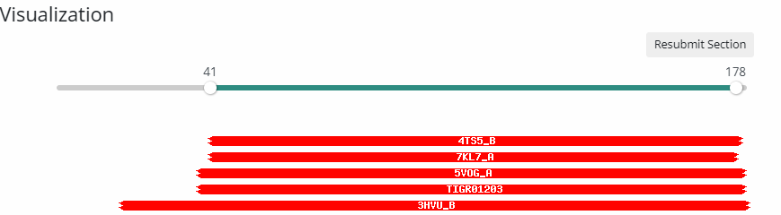

B. CDD analysis of Phelipe_64
Xanthine-Guanine-Hypoxanthine phosphoribosyl transferases (top TIGRFAMs hit TIGR01203) are part of the cI00309 PRTases_typeI Superfamily which include all types in the list of 77 HHPred hits:

C. Clustal Omega alignment of pham 15631 shows two highly conserved areas in all members: a short one at the beginning and a much longer one that overlaps with the phamerator “phosphoribosyl” domains.

D. NCBI Blast using Astro_75 (one of the three largest members of the pham) hits on the other “large” and “medium” PRT’s with the smaller ones scattered between large and medium or after medium. There are no hits to the slightly larger phosphoribosyl pyrophosphate transferase genes: example Archie_72.
II Bosnia_40 (Pham 55804 as of 2-1-2022).
A.HHPred and NCBI p-blast give very good hits to multiple phosphoribosyl transferase genes. Top 40 p-blast hit coverage range is 74-100% with large majority > 90%; e-value = 9e-34 to 6e-67.
B. Standalone CDD does not give any hits.
C. PhagesDB blast: only one decent hit which is the only other member of this pham: Vasanti_29, phosphoribosyltransferase, 249 Score = 125 bits (313), Expect = 1e-28, Identities = 85/254 (33%), Positives = 126/254 (49%), Gaps = 21/254 (8%);.

