PROBLEM: After installing Virtual Box on Windows, there is no “Ubuntu (64-bit)” option in the dropdown menu, only “Ubuntu (32-bit)”.

We switched the SEA Virtual Machine to be 64-bit this year, and this is a new problem that has arisen with the switch. There are two steps below that should fix this and allow you to select a 64-bit option for your VM installation. The first step can be done from within Windows fairly quickly. If that doesn’t work, the second step required entering your system’s BIOS, so we recommend trying the first one, then moving on to the second only if necessary.

Step 1: Change Hyper-V settings (easier fix)

- In Windows, open the “Turn Windows Features On of Off” window.
You can get there by either going to Start Control Panel Programs Turn Windows Features On/Off, or searching for “Windows Features”.
- Locate the Hyper-V checkboxes and make sure they are all UNCHECKED. See the screenshot below.

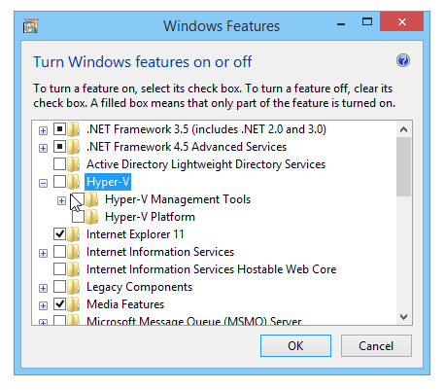

- Restart Virtual Box and see if the 64-bit option is enabled. If yes, yay! If not, go to Step 2. In either case, leave these unchecked.

Step 2: Enable Intel virtualization (more complicated fix)

- Enter your computer’s BIOS (Basic Input/Output System).

This may also be called UEFI. The ways to do this vary by manufacturer, but common ways to do this include holding down the Shift key then restarting the computer, or pressing the Fn or F2 key while the computer powers on. It always involves restarting and if you see a message like “Press F2 to enter setup” then do so! If you see Windows, you’re too late, just restart and try again.

If you’re having trouble, Google your computer’s make/model and BIOS. For example Google “Enter BIOS on HP Envy 17” and follow the instructions.

- In the BIOS/UEFI, you want to find some settings regarding Virtualization. These may be in a section called Security. The two settings you are looking for are called:
Intel (R) Virtualization Technology
Intel (R) VT-d Feature

Once you’ve located these, make sure they are both ENABLED.
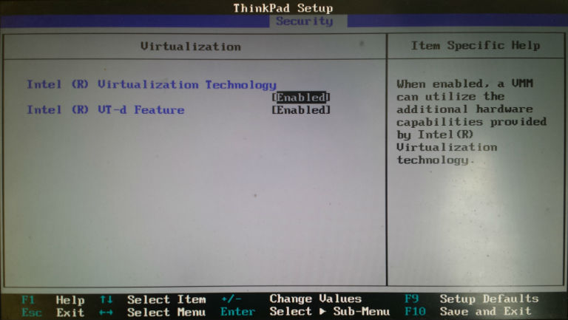

- Exit the BIOS and boot into Windows. Now Virtual Box will have an “Ubuntu (64-bit)” option in the dropdown menu.

