How to rearrange a Genome Annotation in DNA Master

Welkin Pope and Debbie Jacobs-Sera
June 24, 2016

This method allows you to change the underlying sequence in a DNA Master annotation file and automatically adjust the features that you have already annotated to reflect the new sequence. Sequence changes can include adding or deleting sequences at specific genome locations, or rearranging a circular genome to choose a new bp 1.

Open your DNA Master file. Recreate your documentation.
Then Go to Genome -> Rearrange.

Depending on what you want to do (insert or delete bp from your sequence or rearrange), use the appropriate tab.

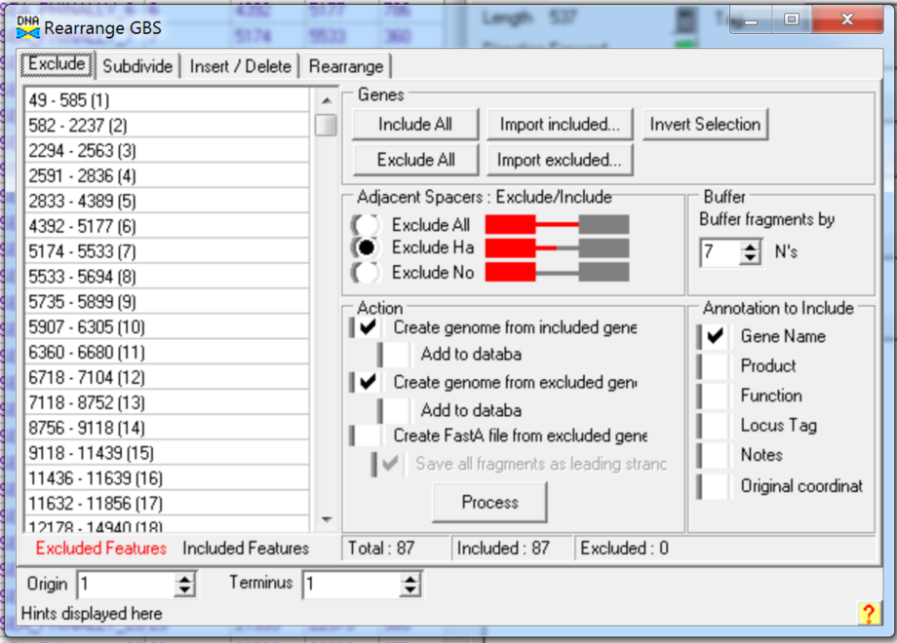

Remember to click the applicable boxes in the ‘annotation to include’ column. All of the items selected here will be written to the documentation of your new file.

A rearrangement example:

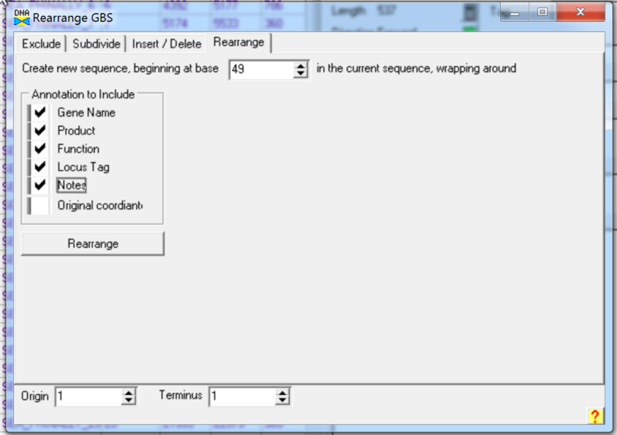

When you click rearrange, you will be asked to parse the corrected annotation information from your old genome onto your new sequence. NOTE: BLAST data does not parse, so your file will have to be reBLASTed.

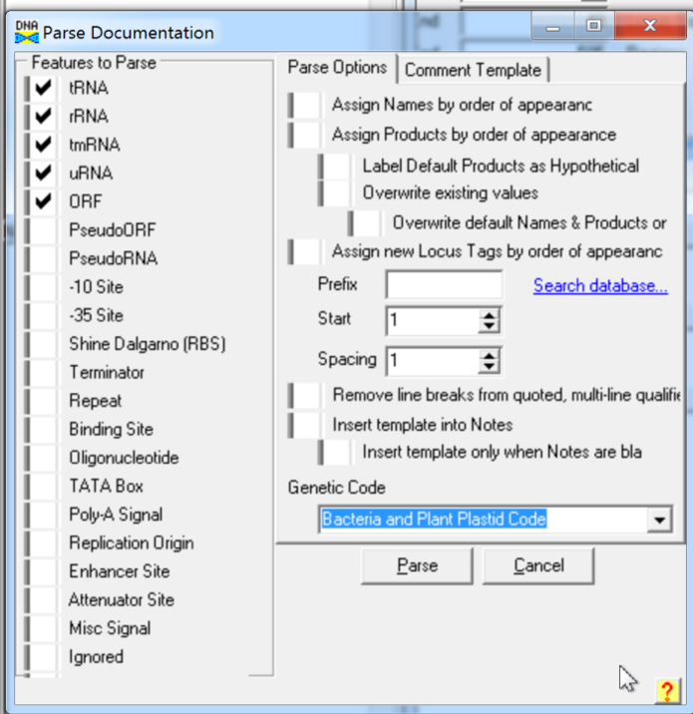

If you have added/deleted base pairs to the underlying sequence, you may want to click the “raw” button on the sequence tab, as that will post the sequence changes to the database.

When you have finished, check the end of your sequence to make sure that there is not ‘NN’s at the end of the genome sequence. If you do see ‘NN’s, delete them, and then click “raw”.

Save the file.

