2020 Phage Genomics Workshop
December 7-18, 2020

workshop attendees
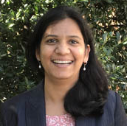 | Swati Agrawal  University of Mary Washington |  | 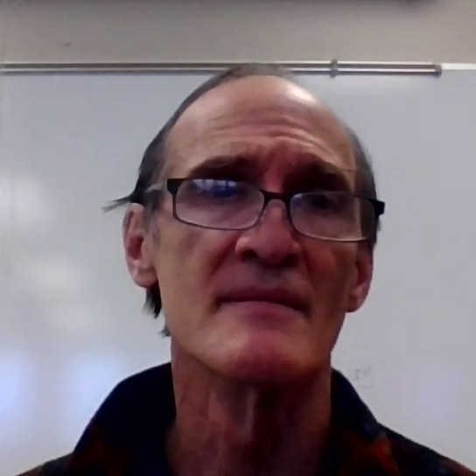 | Karel Pluhar  NHTI Concord’s Community College
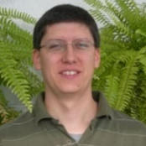 | David Puthoff  Frostburg State University |  |  | Leonidas Salichos  New York Institute of Technology
 | Ranalda Tsosie  Salish Kootenai College |  | 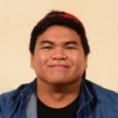 | Cyril Versoza  Arizona State University
 | Derek Warren  University of the Ozarks |  | 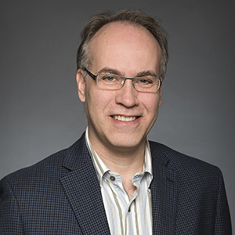 | Keith Wheaton  University of Ottawa
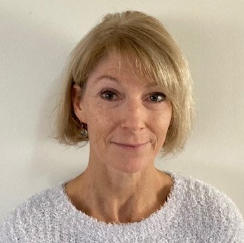 | Beth Wilkes  NHTI Concord’s Community College
workshop facilitators and support
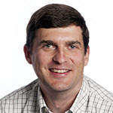 | Billy Biederman  HHMI |  | 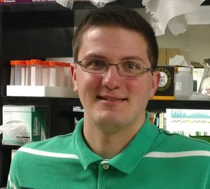 | Christian Gauthier  University of Pittsburgh
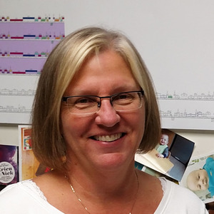 | Debbie Jacobs-Sera  University of Pittsburgh |  | 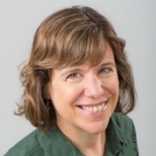 | Karen Klyczek  University of Wisconsin-River Falls
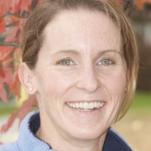 | Sally Molloy  University of Maine |  | 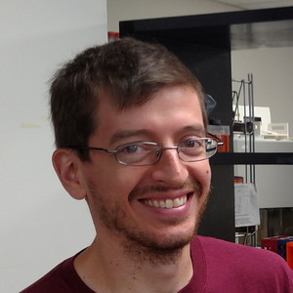 | Dan Russell  University of Pittsburgh
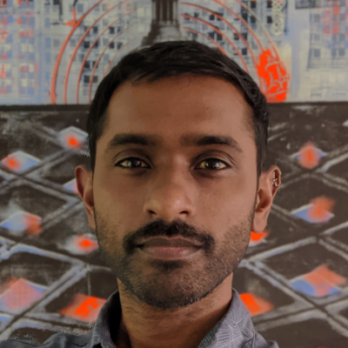 | Vic Sivanathan  HHMI

