How to Add DNA Master to your SEA Virtual Machine

This should be considered a beta test, since we haven’t really tested this at all, but if you’d like to give it a shot, instructions are below. If this goes well, this will be the default option for the 2016-17 academic year. Please document any issues on the appropriate forum:
http://seaphages.org/forums/topic/83/

- Make sure you have enough memory allocated to your SEA Virtual Machine
  - Open VirtualBox (but do not launch your SEA VM yet)
  - Single-click the SEA VM so it’s highlighted, but still says “Powered Off”, then click “Settings”.
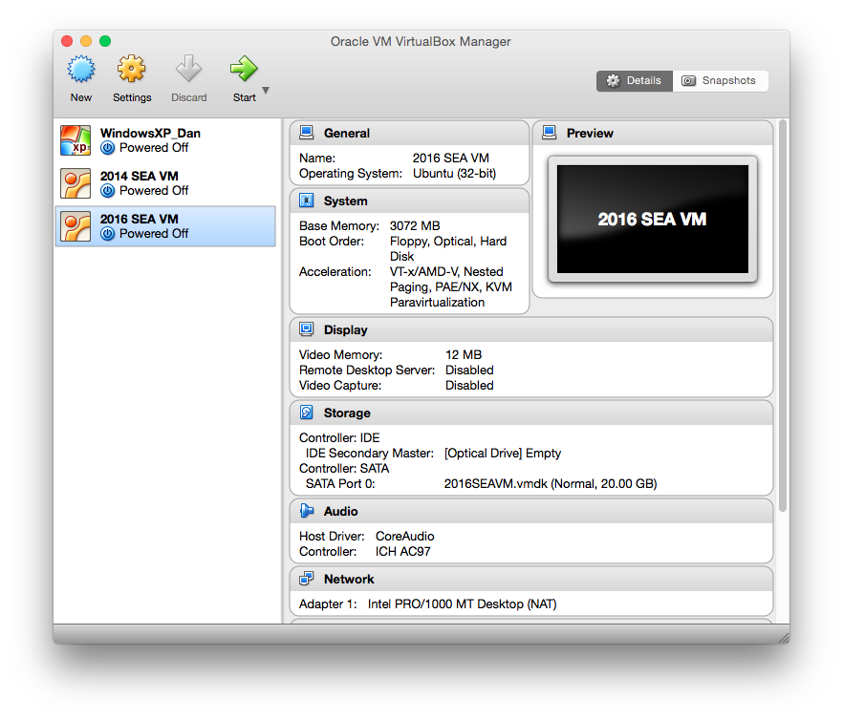
  - Select the “System” button. Check the “Base Memory” value. It should be at least 2048 MB (2 Gb). If you can afford the memory, you may want to raise it even higher, to 3 Gb (3072 MB) or 4 Gb (4096 MB).
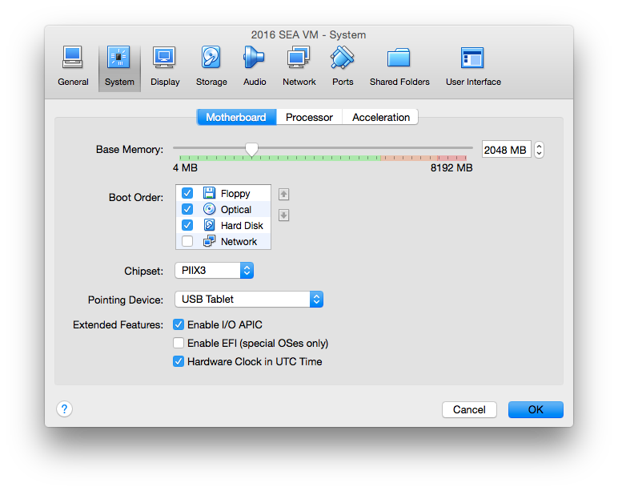
  - Click OK.

NOTE: Keep in mind that RAM allocated to your VM is not available to the rest of your computer while using the VM, so the higher the “Base Memory” value you choose, the less memory will be available to other programs. If you computer only has 2 Gb of RAM, we don’t recommend trying this approach at all.

- Install wine on the SEA Virtual Machine
  - Launch your SEA VM by double-clicking it or clicking “Start”.
  - Log in to the Sea Faculty account (password: janelia).
  - Launch the Ubuntu Software Center by clicking on this icon on the left bar:

  - Type “wine” in the search box and press enter.
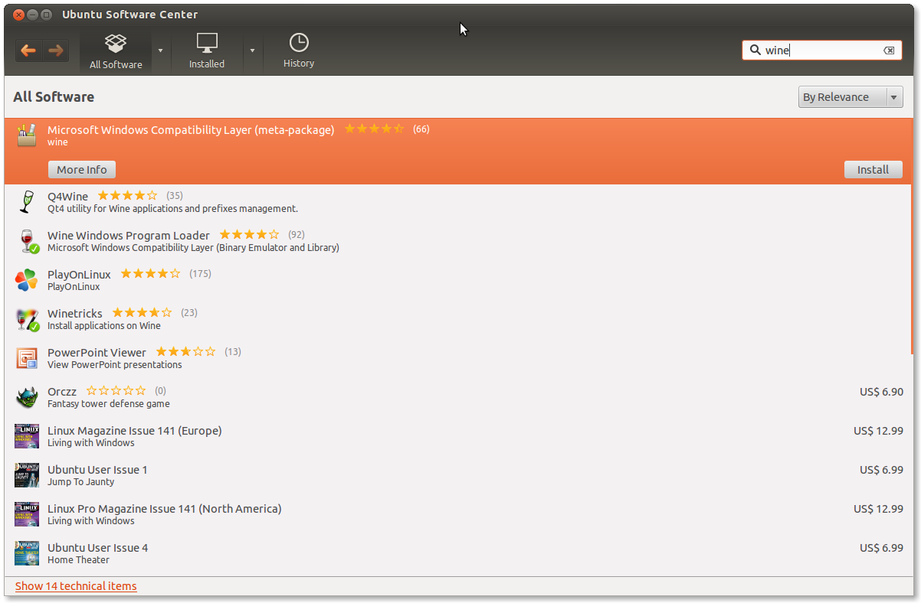

  - The first item should be “Microsoft Windows Compatibility Layer (meta-package)”. Select this and click the “Install” button on the right side.
  - When prompted, enter the password (janelia) for the SEA Faculty account and click “Authenticate”.
  - Wait until the install progress bar completes, then close the Ubuntu Software Center.

- Download DNA Master
  - Within the VM, launch the Chrome web browser from the left bar.
  - Google “DNA Master”, or go directly to: http://cobamide2.bio.pitt.edu/computer.htm
  - Click the DNA Master icon to download the DNA Master installer.
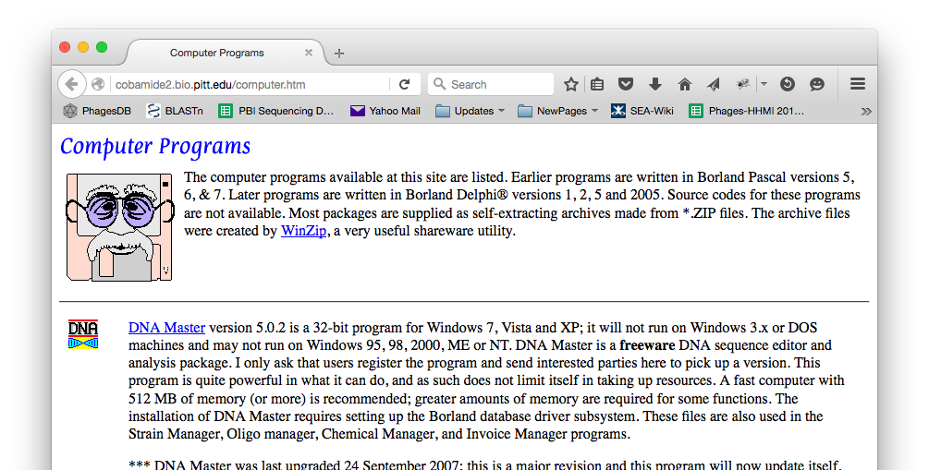
  - Wait for the download to complete.

- Install DNA Master
  - Within the VM, open your file browser by clicking this icon:

  - Select the Downloads folder from the sidebar.
  - Double-click the “dna master.exe” icon to launch the installer.
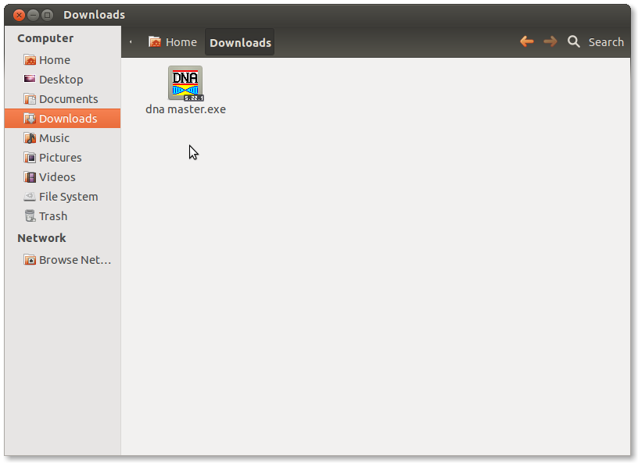

  - Click “Next” several times to move through the installation process.
  - At the final screen, un-select “Run DNA Master Now”, then click “Finish”.

- Download icon and launcher
  - Within the VM, go to the following URL in Chrome:
http://seaphages.org/static/images/DNAMaster.gif

  - When the DNA Master icon appears, right-click and choose “Save image as…”
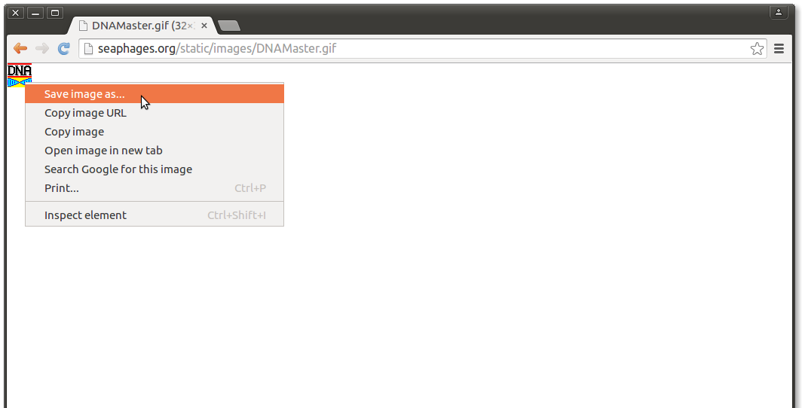

  - In the Save File window that opens, select the “Downloads” folder.
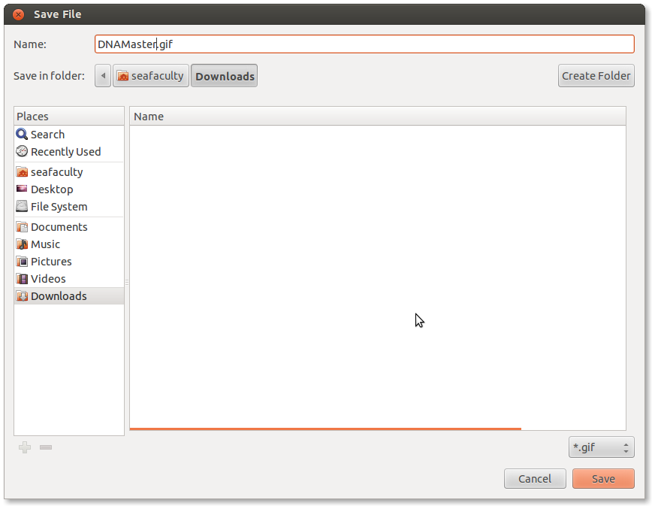

  - Click “Save”.
  - Within the VM, go to the following URL in Chrome:
http://seaphages.org/static/images/DNAMaster.desktop
(a file should automatically download to your Downloads folder)

- Create launcher shortcut (requires command-line, but one time only)
  - Open a Terminal by clicking on the follow link on the left bar in the VM:

  - Type the following commands exactly in the terminal, taking care to get all capitalization and spaces correct. Press enter after each one. There are three total. (If prompted for a password, enter “janelia”.)

chmod 755 ~/Downloads/DNAMaster.desktop

mv ~/Downloads/DNAMaster.desktop ~/.local/share/applications/

sudo mv ~/Downloads/DNAMaster.gif /usr/share/icons/

  - Open a file browser by clicking on the icon:

  - Use the “View” menu to select “Show Hidden Files”.
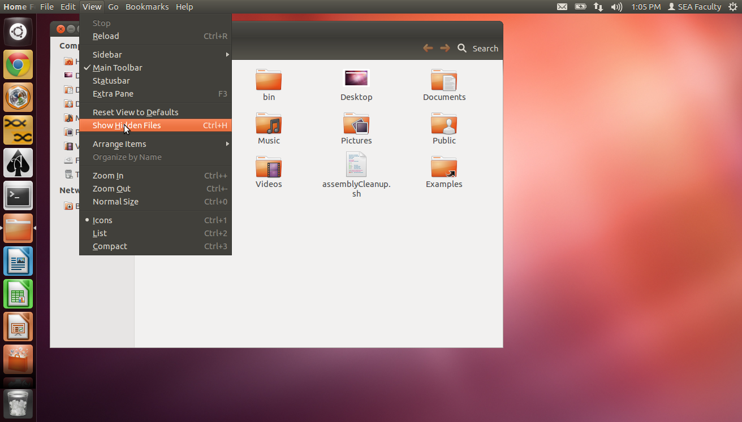

  - Go into the now-visible “.local” folder, then into the “share” folder, then into the “applications” folder.
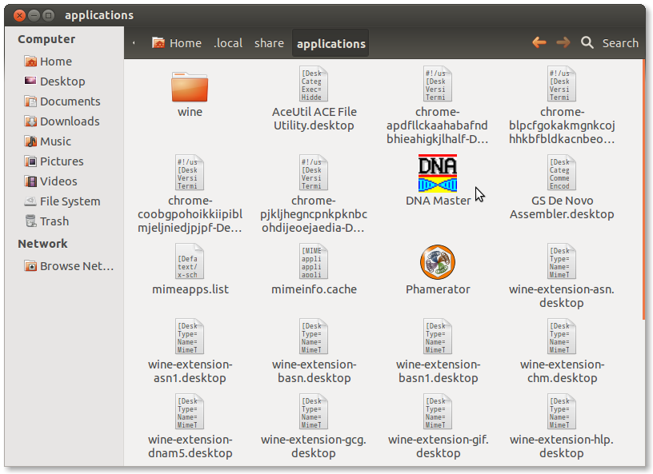
  - Double-click the DNA Master icon to launch DNA Master.
  - As soon as the program opens, locate its icon on the left bar, right-click on that icon, and choose “Lock to Launcher”.
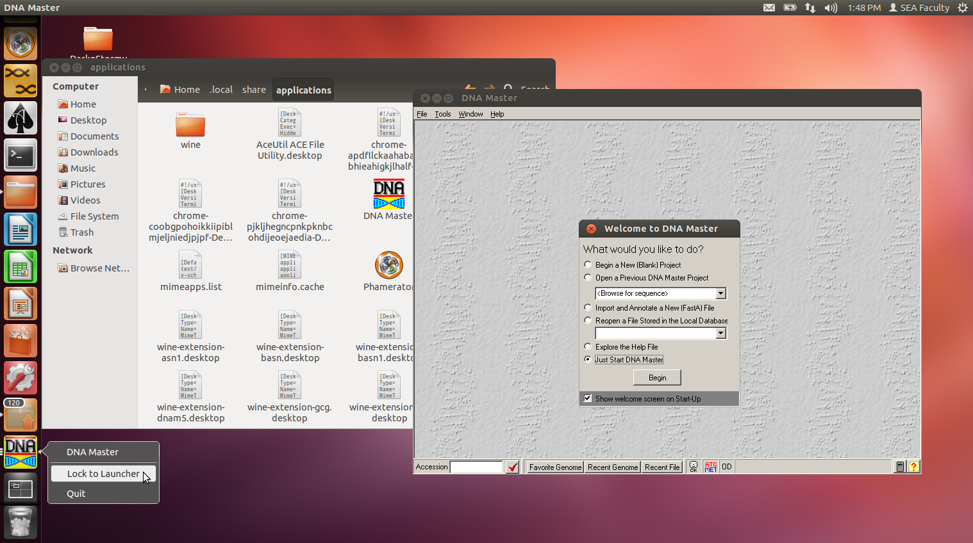

  - Close DNA Master, and verify that the DNA Master icon is still on the left bar.
  - If desired, you can move the DNA Master icon up or down in the list of applications by clicking-and-holding on it for a moment, then dragging it up or down.

- Use DNA Master
  - Click the DNA Master icon on the left bar to launch the program. (If prompted, select “Begin”.)
  - Go to Help Update DNA Master. If all went well, you should see the following message:
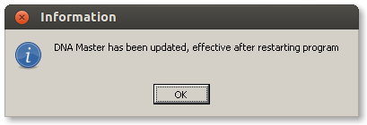

  - Use it as you would on Windows! Let us know what you discover.

