CONSIDER FOR TALK
8th Annual SEA-PHAGES Symposium Abstract
Morehouse College
Atlanta GA
Corresponding Faculty Member: Larry Blumer (lblumer@morehouse.edu)
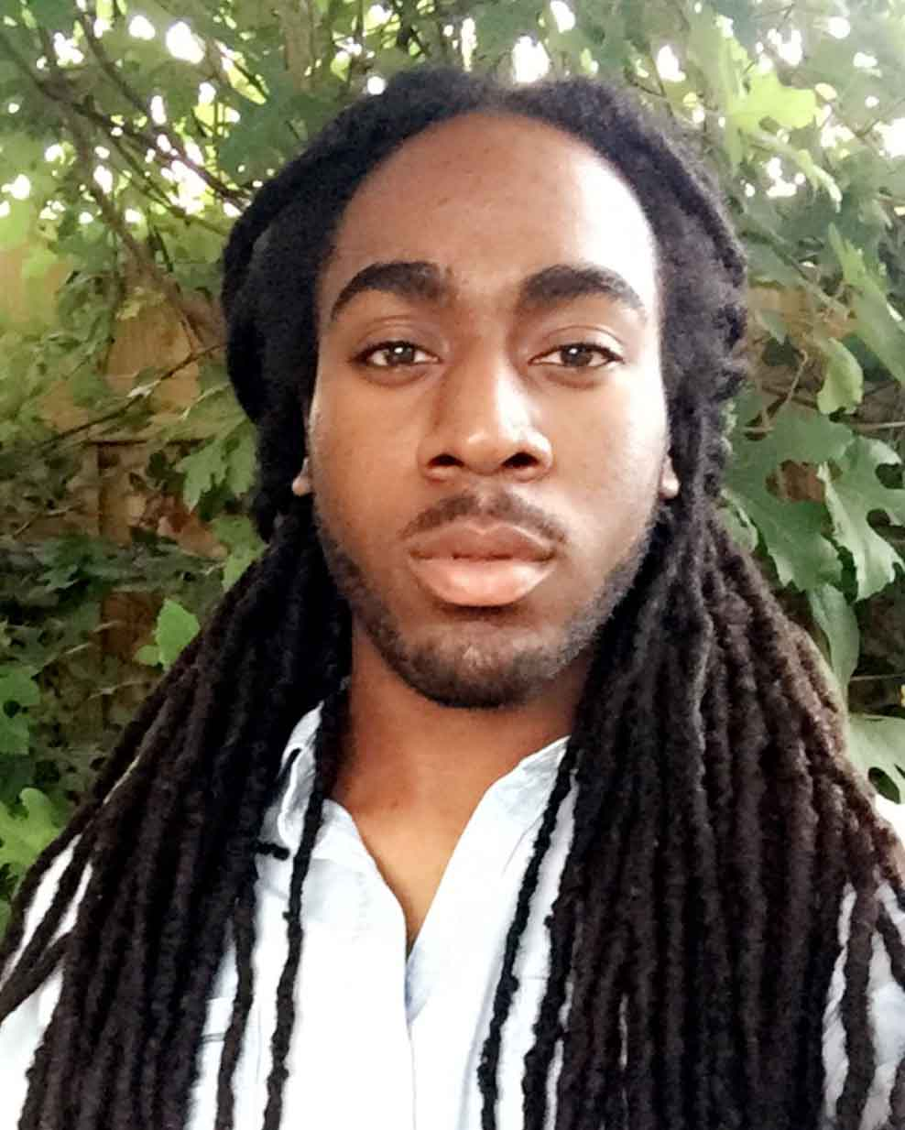
Ziha G Meghoo-Peddie
Darius D Artis
The discovery and annotation of four new mycobacteriophages
Ziha G Meghoo-Peddie, Darius D Artis, Jasanta M Ackles, Ryan J Brazier, Ronald M Bryant, Kerel O Callwood, Isaiah H Carter, Cameron L DeBose, Christian D Edwards, Isaiah C Ezemba, Renshal R Joaquin, Zakai M Meghoo-Peddie, Ryan W Moore, Christopher E Smith, Adam J Turner, Raymond L Vorters, Jeffrey J Wider, Alexandra Peister, Lawrence S Blumer
Mycobacteriophages CLED96, Remy19, Wilder and Zakai were isolated from soil samples in or near Atlanta, Georgia, using Mycobacterium smegmatis as the host. CLED96 and Remy19 are both Cluster G1 viruses 41,456bp and 41,901bp long respectively. Wilder and Zakai are both Cluster L2 viruses 75,806bp and 76,363bp long respectively. The purpose of our research was to finalize draft annotations of all four phages by manually confirming potential genes and identifying gene functions. Utilizing the annotation program, DNA Master, and guided by heuristic GeneMark output for all four phages, we determined the most likely open reading frames to identify each gene in these four genomes. We were particularly interested in the similarities and differences between these phages and other phages in the same Clusters. Synteny is very clear in all these phages in the first half of each genome. All four phages have programmed translational shift in the tail chaperone genes just upstream of the tapemeasure gene. Both Cluster L2 phages had 14 tRNA sequences after bp 40,000 but none were detected in the G1 phages. Comparing Phamerator maps of the genomes in the same cluster revealed remarkable similarity in both nucleotide sequences and protein products. However, differences between our phages and those previously annotated in Clusters G1 and L2 are located in the second half or near the end of each genome. This pattern of variation among phages in these clusters indicates that large-scale mutations (deletions and additions) in the late genes are common and do not disrupt essential functions for phage reproduction. The late genes in the genomes of phages are less essential than the early genes for lytic cycle functions.

