CONSIDER FOR TALK
8th Annual SEA-PHAGES Symposium Abstract
University of Maryland, Baltimore County
Baltimore MD
Corresponding Faculty Member: Steve Caruso (scaruso@umbc.edu)
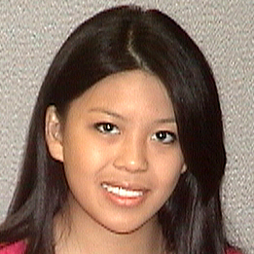
Phuong T Hoang
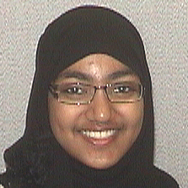
Asfiya Mariam
Two Pacific Bacteriophages Isolated and Characterized
Shabaana Ali, Jessica M Allison, Nitika Bansal, Elizabeth A Cardosa, Si Chen, Ian A Crosby, Leo Endres, Samantha Eng, Steven A Felkoski, James L Heins, Phuong T Hoang, Keenan T Hope, Omololu Imani, Nathaniel L Jackson, Anan Li, Caitlyn Maczka, Pari M Majethia, Asfiya Mariam, Natalie McDonald, Nakhleh I Shireen, Kaylie M Nguyen, Shivakshi Pancholi, Odilia Sendze, Nora Wang, Sefa Kilic, Ivan Erill, Steven M Caruso
UMBC Phage Hunters isolated, sequenced and annotated phages from two different bacterial species in 2015 – 2016. Streptomyces phage Nanodon was isolated from a volcanic soil sample collected from Kilauea, HI using Streptomyces griseus griseus ATCC 10137™ as a host. This Siphoviridae phage produced clear, variably sized plaques on supplemented nutrient agar, and has a linear genome of 50,082 bp, with 77 protein coding genes and 65.7% GC content. Initial classification of Nanodon as a BD1-cluster phage was supported through phylogenetic analysis of the terminase and portal proteins. Bacillus phage SalinJah was isolated from soil collected in Gyeonggi-do, South Korea and cultivated on Bacillus thuringiensis Berliner DSM 350. SalinJah has a wide host range among B. cereus group spp., though not among other tested Bacillus spp. SalinJah is a Myoviridae with a linear genome of 161,140 bp, 38.7% GC and 291 protein coding genes. SalinJah appears to be a member of the C1 sub-cluster, though differences highlighted by Phamerator and phylogenetic analysis of tape measure protein, tail sheath protein, and DNA polymerase suggest a potential split or sub-sub cluster. For the second year, UMBC Phage Hunters participated in the intercollegiate CACAO competition, this year competing against three other SEA-PHAGES campuses. As part of the competition, UMBC Phage Hunters read nearly 80 papers and submitted a total of 125 GO annotations using primary literature and orthology assessment.

